IE Orientation and 20th Annual Faculty Development Symposium on University English Teaching
8:30 AM, Saturday, April 6, 2013, Shibuya Campus

Our objectives this year are to provide you with an orientation to the new campus, classrooms, and resources; to update IE Core, Writing, and OE teachers about the new textbook references for Interchange 2, 4th ed., and Interactions 2, 6th ed.; to provide you with new teaching ideas and applications of technology in education; to familiarize teachers with the use of Engrade.com, and of the AGU Portal, the latter as a means of requesting rooms, and posting syllabuses.

In order that you get the most from the workshops and other sessions, please bring your teacher ID card (and your LDAP password). From now on, you will use your ID card instead of a key to open the cabinet with your classroom’s AV equipment. If you do not have an LDAP password, please go to the office of the computing centre, Building 11, 1F, before the Orientation to obtain one. New teachers will have ID cards mailed to them on April 4th.

Secondly, please bring any mobile device that you intend to use in the classroom. For example, if you have a tablet computer (and your LDAP password), you can log onto WiFi in Building 17. We are now recommending the use of Engrade.com for grading as it is free and can be accessed on the Internet. For those new to the program, please log on to it and register at (https://www.engrade.com/).
We will provide a short demonstration of it during the mentoring sessions. You can also check out the help menu (https://wikis.engrade.com/help).

Next, if you plan to take a group to the musical “Into the Woods,” please let us know so that we can prepare the appropriate number of handouts.

Finally, you should have received your classroom assignment in the mail. Regrettably, classroom assignments are almost impossible to change at this point. This is something both Joseph and I have experienced in trying to alter our own classroom allocations. Like some of you, I’ll be teaching an IE Core class in two different rooms.

To get to the Saturday Orientation, April 6th, please enter building 17#, walk past the escalator to the last pair of elevators on the right hand side. These escalators go all the way to the 12th floor. Stop at the 8th floor.

Looking forward to seeing you,

IE Coordinators
Joseph Dias
Gregory Strong

Campus Reference Map and timetable

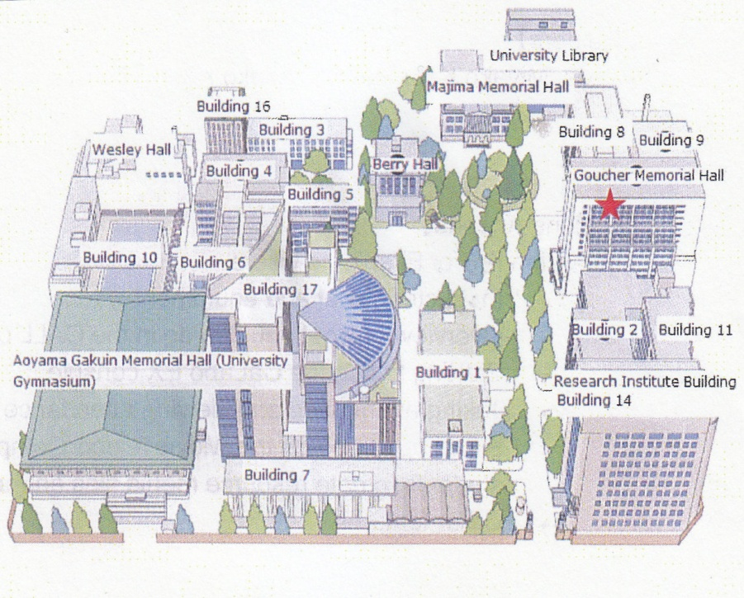 | 2013 Timetable:  1st period 9:00 - 10:30  Chapel Break 10:30 – 11  2nd period 11:00 – 12:30  LUNCH  3rd period 13:20 – 14:50  4th period 15:05 – 16:35  5th period 16:50 – 18:20  6th period 18:30 – 20:00  7th period 20:10 – 21:40  koushi hikae shitsu (Teachers’ lounges) are in Buildings 1 and 3, 1F. The Foreign Language Lab DVD, VHS tapes, and CD roms are in Building 8. The computer lab is in Building 11, 1F.

Mentor Sessions:  (1)AGU Portal:  Takeda, N.  Bulach, J.  Browning, T.  Twaddell, B.  Unosawa, K.  Mohamed, G.  Shade, E.  Thomson, B.  (1) IE Listening:  Namba, K.  Unosawa, K.  Katsumata, E.  Inouye, K.  Nakasone, K. | (2) Engrade:  Bulach, J.  Twaddell, B.  Unosawa, K.  Katsumata, E.  Namba, K.  Howl, P.  Thomson, B.  (3) IE Writing:  Anderson, Tom  Browning, T.  Martin, J.  Nakamura, D.  Twaddell, B.  Walker, R.  Martin, J.  Creative Writing:  Eric Shade  Gamal Mohamed

TIME | Building 17: 8th floor
8:30 | COFFEE
8:45 | Introduction – Dias, Strong  Department handbook  IE Core and Writing: Reboot Interchange 2 (4th ed.) and Interactions 2 (6th ed.)  Room 810 |  |  | Campus Tour 1 for Other Teachers - Dias  • Department handbook  • teachers’ preparation rooms  • department resource centre  • media library  • computing centre
9:30 | Student Plagiarism in IE Core and Writing Classes – Bollinger Room 810
10:00 | Scaffolding Discussions – Harper  Room 810 |  | Mentoring Session I:  AGU Portal, Engrade,  Active Listening,  IE Writing,  and Creative Writing  – Anderson et al.  Room 808 |  | Teaching Content Classes 1:  A Colloquium by IE Seminar Teachers – Dias et al. Room 809
10:15 | Literary Terms Through Film –  Bollinger  Room 810
10:30 | Intercultural Awareness through Letters – Takeda  Room 810
11:15 | COFFEE
11:30 | Summarizing “Mary Hillis – 21st Century Tools for Teaching Literature” - Strong  Room 810
11:45 | Apps for Education –  Fuhlendorf, Reimann, Dias  Room 810 |  |  | Teaching Content Classes 2:  A Colloquium by IE Seminar Teachers – Strong et al.  Room 809
12:45 | Self-Publishing Textbooks – Bauman, Reimann  Room 810 | Mentoring Sessions 2: AGU Portal, Engrade  - Dias  Room 808 |  |  | “Into the Woods” - Fieldtrip to a Musical-Strong  Room 809
Campus Tour 2
- Dias

IE Orientation and 20th Annual Faculty Development Symposium on University English Teaching

Sessions:
1) Introduction, Department Handbook, IE Core and Writing: Reboot – two textbooks used in IE Core and Writing classes have been revised. This session will outline the changes in the IE Core and Writing booklet, how they will affect freshmen and sophomores differently, and provide an overview of the Interactions 2 reading text, a lower level text than Mosaic 1 which we have used previously in the IE Program.

2) Campus Tour 1 – this tour will be offered twice during the Symposium in order to provide teachers attending other sessions the opportunity to take part in it. The first tour is intended for IE Listening teachers and other teachers who are not teaching in the IEP.

3) Student Plagiarism in IE Core and Writing Classes – this interactive session will deal with some new examples of student plagiarism in journal writing and in IE writing courses. We will open this session up to hear about your experiences with the problem and suggestions that you might have to mitigate it.

4) Scaffolding Discussions – Paul Harper will show how a framework of additional questions can offer a very effective means of introducing students to the discussion task in the IE Core class.

5) Literary Terms Through Film: Whale Rider – Deborah Bollinger will describe how she uses the film Whale Rider to introduce students to literary terms. This session is based on her article in the 2012 edition of the department journal, Thought Currents.

6) Mentoring Session I: this part of the symposium will begin with a review of the use of the AGU Portal, and Engrade which is free grading software available online. Afterward, course teachers in small groups with mentors Tom Anderson, Keiko Inouye, Kazuko Namba, and Eric Shade, and four or five mentees (teachers doing a course for the first time) will look at Active Listening, IE Writing, and Creative Writing.

7) Teaching Content Classes 1: A Colloquium by IE Seminar Teachers – Joseph Dias chairs this discussion by Hamilton Armstrong, Jeff Bruce, Sue Binder, Deborah Bollinger, and Paul Howl on how they use content in language teaching in their IE Seminars. Teachers will outline their courses, projects, and challenges.

8) Intercultural Awareness through Letters – For several semesters, Nicole Takeda has experimented with a letter exchange in English between students in the IEP and Cambodian students. She will describe the benefits to our students in terms of them of intercultural communication and in helping them to move beyond cultural stereotypes.

9) Summarizing “Mary Hillis – 21st Century Tools for Teaching Literature – among the standout presentations on educational technology at the JALT 2012 conference was this one. (See it at http://www.slideshare.net/). Greg Strong will summarize it.

10) Apps for Education – this session has become an annual one due to its popularity and because of the growing number of new apps for education. Arno Fuhlendorf, Andrew Reimann, and Joseph Dias will take us through their latest finds.

11) Teaching Content Classes 2: A Colloquium by IE Seminar – Greg Strong covers the second part of the colloquim, describing his use of content in language teaching and that of other IE Seminar teachers.

12) Self-Publishing Textbooks – John Bauman and Andrew Reimann have been developing expertise in publishing their own textbooks in Japan and on the Internet. They will take us through the process, and describe some companies and prices.

13) Mentoring Session 2: this repeats part of “Mentoring Session 1#.” It only covers the use of the AGU Portal, and Engrade which is free grading software available online.

14) Campus Tour 2: this tour is for those teachers who could not attend the first tour and missed the tour in January.

15) “Into the Woods”- Preparing for a Fieldtrip to a Musical – this session will interest teachers considering a class fieldtrip to attend this Stephen Soundheim comic musical. It’s a modern take on such Grimm’s Fairy Tales as “Cinderella,” “Little Red Riding Hood,” and “Jack and the Beanstalk” and shows are from May 16-19, 7PM, 1PM.

Presenters:
Tom Anderson – Tom Anderson comes from Calgary, Alberta and has been living in Japan for 28 years. He has published articles and given presentations on English teaching in Japan, Canada, the U.K., and the U.S.A. He's starting his thirteenth year of teaching in the IE Program and is interested in developing materials and curriculum for writing classes. (E-mail: tom.c.anderson@gmail.com).

Hamilton Armstrong is from New Orleans, Louisiana. In Japan since 1987, he began teaching at Aoyama Gakuin University in 1994. Hamilton has a Master of Fine Arts (MFA) and PhD. His areas of specialization and interest include theatre, public speaking, voice, literature of the oppressed, social justice, gothic literature, and micro-fiction. (Email: ariel97us@yahoo.com)

John Bauman - first came to Japan 25 years ago, after receiving his Masters Degree from the University of Illinois at Chicago. Currently teaching at AGU, Hosei University and Ochanomizu University, he also does corporate training in Tokyo. He has an extensive background in business and education in Japan, China, and the USA, with a strong focus on cross-cultural business communications. John also has wide experience in the development of content for training programs in both business and higher education contexts (E-mail: johnlee15@jbauman.com).
Susan Binder - has been teaching writing, art history, and humanities courses in a number of universities and programs in Japan for 15 years. She is interested in keeping the arts and humanities alive in the classroom and is continuously devising ways to engage student's interest in these subjects. (E-mail:qktokyo@gmail.com)

Deborah Bollinger completed her graduate studies (M.A.T. in TESOL and French) at the School for International Training in Vermont. She taught EFL in France, was a Peace Corps volunteer in Morocco, and then an ESL teacher in the U.S. In 1997, she came to Japan to Tokai University, moved to Doshisha Women’s College in Kyoto, and in 2006, J.F. Oberlin University, Tokyo. Currently, she teaches at Aoyama Gakuin University, Nihon University, Meiji Gakuin University, and Hosei University. Her pedagogical interests include learner autonomy, motivation, CALL, and intercultural communication. (Email: deb.bollinger@gmail.com)

Jeff Bruce--did his graduate studies in Teaching English as a Second/Foreign Language in the linguistics department of Northwestern University,Chicago. He's been teaching at Aoyama since 1994 and also teaches at Asuka Metropolitan HS in Tokyo and Polytechnic University in Kodaira. At present, working for Nullarbor Press and Cengage Learning, he’s written more than 50 books including TOEIC preparation and other educational materials. (E-mail: jbruce@a.toshima.ne.jp)

Joseph V. Dias - co-coordinates the IE Program in the English Department of Aoyama Gakuin University. He also teaches courses on intercultural communication and food culture. His research interests include computer-assisted language learning and autonomy in language learning. He's currently the program chair of the Lifelong Language Learning SIG of JALT [If you want to be part of the LLL-SIG's forum at JALT in Kobe this year let him know!]. (http://www.cl.aoyama.ac.jp/~dias/)
(E-mail: jodias@cl.aoyama.ac.jp).

Arno Fuhlendorf - - From Calgary, Canada, He has been teaching in the IE program for three years. Although originally studying to be a microbiologist, he has been interested in language and communication since his childhood in Namibia. He also teaches at Bunkyo Gakuin, Chiba, and Nihon Universities. His research interests include World Englishes, vocabulary acquisition, and the use of drama in the ESL classroom. (E-mail: a.m.fuhlendorf@gmail.com).

Paul Harper - teaches English communication classes and content classes built around European and American culture. He has an undergraduate degree in English and American Literature, a graduate degree in Liberal Arts, and is pursuing his doctorate in History. Paul has taught English in Japan in a variety of settings since 1992, and has studied TESOL at the graduate level in Japan, the US, and Australia. (Email: pakharper@mac.com).

Paul Howl- Before moving to Japan in 2003, Paul taught ESL for six years in San Diego. Currently teaching at AGU, Tamagawa University and The University of Maryland, he often incorporates role play in many of his classes. Paul participates onstage and backstage with Tokyo International Players, a semi professional acting company, and has written academic articles about plays, and given presentations on using Drama and Film to enhance speaking skills. (E-mail: pfhowl@yahoo.com).
Keiko Inoue – A longtime listening teacher, she is currently teaching both Active Listening and e-learning and honing her schools in teaching student-centered courses (E-mail: keiinouye@hotmail.com).
Kazuko Namba – A very experienced listening teacher in the IE Program, she has presented on Active Listening at JALT and ACTJ in Tokyo as well as on reading teaching. She also teaches writing at AGU and Tamagawa University.
(E-mail: kazuko.namba@gmail.com).

Andrew Reimann - Associate Professor of International Studies at Utsunomiya University, he has a PhD in Applied Linguistics from Macquarie University. He teaches classes on Comparative Culture Studies and Intercultural Communication which focus on raising cultural awareness using an ethnographic approach. His research interests include communication styles, speech acts and the use of technology in communication and education. He has recently published three books in Japan and Germany; Ethnographic Encounters, Cultural Studies Handbook and Raising Cultural Awareness as part of EFL Teaching in Japan. (E-mail: anreimann@yahoo.com)

Nicole Takeda – interested in cross-cultural values, ever since her degree taken at the American University of Paris, she has been developing ways to introduce global issues into her language classes (www.nicoletakeda.com). For the past four years, she has been running her own government-accredited NGO English language school for underprivileged youth in Siem Reap, Cambodia (www.bea-cambodia.org). Two years ago, she introduced a writing exchange between her NGO and her IE core students, helping Japanese students develop cultural empathy. Soon, over 200 students will have participated in this exchange program (Email: takeda_nicole@yahoo.com).

Eric Shade - a graduate of Penn State University (BA, English Literature), he was a James Michener Fellow at the University of Houston (MFA, Creative Writing). He has taught ESL in Korea, the US, and Japan, in addition to having taught writing and literature courses, to native speakers, in the States. He teaches a variety of courses at AGU, Nihon University, and Chuo University. His book of stories, Eyesores, won the Flannery O'Connor Award for fiction and has recently been released in paperback (http://www.ugapress.org/index.php/books/eyesores). (E-mail: ecshade@gmail.com)
Gregory Strong – IE Program co-coordinator, a teacher, teacher educator, a curriculum materials writer, and some time writer, recently of graded readers with which he sharpens his skills at narration and plotting, not to mention experimenting with literary terms (http://gregorystrong.com). (E-mail: gregorybstrong3@yahoo.ca).

