2016 Active Listening
Scope and Sequence
Improving listening comprehension is a difficult challenge. First of all, improvement occurs over long periods of time and through extensive exposure to the target language. Secondly, some of the listening classes in the Integrated English Program are large ones of as many as 30 students, so it is difficult to organize a class. A third part of the challenge is to maintain student interest in listening over long periods of time.
Needs analyses were undertaken on earlier versions of this listening course. These involved large scale and extensive student surveys and interview protocols. These showed that students were unhappy with activities in which they were passive learners and they sought more choice in their listening materials. As the same time, there was also a need for more individualized instruction.
In 2009, we introduced a new course based on principles of blended instruction that combined traditional instruction with new technologies such as listening to streaming video on the Internet, and access to a self-access component through the reallyenglish online website.
At the same time, we tried to make listening more interactive through requiring students to undertake tasks that required listening to be integrated with writing and speaking as well as maintaining student interest through their choice of materials. This was the principle behind our very successful listening interactions, a small group activity that students consistently rate very highly in terms of their interest.
This teacher guide was prepared by Gregory Strong and Joseph Dias and includes material from Kazuko Namba, and Keiko Inouye and suggestions from other listening teachers. (Revised 31 May 2016).
- Course Objectives …………………………………………….3
- Breakdown of Grades ……………………………………….9
A Sample Lesson Plan ………………..…….…….……….10
- Interactions and write-ups ……………..………………11
- Teaching IE 3 Presentation Skills ………….…..…….18
- Appendixes
- Sample Course Outline ……………………………….22
- Sample Student Interaction
Question Sheet …………………………………………..24
- Sample Student Listening Reports ………………….25
- Sample Movie Listening Log …………………………..29
- reallyenglish Information
a) Issuing registration keys …………………………….34
b) Program features ……………………………………….40

Active Listening I | Active Listening II | Active Listening III
Themes:  Memories & Childhood, Urban Life, Food, Travel | Themes:  Changing Times & Technology, Workplace, Autobiography, Geography | Themes:  Psychology & Relationships, Intercultural Communication, Environment & Living Spaces, Media
Tasks:  25 reallyenglish units  4 listening reports  3 Interactions (large classes do 2 and 1 extra report) | Tasks:  25 reallyenglish units  4 listening reports  3 Interactions (large classes do 2 and 1 extra report) | Tasks:  25 (35) reallyenglish units  5 listening reports  2 Interactions  Group presentation task (large classes do 1 Interaction and 1 presentation and 1 extra report)

Course Objectives for Active Listening I, II, III
- Through exposure to authentic listening materials on the Internet and to the interviews and features on Summit TV, students will learn vocabulary, idioms, and conversational styles of speakers of English.
- Through participating in “Interactions,” students will improve their abilities at small group discussion including the use of eye contact, gestures, questioning, and follow-up questions.
- Through making question sheets for the “Interactions,” students will become more aware of the value of pre-listening and post-listening strategies in developing listening comprehension
- Through listening tasks such as making oral and written reports on high interest audio downloads at websites and through listening to contemporary movies, students will improve their language skills and become more familiar with the APA style for citations.
- Through lessons at reallyenglish, students will work on listening units suitable to their language level and improve their test-taking skills.
- Through exposure to a variety of listening genres – interviews, news features, narratives, and drama, students will learn some features of genre from each.
- Through varied activities in a single class, and a variety of tasks over the term, teachers will create an active classroom and sustain student interest in the course.
- In IE Level III, students working in groups will create a presentation that demonstrates a coordinated group effort, introductions, effective visuals, use of eye contact, and fluent speech (without reading).

IE 1 Active Listening
 | Memories Childhood | Urban Life | Food | Travel
(A) IN-CLASS  Supplementary materials can be drawn from the old IE Listening Program | SUMMIT TV 1-1#: On-the-Street: “How Would You Describe Yourself?”  SUMMIT TV 2-1#: On-the-Street: “Dreams and Goals”,  SUMMIT TV 1-8#: Short Documentary: “Being a Better Parent (Discipline),  REAL TALK:  Duffy, music | SUMMIT TV 1-5#: On-the-Street: “How Do You Feel About Living in the Suburbs?”  SUMMIT TV 2-4#: Short Documentary: “Handling Anger” | REAL TALK: Robbins & Vegetarians | SUMMIT TV 2-6#: Short Documentary: “Air Travel: Travelers Beware!”
 | INTERACTION: Introduce a favorite song on YouTube to some classmates (Note in APA Style; below) | INTERACTION: Report on a news item on a social issue (Note in APA Style) | INTERACTION: Find the best unusual recipe to share with some classmates (Note in APA Style) | INTERACTION: Choose a city and present a weekend itinerary (Note in APA Style)
C) TEACHER-MONITORED SELF ACCESS  Homework | Students are to complete 25 units of reallyenglish. This part of the course is to be done as homework. The teacher sets deadlines for which students receive a score for the participation part of their grades. In order to keep up with the class, students will get a point for finishing 8 units by the fourth week of the course, 12 units by the 8th week, and 16 units by the 12th week. The teacher should prepare screenshots/printouts of each deadline and show students their relative progress or lack of progress.
(D) SELF-DIRECTED LISTENING  Homework | Students should complete 4 reports (or 2 reports and 1 movie listening log). In large classes (over 25) where students are only doing 2 interactions, they should do 5 reports. For every assignment, whether movie or report, students should note the listening site or movie according to the APA style. Each listening report should relate to a theme in IE 1 Active Listening: memories-childhood, urban life, food, and travel.  Stone, C. (Director). (2007). How to remember people’s names [Online video clip]. Video Jug.com. 10 March 2016. Retrieved from <https://www.youtube.com/watch?v=7Q74cJtVpkA>. [Access it from YouTube.]
Participation marks will be given in class for attendance, completing reallyenglish units on schedule (assess the students 3 times on this point over the term), performance on vocabulary tests, in-class effort. Please note that the units for reallyenglish must be finished by the last class which is well before the date on the reallyenglish website.

IE 2 Active Listening
 | Changing Times & Technology | Workplace | Autobiography | Geography
(A) IN-CLASS Supplementary materials can be drawn from old the IE Listening Program | SUMMIT TV 2-9#: On-the-Street: New Technology  “The problem’s not with the technology” | SUMMIT TV 1-3#: On-the-Street: “Saving Money”  SUMMIT TV 1-10#: “Work and Leisure”  REAL TALK: Amy Christmas and job satisfaction | SUMMIT TV 2-3#: On-the-Street: “Frightening Experiences”,  SUMMIT TV 1-2#: Short Documentary: “Beck, Musician”  REAL TALK: Cornel West | SUMMIT TV 2-2#: Short Documentary: “Dr. Torstveit’s Vacation”  REAL TALK: Oxford RAs
(B)INTERACTIONS  Choose 3/4  Homework | INTERACTION: Introduce the funniest/best commercial (Note in APA Style) | INTERACTION: Explain how to write a resume, find a job, take an interview, etc. (Note in APA Style) | INTERACTION: Celebrate a hero  (Note in APA Style) | INTERACTION: Describe an example of Human Population, Cultural Geography, etc. (Note in APA Style)
C) TEACHER-MONITORED SELF ACCESS  Homework | Students are to complete 25 units of reallyenglish. This part of the course is to be done as homework. The teacher sets deadlines for which students receive a score for the participation part of their grades. In order to keep up with the class, students will get a point for finishing 8 units by the fourth week of the course, 12 units by the 8th week, and 16 units by the 12th week. The teacher should prepare screenshots/printouts of each deadline and show students their relative progress or lack of progress.
(D) SELF-DIRECTED LISTENING  Homework | Students should complete 4 reports (or 2 reports and 1 movie listening log). In large classes (over 25) where students are only doing 2 interactions, they should do 5 reports. For every assignment, whether movie or report, students should note the listening site or movie according to the APA style. Each listening report should relate to one of the themes in IE 2 Active Listening: changing times-technology, workplace, autobiography, geography.  Stone, C. (Director). (2007). How to remember people’s names [Online video clip]. Video Jug.com. 10 March 2016. Retrieved from <https://www.youtube.com/watch?v=7Q74cJtVpkA>. [Access it from YouTube.]
Participation marks will be given in class for attendance, completing reallyenglish units on schedule (assessed 3 times over the term), performance on vocabulary tests, in-class effort. Please note that the units for reallyenglish must be finished by the last class which is well before the date on the reallyenglish website.
IE 3 Active Listening
 | Psychology &  Relationships | Intercultural Communication | Environment & Living spaces | Media
(A) IN-CLASS  Supplementary materials can be drawn from the old IE Listening Program | SUMMIT TV 2-1#: On-the-Street: “Strengths and Weaknesses: I’m Really Good At…”, SUMMIT TV 2-5#: On-the-Street: “Phobias and Superstitions”, SUMMIT TV 1-4#: Short Documentary: “Selling Them Short” | SUMMIT TV 2-8#: Short Documentary: “The Simpsons” | SUMMIT TV 2-10#: Short Documentary: “The Ndoki Rain Forest” | SUMMIT TV 1-7#: On-the-Street: Advertising:  “I think there’s too much”;  SUMMIT TV 1-9#: On-the-Street: News: “I don’t believe everything I read”  REAL TALK: Philippe, a Photographer in Japan
(B) STUDENT PROJECTS  Choose 3/4  Homework | INTERACTION: Describe a self-help video after a search on YouTube, ie. the “video jug channel,” then choose one  on becoming more confident, etc. (Note in APA Style) | PRESENTATION: Introduce a video on an aspect of intercultural communications (Note in APA Style) | PRESENTATION: Prepare an environmental brief “for action” on an environmental problem (Note in APA Style) | INTERACTION: Introduce an English movie trailer at imdb.com or YouTube and ask questions of the group (Note in APA Style)
C) TEACHER-MONITORED SELF ACCESS  Homework | Students are to complete 25 units of reallyenglish. This part of the course is to be done as homework. The teacher sets deadlines for which students receive a score for the participation part of their grades. In order to keep up with the class, students will get a point for finishing 8 units by the fourth week of the course, 12 units by the 8th week, and 16 units by the 12th week. The teacher should prepare screenshots/printouts of each deadline and show students their relative progress or lack of progress.
(D) SELF-DIRECTED LISTENING  Homework | Students should complete 5 reports (or 3 reports and 1 movie listening log). In large classes (over 25) where students are only doing 1 interaction, and 1 presentation, and they should do 6 reports. For every assignment, whether movie or report, students should note the listening site or movie according to the AP style. Each listening report should relate to one of the themes in IE 3 Active Listening: psychology-relationships, intercultural communication, environment-living spaces, media. A sample of APA Style:  Stone, C. (Director). (2007). How to remember people’s names [Online video clip]. Video Jug.com. 10 March 2016. Retrieved from <https://www.youtube.com/watch?v=7Q74cJtVpkA>. [Access from YouTube.]
Participation marks will be given in class for attendance, completing reallyenglish units on schedule (assessed 3 times over the term), performance on vocabulary tests, in-class effort). Please note that the units for reallyenglish must be finished by the last class which is well before the date on the reallyenglish website.
IE 3 TRANSFER Active Listening
 | Psychology/ Relationships | Intercultural Communication | Environment/ Living spaces | Media
(A) IN-CLASS  Supplementary materials can be drawn from the IE Listening Program | SUMMIT TV 2-1#: On-the-Street: “Strengths and Weaknesses: I’m Really Good At…”, SUMMIT TV 2-5#: On-the-Street: “Phobias and Superstitions”, SUMMIT TV 1-4#: Short Documentary: “Selling Them Short” | SUMMIT TV 2-8#: Short Documentary: “The Simpsons” | SUMMIT TV 2-10#: Short Documentary: “The Ndoki Rain Forest” | SUMMIT TV 1-7#: On-the-Street: Advertising:  “I think there’s too much”;  SUMMIT TV 1-9#: On-the-Street: News Sources: “I don’t believe everything I read”  REAL TALK: Philippe, a Photographer in Japan
(B) STUDENT PROJECTS  2 Interactions  1 Presentation  Homework | INTERACTION: Describe a self-help video after a search on YouTube, ie. the “video jug channel,” then choose one  on becoming more confident, etc. (Note in APA Style) | PRESENTATION: Introduce a video on an aspect of intercultural communications (Note in APA Style) | INTERACTION: Introduce an English movie trailer and assign questions to the group (Note in APA Style) | PRESENTATION: Prepare an environmental brief “for action” on an environmental problem (Note in APA Style)
C) TEACHER-MONITORED SELF ACCESS  Homework | Students are to complete 35 units. This part of the course is to be done as homework. The teacher sets deadlines for which students receive a score for the participation part of their grades. In order to keep up with the class, students will get a point for finishing 12 units by the fourth week of the course, 20 units by the 8th week, and 28 units by the 12th week. The teacher should prepare screenshots/printouts of each deadline and show students their relative progress or lack of progress.
(D) SELF-DIRECTED LISTENING  Homework | Students should complete 5 reports (or 3 reports and 1 movie listening log). For every assignment, whether movie or listening report, students should note the listening site or movie according to the APA style. Each listening report should relate to one of the themes in IE 3 Active Listening: psychology-relationships, intercultural communication, environment-living spaces, media. A sample of APA Style:  Stone, C. (Director). (2007). How to remember people’s names [Online video clip]. Video Jug.com. 10 March 2016. Retrieved from <https://www.youtube.com/watch?v=7Q74cJtVpkA>. [Access from YouTube.]
Participation marks will be given in class for attendance, completing reallyenglish units on schedule (assessed 3 times over the term), performance on vocabulary tests, in-class effort). Please note that the units for reallyenglish must be finished by the last class which is well before the date on the reallyenglish website.
Breakdown of AL 1 Grades:
(B) STUDENT PROJECTS - 3 INTERACTIONS (Only 2 INTERACTIONS in large classes) | 30%
(C) TEACHER-MONITORED SELF ACCESS (25 units) | 25%
(D) SELF-DIRECTED LISTENING | 20%
Participation (completing reallyenglish on schedule, vocabulary quizzes) | 5%
IE Listening Final Test | 20%

Breakdown of AL 2 Grades:
(B) STUDENT PROJECTS - 3 INTERACTIONS (Only 2 INTERACTIONS in large classes) | 30%
(C) TEACHER-MONITORED SELF ACCESS (25 units) | 25%
(D) SELF-DIRECTED LISTENING | 20%
Participation (completing reallyenglish on schedule, vocabulary quizzes) | 5%
IE Listening Final Test | 20%
Breakdown of AL 3 and AL 3 Transfer Grades:
(B) STUDENT PROJECTS - 2 INTERACTIONS (Only 1 INTERACTION in large classes) | 20%
(B) STUDENT PROJECTS – PRESENTATION | 15%
(C) TEACHER-MONITORED SELF ACCESS (25 units; 35 units for AL 3 Transfer) | 20%
(D) SELF-DIRECTED LISTENING | 20%
Participation (completing reallyenglish on schedule, vocabulary quizzes) | 5%
IE Listening Final Test | 20%
In the Active Listening courses, students will not be given marks for attendance. Students should be attending classes and participating in them. Instead, students will lose marks if they are absent from class without a legitimate excuse. Legitimate excuses consist of serious illnesses (with a doctor’s note), or family-related absences such as attending a funeral. Please warn students of this policy in the first class and identify students who begin to show a pattern of absences and tardiness and warn them appropriately. Remind that them that they must pass all three IE courses to obtain credit for IE Level I, II, or III.
Deducting Marks for Absences
Absences | Maximum Grade
1 | * No effect on grade
2 | Final grade cannot exceed 89%
3 | Final grade cannot exceed 79%
4 | Final grade cannot exceed 69%
5 or more | Fail (unless legitimate absences)

A Plan for the first 2 classes
Class | Lesson | Homework
1 | - Course outline, description of the 4 components: A, B, C, D, participation, and the final test.  - Assist students to Log-in to the reallyenglish website and demonstrate how to trouble-shoot log-in problems through using the FAQs and each student’s “My Page”. Use the exact URL or you will not be able to login. Ensure that all the students have created and filed a password.  -Direct students to take the reallyenglish assessment test. Afterward, the website will generate an individual learning path for each student. Unless you are teaching an IE 3 Active Listening class for returnees, tell the students to do 80% of the listening units rather than reading or another type.  -Make sure that every student in the class has taken the test and logged onto the website to try a lesson.  - Allow 15 min of class time for students to work on a reallyenglish unit. Ensure that all students have registered and know how to use the FAQs and “My Page”. Use this time to assist students having trouble logging in, etc.  - Describe how an INTERACTION (B) will be done. (Refer to the Appendix to find the websites and instructions for Internet resources for the video sequences). Ask students to pick 3 possible videos from the website(s). | (C) log-in to reallyenglish, begin units  (B) work on INTERACTION
2 | - Allow 15 min of class time for students to work on a reallyenglish unit. Use this time to assist students who have lost their password or to help any students who missed the first class and need to log on and take the test.  - For the INTERACTIONS, circulate a sign-up list for dates and topics (do not allow students to choose the same ones). INTERACTIONS which should start in 2 weeks.  - Show the list of language learning websites (D) and the report form and explain these. Set due dates for each report.  - IN-CLASS, Summit TV lesson (A) in remaining class time | (A), (B), (C), (D)

Written assignments:
Students should format their papers to 12-point Times New Roman at 26 lines per page. In addition, they must put a page number and the title of the writing assignment in the upper right corner of the document
The following diagram shows how to change the line spacing in the Japanese version of MS Word. All of the university laptops come loaded with this program, so this should be easy for you to show to your students.
This will be particularly important to show to freshman students in the Spring semester. An explanation of this can also be found on page 70 of the students’ IE Core and Writing booklet.

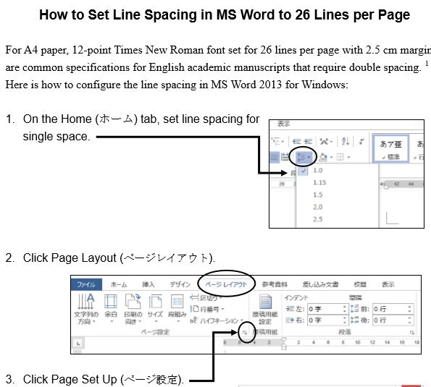

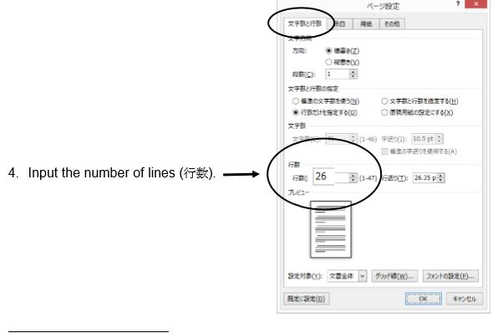
In addition, the students must put a page number and the title of the writing assignment in the upper right corner of the document. They need to put their name and student number on the first page.

Student “Interactions”:
To do an interaction, each student leader must find an online video suitable to the unit theme. They are supposed to listen to it a number of times, making notes to prepare a question sheet for their classmates.

You need to provide a short demonstration in class of using an online website. Please note that students can activate a closed caption (cc) function on many YouTube videos. As in the following example, the boxed cc in the lower righthand corner means that captioning is available. The screenshot shows the sequence with captioning function operating.
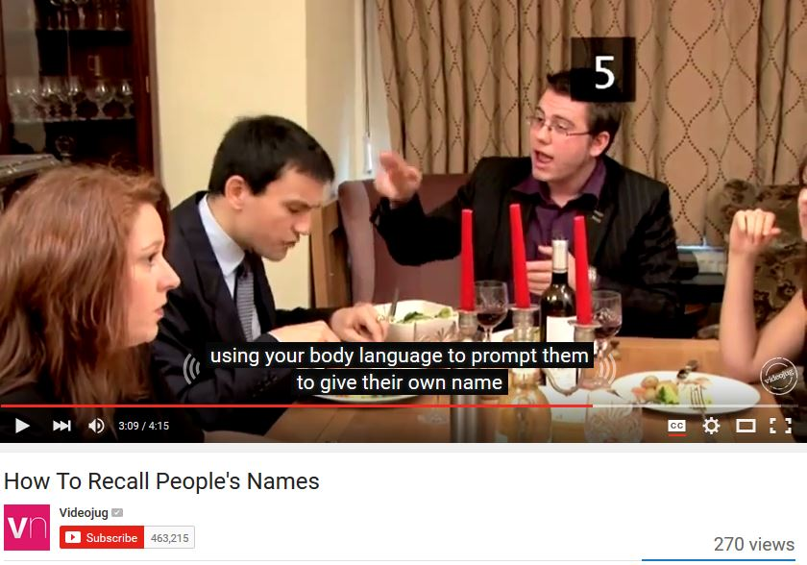
Student “Interactions” Question Sheet:
After note-taking on the video, students must create a question sheet to assist them in doing the Interaction and as a record of their work. Later, the teacher collects the question sheet and marks it. The question sheet should follow the format of this example.

Pre-Listening Questions:
Stone, C. (Director). (2007). How to remember people’s names [Online video clip]. Video Jug.com. 10 March 2016. Retrieved from <https://www.youtube.com/watch?v=7Q74cJtVpkA>.   | NAME _____________  NUMBER __________
- How do you remember people’s names?
- What do you do when you cannot remember the name of the person you meet?
- What methods do you use to remember names?

Key Vocabulary Words
- Repetition- the act of repeating
- Ludicrous- causing laughter because of absurdity; ridiculous.
- Distinguish- to mark off as different
- Discreet- show judgment in ones conduct or speech
- Cement it- memorizing it, glue on to your brain

Get Some Skills
Shock, ________, their names has completely disappeared from their memory. Repetition. Repetition. Repetition. The _________ is to do this without noticing. Association. During your first conversation, subtly study their ________ and __________, paying particular attention to any distinguishing features. Find a rhyme. Alternatively, try making a _________ rhyme out of their name. However, no-one is perfect, and if you find yourself unable to remember a name, don't fret. ___________ has the answers.
Post Listening Questions
- How effective is association for you?
- What did you think about using ludicrous rhymes?
- What do you do when all else fails and you can’t remember a name?

Interactions Leader’s Opinion – In a paragraph describe your opinion of the clip. Think of the following points: Why did you choose it? What do you think of the clip? How easy was it to understand?

Each student needs to show where the material comes from (using the APA Style), and to create pre-listening questions, key vocabulary words, the “get some skills” section, post-listening questions, and finally, a paragraph describing their opinion of the video clip.
To get students to properly cite their material, you need to show them the format in the question sheet. In addition, you should show them one of two online websites (easybib.com and son of citation).
These websites help you to create citations, even websites and media.
[This website, the more sophisticated of the two, allows you to add/delete URLs, date of publication, etc.] http://www.easybib.com/
http://www.citationmachine.net/apa/cite-a-film/manual
[The iPad version cuts out the ads] (iPad) http://tinyurl.com/cm-mla

Following your earlier demonstration of finding an online video, ask each student in class to find a video themselves and to create an APA reference for it using the Son of Citation website. DO THIS IN YOUR FIRST CLASS so that you can walk among the students and guide them through the activity. They can check one another’s work as well. Do not depend on the students IE Core or IE Writing teacher to do this. They will likely tell the students of the website, but these teachers do not have a CALL classroom where the teacher can demonstrate and supervise students using the website to create APA style references. We are counting on IE Listening teachers like you to show students how to do this.

The students just input the information and choose APA.
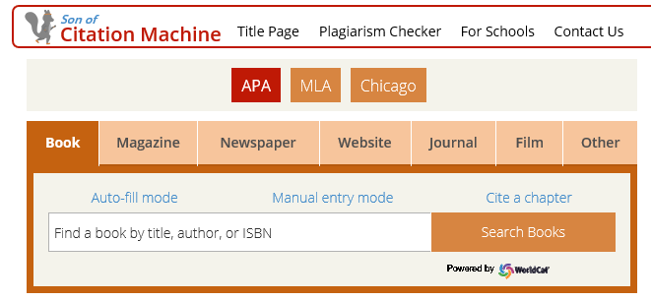
Now you choose the correct media. Enter the information as prompted. The following is the Diane Rehms show, “Friday news roundup” on National Public Radio.
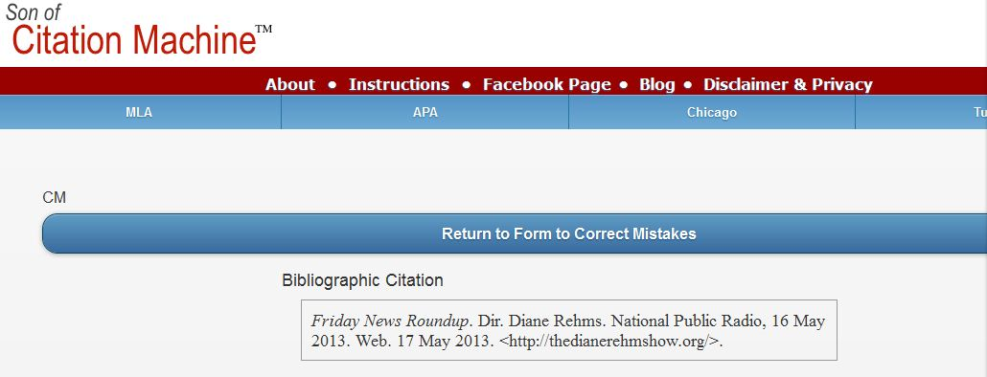

Remind the students to indent the second line of the entry:
Rehms, D. (2016). Friday news roundup. [audio clip]. National Public Radio.com, 16 May 2013. Retrieved from Web. 17 <http://thedianerehmshow.org/>.
Organizing “Interactions” in class (See Appendix)
- Form groups of 4 or 5 students; 6 or 7 in a class of 24; 10 groups of 4 or 5 students in a large class. All the students should log onto a computer.
- Ask one INTERACTION leader to go to each group. The leader logs into a computer. The leader tells the group members to go to the site. He or she asks some pre-listening questions/introduces the topic.
- The leader asks each group member to play the video on the site and to listen to it. The group also does some listening questions.
- Depending on how difficult the group finds the video, and the level of the listening class, the leader may re-play the video 2 or 3 times.
- After the group has listened to it, the leader asks some post-listening questions.
- The INTERACTION leader moves to another group and logs onto a pc.

Interactions: Oral and Written Checklists
INTERACTION oral checklist

Student | Date
Topic |  | Score
1. Used appropriate eye contact and gestures with the group

2. Avoided reading, and spoke clearly and enthusiastically

3. Kept the group using English for the whole INTERACTION

4. Asked good questions and used follow-up questions

5. Kept the group focused on their work on the INTERACTION

INTERACTION written work checklist

Student | Date
Topic |  | Score/10
1. Noted the url, date, etc. for video (APA style), pre-listening questions

2. Included at least 5 key words and definitions

3. Made a paragraph summary or summary with questions of the video clip

4. Created during-listening, and post-listening questions

5. Handed in a typed, well-presented written report

Teaching IE 3 Presentation Skills
- 1st class HW
- Introduce self --produce a transcript of
- Choose emcee the video
- Teacher provides list of Internet
sites on the Internet
- Select video

- 2nd class
- Choose graphics HW
- Devise survey questions --prepare note-cards at
and listening questions home
- Decide on the recommendations

- 3rd class HW
- Show the class the marking criteria -- students practice at
- Finish preparations home; time their work
- Groups all practice in pairs of students

- Presentation Day
- Remind them of the marking criteria
IE 3: A Simple Rating Scale for the Presentation
GROUP PRESENTATION (10 points)

Students: |  | Date | A | B | C | D | E
Topic:

Non-Verbal  /2 points | 1. Good posture, appropriate eye contact with  audience. Gestures such as pointing to the slides or  visuals.
Fluency  /2 points | 2. Spoke fluently, and confidently, referring to note  cards only occasionally. Used a clear and attractive  tone of voice with few pronunciation errors.
Materials  /2 points | 3. Chose pictures, slides, and other visual aids well.
Content  /2 points | 4. Details such as names, numbers, and other  description details were provided. Used several transitions, such as “first of all,” “another,” “next,” or “in comparison,” “for example,” etc.
Framework  /2 points | 5. Had a self-introduction providing the student’s  name, and topic, and the student’s partners. The  conclusion had a short summary and a closing  remark about the topic.
Comments: (Possible Group score) /10 |  |  | Final Scores  /10

IE 3: A Peer Review form for the Presentation
Peer Review for Presentation
Reviewers
Date
Group No.
Title
Good Points
Constructive advice
What have you learned?

IE 3: Peer Outlines and Rankings for the Presentation
Presentation Outlines (IE) Name _____________________________
During the presentation, take notes and make an outline. This will be collected.
name/ group | Outline and Note-taking

☆_______________ is the best because _______________________________________
Appendix 1: SAMPLE COURSE OUTLINE
IE Active Listening III --we will do 4 types of listening: (a) In-class, (b) student projects (interactions, and presentations), (c) teacher-monitored self-access, (d) self-directed listening. We cover the 4 themes of IE Writing, and IE Core.
 | Relationships/Psychology | Intercultural Communication | Media | Environment
(A) IN-CLASS | DVD | DVD | DVD | DVD
(B) STUDENT PROJECTS | INTERACTION: Describe a video from YouTube, ie. the “video jug channel,” on becoming more confident, prepare for a date, make friends, etc. | PRESENTATION: Introduce video on an aspect of inter-cultural communications | INTERACTION: Introduce your favorite English movie trailer and questions | PRESENTATION: Prepare an environmental brief “for action” on a problem
(C)TEACHER-MONITORED SELF ACCESS  Homework | Complete 25 units per class. These must be finished by the last class, not by the last date listed on the website. In order to keep up with the class, students will get a point for finishing 8 units by the fourth week of the course, 12 units by the 8th week, and 16 units by the 12th week. http://ac.reallyenglish.com/aoyama/reg/
(D) SELF-DIRECTED LISTENING  Homework | You should complete 5 reports or 3 reports and a movie listening log. You can view many movies and TV shows in the AV library, 1F, Building 8.
Breakdown of Grades:
(B) Student Projects - 2 INTERACTIONS | 20%
(B) Student Projects – 1 PRESENTATION | 10%
(C) Teacher-Monitored Self Access (30 units) | 25%
(D) Self-Directed Listening | 20%
IE Listening Final Test: July 19th | 20%
Participation (completing reallyenglish units on schedule, vocabulary quizzes) | 5%
Attendance Policy
Absences | Maximum Grade
1 | * No effect on grade
2 | Final grade cannot exceed 89
3 | Final grade cannot exceed 79
4 | Final grade cannot exceed 69
5 or more | Fail
3 lates = 1 absence
2013 COURSE CALENDAR
April 12 | Course overview, students log on to reallyenglish, take the assessment test, try at least one unit, Interaction topics assigned for homework
19
26
May 10 | Interaction 1A# *8 units reallyenglish due
17 | Interaction 1B#
24 | --2 listening reports due
31 | *16 units reallyenglish due
June 7 | Interaction 2B#
14 | Interaction 2A#
21
28
July 5 | Presentations *25 units reallyenglish due
12 | Presentations –last 2 Listening Reports due
19 | TEST—course evaluations
Appendix 2: SAMPLE STUDENT INTERACTION: IE III
Nolan, C. (Director). Batman begins. (2005). Online video clip, Imdb.com. 10 March 2016.
Retrieved from <http://matttrailer.com/batman_begins_2005.>
- Pre-Listening Questions
- What do you know about the super-hero “Batman”?
- One of the characters in the movie talks about developing “the powers of the mind.” What type of powers do you believe could be developed?
- Why do people become criminals?

- Five Vocabulary Words or phrases.
- criminal – a thief, or bad person
- will – the determination to do something
- “journey inwards” – the journey of the mind
- “no turning back” – no chance to change or stop the process
- “more than a man” – Batman will become a super hero

- Order the following sentences correctly as they are heard on the movie trailer.

- Criminal: Where are you?

- Henri: Your parents' was not your fault.
- Henri: The is nothing! But will is everything!
- Batman: Here.
- Henri: If you make yourself more than just a man. If you yourself to an . You become something else entirely. Are you ready to ?
- Henri: You have traveled the world. Now you must journey inwards - what you really is inside you. There is no back.
- Fill in the missing words in the sentences above.

- Post-Listening Questions
- Who is your favourite super-hero and why?
- If you could have a super power which one would you choose and why?
- On the humorous side, what would be some problems with being the boyfriend or girlfriend of a superhero?

- Describe your opinion of the video clip in a paragraph. (What you liked about it? What you were curious about? Whether or not it made you want to see the movie?)
Appendix 3 WEBSITES FOR LISTENING REPORTS
Sites for Student Listening Reports
For this assignment, you need to access one of the following sites. and write two paragraphs (about 10 sentences each) about your experience using it, and list 5 vocabulary words; their definitions and a sentence example for each:
- Report which part of the site you used, including the name of the piece you listened to. Give as many specific details about the listening as you can.

- Report on whether or not you liked the site, would recommend it to other students, and would visit it again. Give as many specific details as you can.
1) ESL Bits
http://esl-bits.net/
- Listen and read –a –long scripts, (b) read and fill in the missing closed word of one part of one classic film script

2) Japan Student Times
http://www.japantimes.co.jp/shukan-st/stories/stories.htm

3) Randall’s Cyber Listening Lab:
http://www.esl-lab.com/
- conversation, (b)general or basic listening quizzes, (c)language learning

4) Arlyn Freed’s ESL/EFL Listening:
http://www.eslhome.com/esl/listen/#nonauthentic

A B C D F Name: _________________

Online Listening Report
1. APA Reference – Online sources are difficult, but try to include as much of the following information as you can - Author, title, publisher, date published, date viewed, URL
2. Summary - Write a short summary of the program.
_____________________________________________________________________________________________________________________________________________________________________________________________________________________________________________________________________________________________________________________________________________________________________________________________________________________________________________________________________________________________________________________________________________________________________________________________________________________________________________________________________________________________________________________________________________________________________________________________________________________________________________________________________________________________________________________________________________________________________________________________________
2. Opinion - Give your opinion of the program. Think of the following points: What do you think of the program and website? How easy was it to understand? Was the program useful for improving your English? Was the topic interesting? Etc.
__________________________________________________________________________________________________________________________________________________________________________________________________________________________________________________________________________________________________________________________________________________________________________________________________________________________________________________________________________________________________________________________________________________________________________________________________________________________________________________________________________________________________________________________________________________________________________________________________________________________________________________________________________________
4. Vocabulary – Write 8 new or key words from the listening. Write the word, the meaning and an example sentence

SAMPLE LISTENING REPORTS
IE Listening Report #2:
“Secondhand Smoke.” (2003). Audio clip. National Public Radio. 24 March 2016. Retrieved from
<http://esl-bits.net/secondhandsmoke.>
I listened to a conversation from esl-bit.net for my report. Here, a woman named Debra is the interviewer, and talks to Dr. Fiore from University of Wisconsin about secondhand smoke. Before the phone connects to Dr. Fiore, there is a pre-talk about how secondhand smoke can damage your health. They say that non-smokers increase the chance of getting lung cancer by 20-30% if they stay around smokers for a long period of time. Dr. Fiore first starts off by talking about smoking and what tobaccos are. He says that smoke contains more than 4,000 chemicals and research proves that secondhand smoke is more harmful then smoking directly. Co-workers and families of smokers can get involved in this and increase the percentage of getting a heart attack if they stay around too long. He mentions that children are more likely to get their health damage easier than adults because they have sensitive lungs. Children could also get asthma, ear infections, and other diseases as well. To avoid breathing the smoke, you could open windows, use fans to blow; however, being smoke free is the best way to protect child. He says that today, many cities have taken away smoking areas in public spaces and outside the road to avoid second-hand smoke. Anyways, at last, the smokers must make the decisions by themselves to quit and the only thing non-smokers could do is to help them through support. There are therapies and medicine to make them quit as well. Lastly as a conclusion, he mentions that quit smoking can protect everyone in our environment.
I had the chance to listen to few of the conversations, and all of them were very interesting and easy to understand. However, it was hard to go through the site and find the links to listen to the topic. Once you get to the page, it was very easy to follow through because some pages provided the text version of the audio. You can also choose the listen speed so if you think the speakers are talking too fast, you can change the speed level as well. This piece made me think about second-hand smoke a lot because I breathe smoke everyday because there are many smokers around me. I recommend this site to people who are at an intermediate level of English because at the beginning it is a little bit hard to follow the links. Also the topics are mostly about world issues and global news, so sometimes hard vocabulary comes out. You can learn new things from this site so if you have the chance, you should try and access it once!

Appendix 4 SAMPLE MOVIE REPORT
IE Listening 3: Movie Listening Log

Movie Title and APA reference:
Verbinski, G. (Director). Pirates of the Caribbean - At World’s End. (2007). (DVD). Walt Disney.
Name:
Student Number:
Date:

Part 1. Paragraphs.
I rate this film as 4# because the first and second films of the Pirates of the Caribbean series are slightly better than this one. In terms of the computer graphic effect, this third film is the most successful. On the other hand, the story of the third one was much more complicated than the others and some parts of it was not really understandable. To me, what counts the most when watching movies is simplicity and expectation. I always look for something in movies that is beyond my expectation. If a story of a movie went just like I had expected, that’s the worst thing that could happen.

Part 2. Choose two questions to answer.
- Which two characters did you like best in the film? Why?
- Were you surprised at the climax of the film?
- What is the theme of the film? How do some of the incidents in the film support the development of that theme?
- Which character did you like best? How is he or she like you?
- What is the setting of the film? What place that you have visited does the setting remind you of?
e) The setting of the film is the Caribbean sea in 17th century. All the beaches in the film always reminds me of Australia. The Australian beach that I went for the first time looked just like the beaches in the film. Its clear water, white sand and trees are something that you can rarely see in Japan. During my exchange experience in Australia, I often went to beaches with my friends and the views of the sunrise or the sunset from those beaches also looked exactly the same as the scenes in the fim. In this film, sunset and sunrise are really important keys to the climax. Even in Japan, I can’t help but look for a ship on the horizon at sunset and sunrise.
I was really surprised by the climax of the film, because Will Turner who hated pirates the most became the captain of the Flying Dutchman.
I tried to come up with some ideas of how the film ends while I watched it, but that was totally unexpected ending. That Jack Sparrow lost his ship “the black pearl” again in the end was also unexpected and it really pleased me because it simply meant that the film still continues. As everyone knows, Pirates of the caribbean 4 came out recently. I did a little bit of research on it and I heard some rumors that The Pirates of the Caribbean series will continue until a 6th episode just like Star Wars did. I really hope so.

Part 3. New Vocabulary and Expressions
Oi! | a British and Australian working class slang interjection used to get someone's attention, or to express surprise or disapproval. “Oi, mate,” he said. “We’ve got to get out of here!”
savvy | to understand, esp. shrewdly. I am savvy about travel.
leviathan | a sea monster. The whale is a leviathan.
Flying Dutchman | The legend of the Flying Dutchman concerns a ghost ship that can never make port, doomed to sail the oceans forever.
Parley | a discussion or conference, especially one between enemies over terms of a truce or other matters. The pirates parleyed with the navy.
fetch | to go to where somebody/something is and bring them/it back  He had to fetch a pail of water.
mad | having a mind that does not work normally; mentally ill, or a joke. The hospital was full of mad men.
pillage | to steal things from a place or region, especially in a war, using violence. Today, ISIS has plundered archeological ruins in Syria.
plunder | to steal things from a place, especially using force during a time of war. The German Army plundered Russia in 1941.
shilling | a British coin in use until 1971, worth 12 old pence. There were 20 shillings in one pound.
superfluous | more than you need or want
immortal | that lives or lasts for ever
impersonate | to pretend to be somebody in order to trick people or to entertain them
noose | a circle that is tied in one end of a rope with a knot that allows the circle to get smaller as the other end of the rope is pulled

Appendix 5(a): reallyenglish Registration Keys REALLYENGLISH KEYS
- Issuing Registration Keys
Please follow the instructions to issue registration keys. Go to http://ac.reallyenglish.com/aoyama/
1 【Mypage Login】
Access your mypage URL, login with your administrator password and ID. Once you have reached mypage, simply click the [keys] link at the top left.
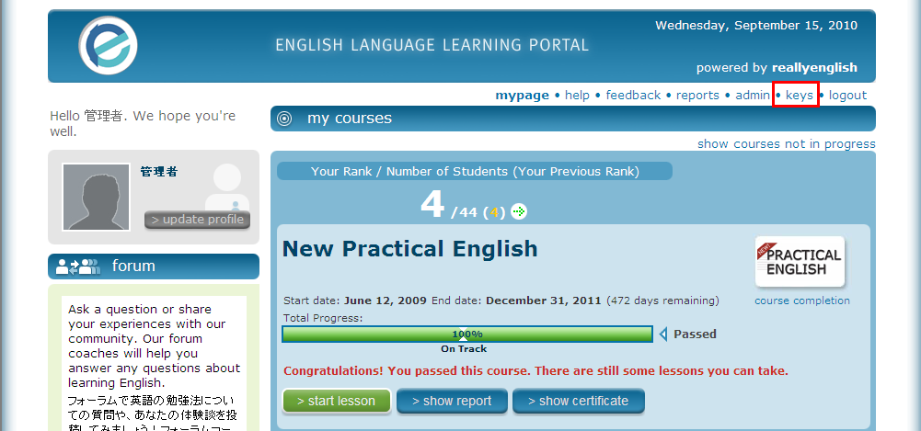
2【Issuing Keys】
Click the [Issue Keys] link.
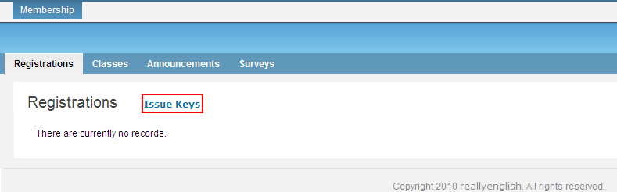
3【Key Issue Step 1 – Users】
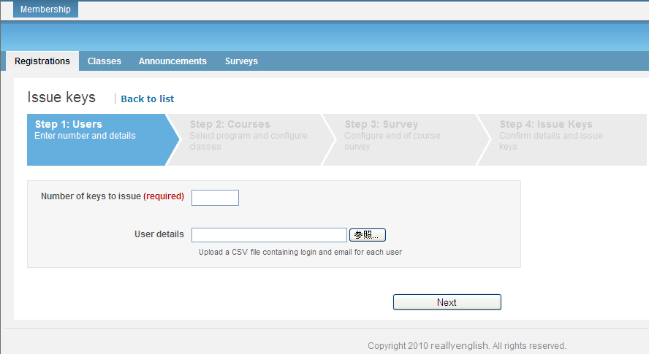
[1]

[2]

[1] Enter the number of keys you would like to issue. If you want to specify the login or email address for keys, please upload your csv data. If you specify the mail address for keys, our system can automatically send a registration notice to the user.
[2] Click here to upload your CSV and click [Next]. The number of users in you csv data must match the number you typed in ① above.
CSV Format
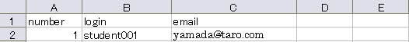
Note: The first row of your CSV data must be「number, login, email」as shown in the table above.
number: please enter sequential numbers starting from 1 for each row of data.
login: please enter the ‘user id’ for each student; email: please enter the email address for each student
4 (a-1) 【Key Issue Step 1. Course Information】（When making new classes）
Please select the program you will use, and click ‘Add New Class’.
※Your program name may be different from the one shown below.
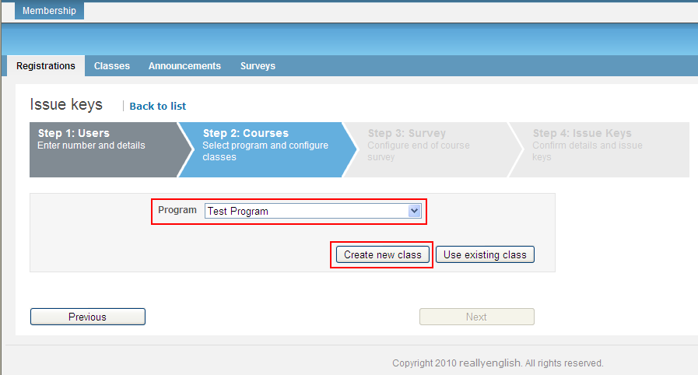
4 (a-2) 【Key Issue Step 2 – Course Information】（When making new classes）
Please select the course you want to assign, and enter a name for your class.
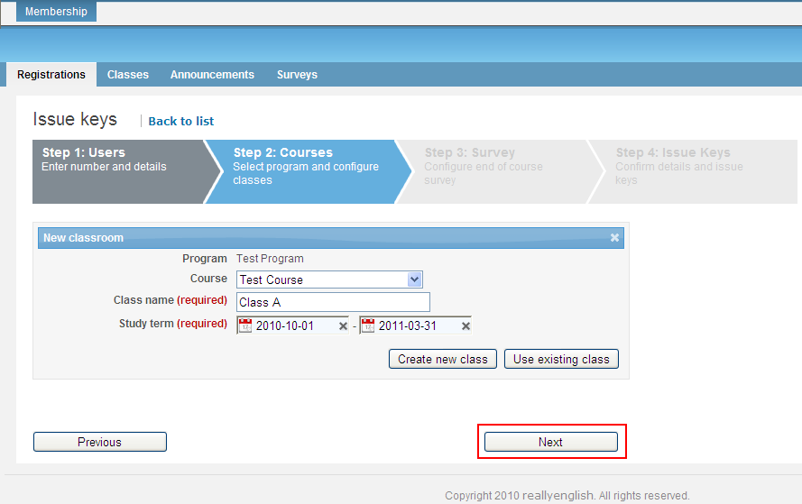
4 (b-1) 【Key Issue Step 2 – Course Information】（When adding users to an existing class）
To add students to an existing class, simply select the program you wish to use and click ‘Add to Existing Class’.
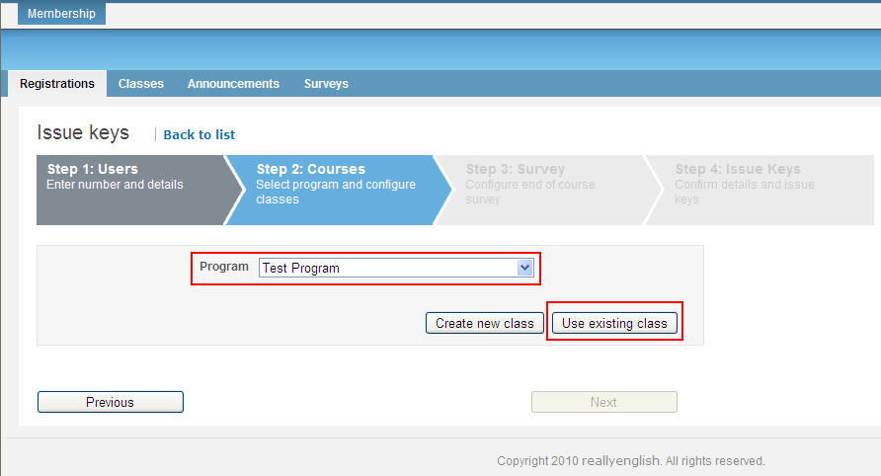
4 (b-2) 【Key Issue Step 2 – Course Information】（When adding users to an existing class.）
Select the class you want to add these students to. The dates for your class will automatically show up on the screen. When you are done, please click ‘Next’.
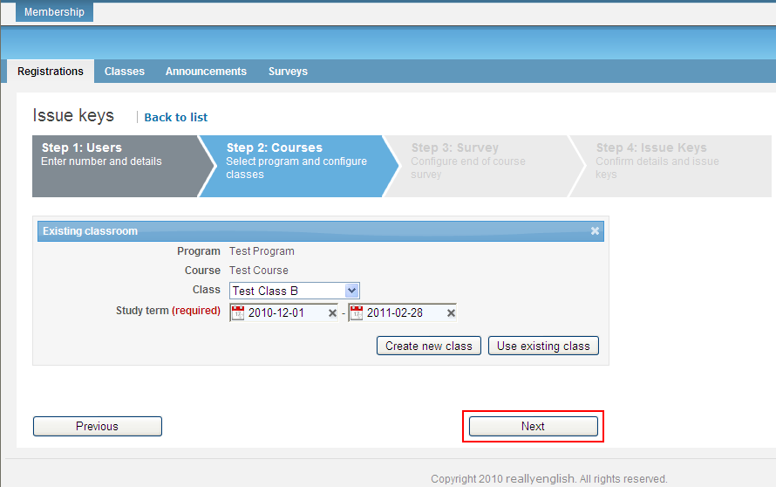
5.1【Key Issue Step 3 - Survey】

REALLYENGLISH KEYS
Our survey is used to evaluate the student’s opinions about the courses they have taken with reallyenglish. Based on your setting, the survey will appear for your students on mypage. Please check the ‘Use Survey’ checkbox. If you do not wish the survey, click ‘Next’ and go to page 7 of this guide.
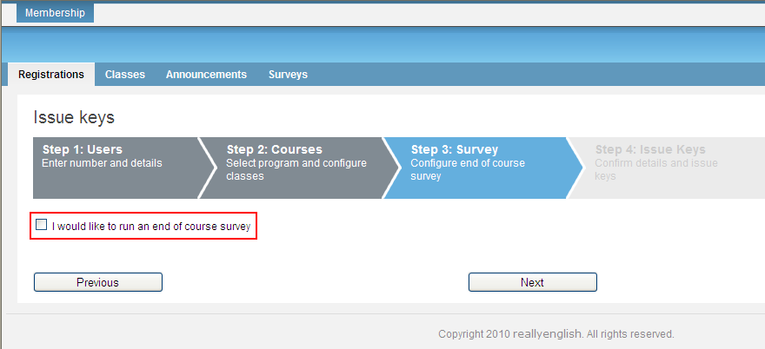
5.2【Key Issue Step 4 - Confirmation】
This step allows you to confirm the number of students, the courses, any survey and also schedule email delivery for your keys. If everything is correct, please click ‘Issue Keys.’ You should issue some extra registration keys. Cut the paper into individual strips of keys, one per student. Bring them all to class. Invariably, students will forget their passwords and need a new key. Also, some students changing levels, may be assigned to your class. They cannot take a record of their work in their previous class. They will have to register again, for your class and start doing reallyenglish again. Usually, as students change levels in the first two weeks, they won’t have done many units of reallyenglish.
6.1 【Key Issue Step 5 - Complete】
After completing the above process, you will be able to see a list of the keys you have created. Additionally, you can download a PDF of the keys that includes the key, and the URL required to register the key. Each key will look like the following.
6.2【Students Inputting Their Registration Keys】
Now students enter their key on a specific URL, http://ac.reallyenglish.com/aoyama/mypage/reg/
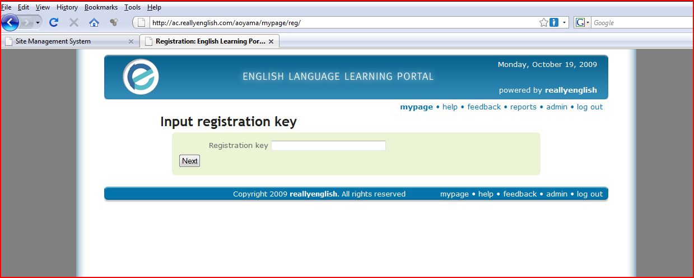

Appendix 5(b): reallyenglish REALLYENGLISH OVERVIEW
1.1【Students working on units in reallyenglish】
After students have taken the diagnostic test, a learning path will be generated for them. Afterward, show them how to find the tabs that differentiate the three types of lessons: Reading, Grammar, and Listening. Although the students may choose units focusing on Reading, Grammar, or Listening, 80% of the required lessons they complete must be in "Listening," ie. 20 out of 25 lessons should be "Listening" ones. In order to get credit for a lesson, students must get score at least, 80% on it.
1.2【Program Updates】
Reallyenglish now operates on cellphones. This should be demonstrated to students in the first class. An "Orientation" in the system explains what they need to do to get started. Please show students this feature in class. Here are the program updates from last year:
- 330 lessons (targeting around the TOEIC 280 level). Please tell students that these are supposed to be in a TOEIC style as well to give them practice in taking tests.
- The learning path has changed from 10 lessons at a time to 5 lessons. This allows the system to adapt the learning path more frequently to the learner's progress.
- reallyenglish has changed the overall look and feel of the course top page.
- reallyenglish has modified the lesson design by moving the next and back buttons, adding a black background, and small design touches.
- Users can change the user language from Japanese to English using the menu page (top right hand corner).
- Every lesson includes a lesson summary (pdf), while Listening lessons also include a podcast (MP3 file). They had these previously, but they can now be downloaded by clicking on icons next to each lesson title on the menu page.
- reallyenglish has improved the sort functions on the menu page--it's very easy to find the lesson by title, topic, etc. now.
The "Trainings" page, which allows teachers to view the progress of their students, also has some improvements. You can access a pie chart by clicking each star rating on the "Trainings" page. The "Training" page shows the progress of each class and is accessible from the "TRAININGS" tab on TMS. Moreover, you can download the progress data, along with the pie chart in excel format from "Create report" on the TOOLS tab. If you have questions about this, you can refer to the help page on TMS.
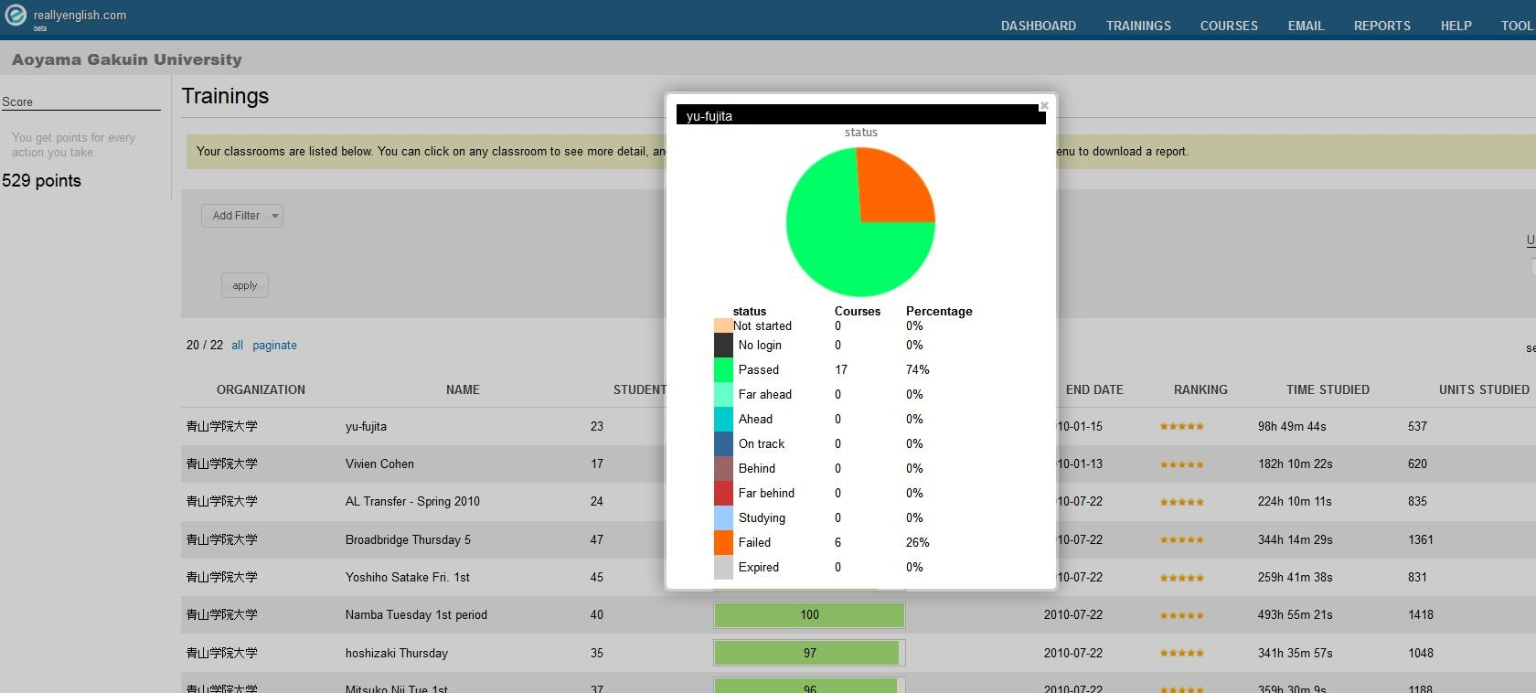
1.3【Pacing your students】
As with many term-length assignments, many students will procrastinate. Even if a student was able to complete all 25 units in the last week of classes, the student would not get much benefit from them. They need to regularly work on these listening units over the term instead of cramming. Show the students printouts (screenshots of the reports once you access your class on the reallyenglish website) of their relative standing in the class at four weeks, eight weeks, twelve weeks, and fifteen.
We have found that students who work on the reallyenglish lessons regularly and sincerely benefit a great deal, particularly students who start at lower levels. One teacher so motivated her students that all of them did much more than the minimum 25 units and one student did more than 200 lessons in a single semester! There is no limit to the number of modules that the students can do. If they feel that their reading or grammar is weak and can be improved by the Practical English program, they may do extra units in those areas.
It is up to the teachers to provide students with incentives to do as many modules as they can. You will be able to see in the course management tools how many units, beyond the minimum, that the students have completed. Most teachers monitor students by giving them three or four deadlines during the term one at the end of each month. Students who don’t complete on time, lose a mark for the self-directed portion of their grades.
As part of your course requirements (Participation), you also can have students create their own vocabulary flashcards using apps and a free Web site: http://www.quizlet.com.

1.4 Logging on
Time and again, we’ve had students who experienced difficulty in logging onto the site. Usually, these students have not been logging on regularly. Panicked as they end of term approaches, then they just google the general website for reallyenglish. Students have a tendency to just google it. Unfortunately, the general site will not allow them to get into. They need to use the following URL. Have students mark your e-mail, post it. Etc.

https://ac.reallyenglish.com/aoyama/account

