30 July 2026

English Department Teachers Handbook
In this handbook, we have tried to articulate the administrative policies of the English Department and Aoyama Gakuin University. We would like to thank Richard Evanoff, SIPEC Dept, for our use of content from the guide and updates that he prepared for his department in 2013 and 2015.

Contents
Page  2  3  4  6  8  8  9  12  16  16 | Campus Map and Key Information Assessment of students  Website addresses, Telephone numbers  (teacher absences, late arrivals)  Part I: Program  Curriculum Telephone numbers,  Overview of the curriculum  General description of the curriculum  Streaming  Changing IE levels  Course descriptions  Semester system  Class periods  Repeater and elective courses  Courses  Overall objectives  Types of courses  General course descriptions  Teaching materials and textbooks  Teacher guidebooks  Student booklets  IE website, IE Texts, IE Group e-mail  Textbook policy  Choosing materials  Ordering textbooks  Teacher Resource Center  Audio-visual and Internet materials  Part II: Policies  Academic standards  Teaching objectives  Course outlines  Teaching methods  English in the classroom  Student expectations  Feedback from students  Feedback from the administration  Feedback from teachers  Classroom dynamics  Seating, student names  Policies for students  Freshman orientation  Grading policy  Attendance policy  Written assignment format  IE writing and Academic Writing database  Plagiarism  Discipline  Teachers’ responsibilities | Page  16  18  19  20  21  22  24  27  40 | Heading  Annual teachers’ orientation  Attendance  Class rosters  Assessment of students  Reporting grades  Conduct toward students  Practices to be avoided  Employment policies  Salaries and transportation costs  Updating information  Annual contracts  Terminating employment  Dealing with teacher stress  Part III: Facilties  General information  Information packet  Getting to the Shibuya campus  Contacting the Shibuya campus  Identity card  Important places on campus  Kyomuka  Faculty lounges  Photocopy facilities  Computer facilities  Cafeteria, bookstore, clinic, library  Audio-visual equipment  Foreign Language Laboratory  AV Library  Placing materials on reserve  Dubbing materials  CALL classrooms  Policies for using other materials  Equipment in other classrooms  Getting assistance  Accessing Internet materials  AFP World Academic Archive  Before you start  Accessing the AFPWAA  Registering with the AFPWAA  Logging in to the AFPWAA  The Aoyama Portal  Using the Aoyama Portal  Before you start  Accessing the Aoyama Portal  Uploading and downloading  Class rosters  Entering grades  Using the writing database
Campus Reference Map and timetable

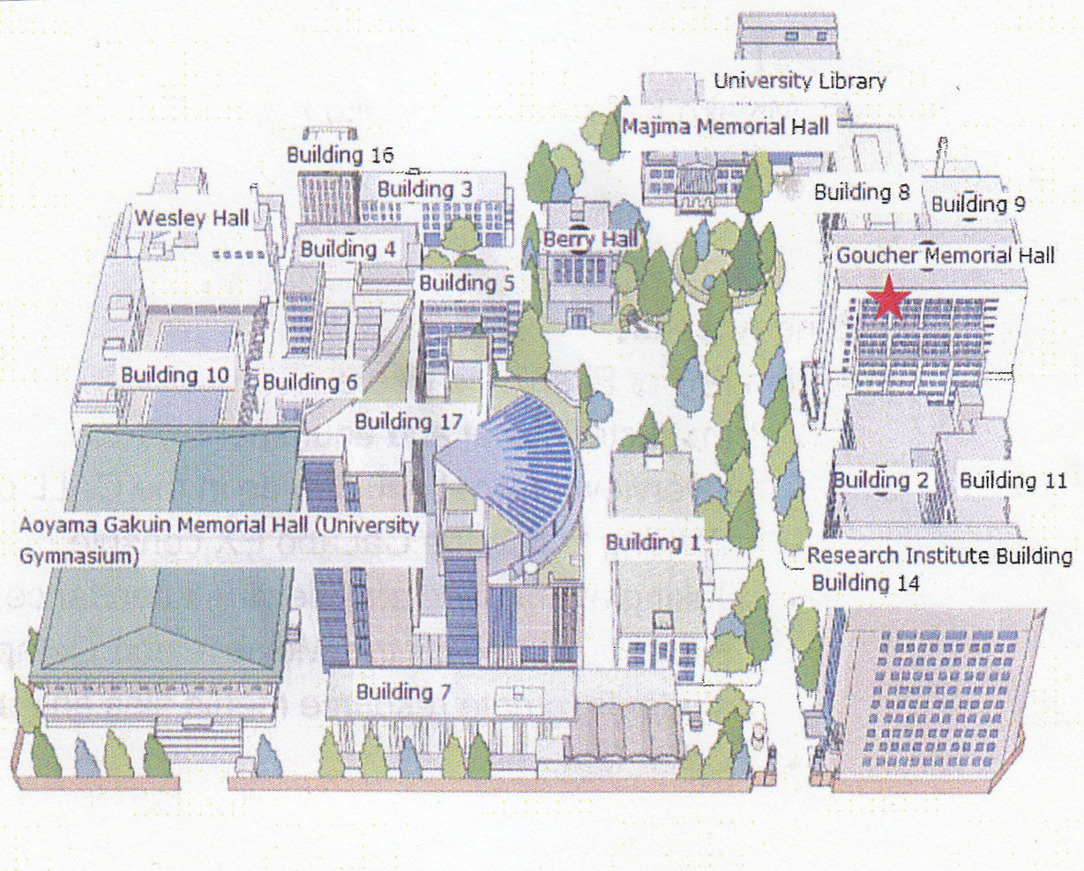  Shibuya Campus: 03-3409-7830 (Ext. 12132)  (call in the event of absences or late arrival).  Kyomuka (administration – 03-3409-9527) Building 17, 2F. Kobaikai (bookstore) Building 1, 1F (03-3409-4401).  Foreign Language Laboratory (FLL), Building 15 (Goucher), 6F (03-3409-7938; on campus 12557). English Department, Building 15 (Goucher), 9F (03-3409-8111). Teacher Resource Center is in the small room beside the English Department office. Hoken kanri center (student clinic) (03-3409-7896), Building 7, 1F. Gakusei Soudan Center, Building 7, 1F (03-3409-8653). | 2016 Timetable:  1st period 9:00 - 10:30  Chapel Break 10:30 – 11  2nd period 11:00 – 12:30  LUNCH  3rd period 13:20 – 14:50  4th period 15:05 – 16:35  5th period 16:50 – 18:20  6th period 18:30 – 20:00  7th period 20:10 – 21:40  Koushi hikaeshitsu (Teachers’ lounges) are in Buildings 1 and 8, 1F, and in Building 17, 2F.  The AV Library with DVD, VHS tapes, and CD roms is in Building 9, 1F. The CALL rooms are coordinated by the FLL on the 6F of Building 15, Goucher (03-3409-7938). The Computer Lab is in Building 2, 1F (03-3409-7850). AGU Library (03-3409-7858)
In the event of a typhoon, please call this emergency telephone number for similar cases. You'll get a message in English and Japanese about a school closure: テレドーム 0180-993171.

IEP Website: http://www.aogaku-daku.org/

IEP texts and instructions available for download: http://www.cl.aoyama.ac.jp/~dias/ListeningDownload.html

IEP Coordinators: Joseph Dias (jodias@cl.aoyama.ac.jp) and Gregory Strong (gregstrongtokyo@gmail.com)

Introduction

Welcome to the English Department of Aoyama Gakuin University. This handbook is intended to provide teachers with an overview of (1) the Integrated English Program (IEP); (2) the English Department and university policies; (3) the facilities of our university. A Scope and Sequence has been prepared for each of the following courses: IE Core, IE Writing, IE Active Listening, Academic Writing, and Oral English. These teacher guides contain explanations of instructional tasks, sample student materials, reading references, and examples of the APA Style guide. In addition, there is a student booklet for the IE Core and IE Writing courses, for Academic Writing, and a student booklet available as a PDF for Academic Skills.
All of these materials may be downloaded from an IE texts’ webpage at http://www.cl.aoyama.ac.jp/~dias/ListeningDownload.html
In addition, you can keep track of news about the IE Program, upcoming guest lecturers, and other news at the IEP Website: http://www.aogaku-daku.org/
You will find your mailbox, copies of the teacher guides, student booklets, course textbooks, supplementary materials, and professional resources in the Teacher Resource Centre beside the English Department office, Building 15 (Goucher), 9F.

Part I: Program

Curriculum

Overview of the IEP. The IEP is a two-year English language learning program for freshmen and sophomore students of the English Department. It is organized into 4 semester-length integrated English courses: IE levels I, II, III; each level had a course in combined skills (IE Core), listening (IE Active Listening), and Writing (IE Writing). Each course meets weekly over a 15-week semester. The final semester of the IEP consists of a student-selected seminar (IE Seminar) on a specialized area of content. Oral English I and II are not classes offered by the English Department, but ones that we coordinate.
The IE Core course integrates the four skills or speaking, listening, reading, and writing. Also, all three courses, IE Core, IE Writing, and IE Active Listening, share themes and attendant vocabulary. There are currently 320 freshmen and an almost equal number of sophomores in the program. The IE courses are taught by approximately 3 full-time faculty, 38 adjunct or part-time native speakers, and 10 adjunct Japanese teachers. At the end of each semester, students evaluate the teachers.

Streaming. Students are “streamed” into classes based on their English ability. They are tested by the ITP, or Institutional Testing Program, a simplified version of the TOEFL test available through the Educational Testing Service. Accordingly, students are placed in levels I, II, and III of the program.

Changing IE levels. In the Spring semester, a few students in your class may feel that they have been placed in a level too hard or to easy for them, so we ask you to contact the IEP coordinators within the first two weeks and we will move them. You will also be given a transfer form to record the students’ information. Students who wish to transfer will need to submit the form to the Kyomuka within the first two weeks.

Course descriptions. Annually, the courses in the IEP are reviewed and revised and updates are posted online and in most cases, published in print form. With the exception of the IE seminars, the IEP coordinators are responsible for book orders and for uploading the course descriptions on the Aoyama Portal (see note later).

IE Core (180 min)

IE Writing (90 min)

IE Active Listening (90 min)

IE I  * Memories and  Childhood  * Urban Life  * Food  * Travel | IE II  * Changing Times  * The Workplace  * Geography  * Autobiography | IE III  * Psychology  * Intercultural  Values  * Environment  * The Media |  | IE Seminar  * Communications  * Linguistics  * Literature

Figure1: The IE Courses and themes at each level.

Each IE course builds on the work done at the previous level. Therefore, a teacher at each level of the program has certain expectations of the students who enter his or her class. This is particularly important for the tasks and objectives in IE Writing. But the same is true for IE Core and IE Active Listening classes. The following figure outlines the central tasks in IE Core classes in the program and this emphasis should be incorporated into your curriculum and your assessments of the students in your class.

Newspaper discussion (25%) | 2 Book reports, oral and written forms (25%) | Maintain a journal or blog (20%) | IE II Poster presentation
Newspaper discussion (25%) | 2 Book reports, oral and written forms (25%) | Maintain a journal or blog (20%) | IE III Presentation, Interview, PSA or Commercial
IE I & II: Interchange 2 grammar, skills (5%) |  | IE I-II-III Interactions 2 reading skills (10%)

Figure 2: Central Tasks for IE I-II-III Core Class

Teachers can supplement these tasks with additional graded assignments, particularly with tasks related to learning vocabulary. However, they should not forget the primary emphasis on these tasks in IE Core.
There are two other IEP courses, Academic Skills, and Academic Writing which students take in their sophomore year. Academic Skills develops students’ listening and note-taking skills through having them listen to several lectures by professors in the English Department.
IE Writing I, II, III cover writing English paragraphs and writing essays with quotations and a short bibliography. Academic Writing teaches students how to conduct original research and to write a long paper. Please review the teacher guides and student booklets for more information about Academic Skills and Academic Writing.

IE Writing I | IE Writing II | IE Writing III | Academic Writing
Writing 3 paragraphs of 150 words:  1. Classification  2. Comparison-  Contrast  3. Persuasive | Introduction to the  Essay: 2 essays of 350 words:  1. Comparison-  Contrast  2. Analysis | Review the Essay:  APA Style for quotes  and references in 2 essays of 350 words:  1. Classification  2. Persuasive | The Research Essay of 1,500 words:  1. Creating a  bibliography  2. Citing references  in the APA style

Figure 3: IE Writing and the Academic Writing course

Course Goals. One goal of the IEP is raise students’ English ability so that they can successfully undertake academic courses taught in English during their junior and senior years. While the emphasis of the program is on the acquisition of language and communication skills, another goal is that students develop their leadership ability and their imaginative and critical thinking abilities. In addition, we hope to expand their awareness of different cultures, and global issues. Finally, the program aims to help students acquire the appropriate communicative and intercultural skills that will enable them to participate effectively in intercultural situations.

Grading. IE Core is taught in a weekly 180-minute class. On another day, there is the 90-minute IE Active Listening course and on a third day, a 90-minute IE Writing course. The grade for each student at the end of the term is based on the following formula: 40% for IE Core; 30% for IE Listening, and 30% for IE Writing. The grades for each student must be very precise, calculated numerically, rather by assigning a letter grade as in other courses. As a result, we strongly recommend that every teacher in the program use grading software to enable the teacher to quickly and accurately calculate grades and to weight different assignments appropriately. Many teachers are using the free online grading site, engrade.com. Others use a very effective classroom management system which is available as an app for iPads and android devices, please see: http://www.idoceo.net/index.php/en/
These grades must be submitted earlier than for other grades at the university because the scores must be combined.
They are to be entered through the Aoyama Portal. Unfortunately, because of the combined score, a student who fails one IE class (ie. by a score of less than 50%) will have to repeat all three classes the following semester. It is particularly important to warn freshmen students of this rule several times and to show them a few examples of it. Repeat the warning in the Fall term.

Plagiarism policy. In 2015, the IEP began to implement new policies and materials to eliminate student plagiarism of sources in essays and of copying other students’ work. Plagiarism of any assignment in any IE course – including Academic Writing and Academic Skills – will lead to failure on that assignment, without the option to rewrite. If a student plagiarizes on a second assignment, s/he will fail the entire course.
A copy of this policy is on the second page of each student guide book. Please refer to the page and go over the policy with students at the start of each year. In addition, we require teachers to have their students submit a hard copy of each of their drafts rather than submitting electronic versions. Finally, we require all IE Writing teachers and all Academic Writing teachers to have their students submit the final draft of their paragraph assignments or essay assignments to the English Department database (a process described in a later section of this handbook). On completion, this searchable database, a multi-year project, will eventually enable teachers to determine if their students have plagiarized another student’s work or writing from the Internet.

Other courses. Adjunct faculty also teach other courses in the English Department. The courses are divided into four general strands: English Literature, American Literature, Linguistics, Communications, and Education and these include numerous elective courses such as Business English, Advanced Academic Writing, Creative Writing, Global Literature, Journalistic Writing, and Media Studies. A description in English of the department and a complete list of the many courses that are offered may be found here:
http://www.aoyama.ac.jp/en/undergraduate/literature/english.html

Teaching Materials and Textbooks

Teacher guidebooks. Over the 22 years that the IEP has been operating, we have gradually developed a series of course syllabi which we review and revise annually in the light of teacher and student comments and contributions, requests from the English Department, and input from the IE Committee. To ensure continuity when new teachers join the program, or when there are changes to courses, we issue a series of Scope and Sequence documents for IE Core and IE Writing, Active Listening, and Academic Writing. These provide teachers with course goals and objectives, grading criteria, suggestions for lessons, and resources. We expect teachers to follow the Scope and Sequence documents as closely as possible so that we can all work effectively together. For example, teachers in an IE level II Writing course, need to know that students coming to the classes have been taught the basics of paragraph structure, principles of organization and certain grammatical structures outlined in IE Writing I. We require teachers to follow the Scope and Sequence documents as closely as possible.

Student course books. Over time, and with many contributions from teachers in the IEP, we have developed a series of student workbooks.
These contain lessons and other resources for teaching IE courses. Among these resources are samples of student writing assignments which provide an excellent resource for teaching writing. The samples provide students with examples appropriate to their abilities and interests. The Scope and Sequence for IE Core classes describes how to teach two key tasks in the IE Core classes, the small group discussion based on newspaper summaries and the book review and use of literary terms in analysis of books.
The IE Core and Writing booklet which retails for only ¥420 at the Kobaikai is designed to be used for students in IE Core and Writing classes at all three levels, so it is very economical. It is meant as a classroom resource, so that teachers do not have to make so many photocopies. It is serves as a means of drawing different teachers and classes together through providing a base of materials. Also, by requiring students to bring their booklets to class, teachers have a ready resource to explain tasks to students, to assign homework, and to effectively use class time. There are many short activities that can be used in class.

IEP Website, IEP Texts, IE Group e-mail. The English Department provides a special English website for program announcements, upcoming educational conferences, and links to different resources. Teachers are strongly encouraged to regularly visit it and to contribute appropriate announcements. We also encourage teachers to use it to provide information about their classes, particularly their seminars. Teachers can post photos and PDFs of assignments, of student work, and links to resources. Most recently, instructions have been posted on how to make PDFs for students to read on their cell phones. The website can be found at http://www.aogaku-daku.org/
Among the unique resources for the IEP, is a page maintained by one of the coordinators, Joseph Dias. From this page, all current versions of teacher guidebooks and student booklets can be downloaded: http://www.cl.aoyama.ac.jp/~dias/ListeningDownload.html
Finally, in order to facilitate communication from the IEP coordinators, we ask teachers to sign up for a gmail group, IE-teachers. From time to time, Joseph Dias or Gregory Strong will circulate an e-mail about a change to the curriculum, a reminder about a procedure or test date, or an upcoming guest lecture. Job vacancies in the program or at other universities are also posted as are opportunities for professional development through attending workshops and conferences or writing content for TESOL publications. We welcome submissions from you of appropriate material.

Textbook policy. With the exception of IE Seminars, there are assigned textbooks for the IE Core classes, IE Active Listening, and IE Writing classes in the IEP. These are Interchange 2, (4th ed.) (2012), Richards, J., with Hull, S., and Proctor, J., and Interactions 2 (6th ed.) (2014), Hartmann, P., and Kirn, E. IE Core students are also required to purchase the IE Core and Writing booklet.
However, teachers of Oral English 1 and 2 are free to choose their own textbooks or to use other materials provided that (1) the textbook or materials meets the objectives of the course; and (2) the textbook is approved by the IEP coordinators.
Generally, students should only be expected to purchase a maximum of one assigned textbook for each class per semester, although teachers can freely supplement the text with outside materials.

Ordering textbooks. As mentioned earlier, teachers do not order textbooks for any courses in the IEP. However, those teaching Oral English 1 and 2, IE seminars, or other courses must order textbooks from the Kobaikai. Information about how to order textbooks from the university bookstore will be sent to you, usually near the end of the second semester for the following academic year. Teachers should order all necessary textbooks for both the spring and fall semesters. Books ordered from publishers in Japan should be ordered by the end of February. Books ordered from publishers abroad can take 2-3 months to be delivered and should therefore be ordered as quickly as possible if they will be used during the first semester. Many, but not all, publishers provide a free teacher's copy of the textbook.
With the exception of the textbooks for IE Core classes, the English Department cannot supply textbooks or teacher's books for teachers. Students are expected to buy all the necessary books for both semesters at the beginning of the academic year since the bookstore only keeps textbooks in stock for a limited time. All textbooks should be bought by students from the bookstore; teachers should not sell textbooks or other materials to students independently.

Teacher Resource Center. Another invaluable resource for teachers in the IEP is this center. It contains a mailbox to pick up messages from the program coordinators and to exchange materials with one another. It has a professional library of books on language teaching in the four skill areas and on teaching content. Copies may be found in the center of the assigned textbooks for each of the IEP courses. It contains DVDs and videos suggested as resources such as the IE/OE Discussion DVD and the New Ways in teaching reading DVD for teachers to use with their IE Core classes. There is a DVD player and a CD player for teachers to preview AV materials. All the materials may be borrowed for 1-week loan periods by recording the teacher’s name, the title of the material, and its catalogue number. There is a small budget available for purchasing new materials; please contact the IEP coordinators.

Audio-visual and Internet materials. Besides materials for the IEP, teachers will be responsible for obtaining any audio-visual materials related to other textbooks they may be using. Many publishers will provide free audio-visual materials to teachers if the teachers have their students buy the textbook. If the teacher cannot obtain free materials, however, it may be possible to have the Foreign Language Laboratory (FLL) order the materials on a teacher's behalf. It is also possible for teachers to use and download free news broadcasts through the AFP World Academic Archive. Instructions for how to access these materials are included in the following section, "Accessing Internet materials." For classes taught in CALL classrooms teachers are free to utilize materials obtainable from the Internet, using the personal computers available for each student in these classrooms.
Teachers who wish to use other audio-visual materials in their classes should use CDs, DVDs, etc. that are available at the Teachers Resource Centre or on 1-week loan from the AV Library, Building 8, 1F. Officially, the AVL only lends CDs and DVDs on a daily basis for use in a class; however, if you indicate a class and period, you can borrow materials for one week.
Teachers may also request that new materials to be purchased for the AV Library. These are subject to copyright, budgetary constraints, and departmental approval.

Part II: Policies

Academic standards

Teaching objectives. Teachers are expected to provide a course outline to students on the first day of class and to review the course objectives with them. For IEP courses, the outline must reflect the objectives and tasks appropriate for the IE course. Only when teachers meet these objectives and followed the instructions in the teacher guide books, may they introduce other materials and activities to a class. All such materials and activities must also be directly related to the theme of a given class. Throughout the course, please help students to develop effective learning strategies in order to meet these objectives.

Teaching methods. Teachers should thoroughly review the course descriptions for the courses they will be teaching to ensure that they follow the curriculum and that students use English communicatively. In other words, students should learn how to express themselves and use "real English" in real situations. This goal is usually understood by students, at least superficially, but they often have not yet developed the appropriate learning strategies to enable them to achieve it. It is important, therefore, for the teacher to clearly explain the goals and objectives of each course so that students have a clear idea of what is expected of them. We recognize the difficulties in bringing students from a passive, lecture-oriented approach to an interactive, learner-centered approach, but this is precisely the challenge we would like to meet.
In terms of general teaching abilities, Melvin Andrade, a teacher in the program, has found some excellent online references in video and print: in video; What are the qualities of a good teacher?" (Alliance4Ed) (Uploaded 2010), http://www.youtube.com/watch?v=ZlpBZPLJ0lA; and in print as PDFs on the Internet, with this excellent short guide: Meta-Analysis of Teacher/Course Evaluation Instructional Dimensions (Feldman, 1988) http://www.uww.edu/Learn/metaanalysis.php; and the best complete guide: MIT Guidelines on Learning that Inform Teaching. 2008, http://tll.mit.edu/sites/default/files/guidelines/learning-guidelines-2008.pdf (This handbook is an adaptation of the University of New South Wales' "Guidelines on Learning" and its associated "Toolkit," available at Guidelines on Learning that Inform Teaching at UNSW. Univ. of New South Wales. 2004. http://teaching.unsw.edu.au/guidelines
Motivation. There are a number of factors in motivating students. Some have been described in earlier parts of this guide. Again, Melvin Andrade has identified some useful links which are listed here: Motivating Students: Strategies, Ideas, and Recommendations. http://www.uww.edu/learn/motivating_students.php; Student Motivations and Attitudes: The Role of the Affective Domain in Geoscience Learning
http://serc.carleton.edu/NAGTWorkshops/affective/motivation.html; as well as some powerpoint slideshows: Six C's of Motivation. Jeremiah Grabowski, Chia-Ying Lin, and Hyo Seon An, University of Georgia, 2006 (Scroll down the page to find the slide show), http://epltt.coe.uga.edu/index.pho?title=Six C%27s of motivation; Wang, S. & Han, S. (2001). Six C's of Motivation. In M. Orey (Ed.). Emerging perspectives on learning, teaching, and technology. Retrieved 4 Feb. 2014, from
http://projects.coe.uga.edu/epltt/
English in the classroom. First of all, there is the reputation of the English Department for producing graduates with good spoken and written English skills. Each of us has an important role to play in making that possible. In promotional literature for the English Department, we claim that all the classes in the IEP are taught in English, including those classes taught by Japanese instructors.
But we want to go much further than that. We expect everyone teaching in the program to make a special effort to get their students to use English exclusively in class. Time and again, we read course evaluations in which students are grateful that their teachers made them use English exclusively in the classroom. Returnees enter the English Department at Aoyama Gakuin University with the impression that they will be able to maintain the level of their English ability. We need to support them in that endeavor by setting a high standard for all the students in the class.
If we keep that standard, the returnee students will feel more comfortable using English and will not feel embarrassed, that they are showing off in front of other students. A number of suggestions are made in the IE Core Scope and Sequence. In brief, these include negotiating fines with students for speaking Japanese in class, creating student contracts, or simply exhorting students to make greater efforts.

Feedback from students. The university conducts annual student surveys for each course as part of its Faculty Development (FD) program. Teachers will be expected to have students fill in these surveys towards the end of each semester. The coordinators of the IEP have developed supplemental questions that are specific to the objectives in the IEP. These will be included in your student evaluation package.
However, the single most important part of the evaluation is the space for open-ended questions on the reverse side of the evaluation (sections G, H). This space is under-utilized by many teachers. You should write a question on the blackboard or show it on the OHC (overhead camera) in the classroom about your class, about any new activity you might have tried, or questions about your class in general such as “What did you like best about the class?” or “”What aspects of the class would you change?”
The surveys are reviewed by the university administration and by the IEP coordinators. The results of the surveys will be sent to the respective teachers so that teachers can review the students' comments and use them to improve their teaching.
Student evaluations are not used to decide whether to renew a teacher's annual contract. However, in very rare cases, they have been taken into consideration. This has been when there has been a consistent pattern of inadequate performance. Certainly, it is your responsibility to ensure that evaluations are done every semester and that you review them carefully, noting any comments from the IEP coordinators.

Feedback from the administration. If a problem is identified with the program itself or with how a teacher is presenting it, we will either revise the curriculum as necessary or the IEP coordinators will make suggestions intended to improve the teacher's effectiveness. While there may be a need for individual guidance in some cases, what we really expect is that our teachers will already have the requisite competence, dedication, enthusiasm, professionalism, etc. to be able to offer effective classes so that guidance from the administration can be kept to a minimum.

Feedback from teachers. Many of the best ideas in the IEP began as teacher ideas, or refinements on activities that were already in the curriculum guides. One such was our discussion task, steadily revised and improved over the years.
We developed a grading scale, learned the value of repetition in teaching it (through filming Hamilton Armstrong’s classes), and Todd Rucynski filmed and produced an instructional DVD for students and teachers. This case shows the benefits of working together and teaching the same classes and curricula.

Classroom dynamics. We hope teachers will bring a high level of enthusiasm to their teaching and try to create a friendly, "safe" classroom atmosphere where students will be encouraged to take risks in communicating with others. At the same time, teachers need to maintain high standards of engagement and discipline. Here are some specific tips:

- Create a seating plan for each class with each student’s name and photo.
Time and again, students note in their evaluations how pleased they were that their teacher knew their names. Using a student’s name is also an excellent way to manage a class, to encourage students to contribute, and if necessary to ask a particular student to pay more attention or to desist from interrupting others. Some teachers create simple paper seating plans and ask students to contribute photos, or the teacher takes their own photos. An excellent software ap that creates seating charts, groups, and other classroom management applications for both iPads and for devices using Android software is ideoceo at http://www.idoceo.net/index.php/en/

- In your first class, insist that your students move up to the front. This will
encourage more interaction and this is essential for better language teaching. It sets the tone for your class. It marks a contrast between your class and those lectures where students typically move to the back of the class and often lose their focus.

- Trying to create good better rapport with and between students is essential,
particularly in Japan (foreign teachers especially need to be aware of this cross-cultural difference). When such rapport is lacking, motivation decreases; students become uncooperative and fail to learn.

4. Adopt a positive and encouraging attitude towards students. Avoid making negative criticisms, condescending remarks, and sarcastic ones that discourage students. Learn how to make constructive criticisms of students in a way that encourages them to achieve higher levels of performance.

- Other motivation techniques include sharing your enthusiasm for teaching and
showing that you value English, and mentioning circumstances such as travel and business where it might prove useful.

- Recognizing your students’ progress and achievements, and helping them to
set their own language learning goals and ways of monitoring their progress.

- Be yourself and share your experiences with students. Try to use humor in your
classes to help your students feel relaxed.

- Use variety in your teaching materials, but also establish certain expectations of
how tasks are to be done and be clear in your instructions and expectations.

- Avoid being too opinionated or insistent on your own views.
Teachers should see themselves as facilitators in class. Teachers need to help students reach their own conclusions rather than look at our classes as platforms to advance their own opinions or personal agendas.

- While there is a need for firmness in dealing with discipline problems, being too
authoritarian or "strict" often exacerbates problems. Losing one’s temper is even worse. Focus on resolving the immediate problem and on dealing with a particular student rather than on venting your frustrations and creating a tense atmosphere in your class. Trust and respect students, and expect trust and respect in return.

- Students frequently want to participate in class, but for various reasons may
feel inhibited. This behavior which may be misinterpreted by their teachers as being uncooperative). Rather than simply expecting students to actively participate in class, give them specific opportunities to do so.

- Including more interaction in the classroom can significantly increase student
motivation and initiative. Classes that are too teacher- or textbook-centered often fail to motivate students because students are only expected to passively absorb the material rather than to actively engage with it.

13. Involve students in parts of the classroom decision-making process. Recognize that students have different interests and different learning styles, which should be taken into account. The use of English in class is something that can be very effectively negotiated with students. If they feel that they have helped establish the rule, then they have a greater incentive to follow it.

14. Set high standards and then show students how to achieve them. Students who have only learned English for entrance examinations may not know how to actually use the language. Students need to "learn how to learn" and teachers should constantly be giving students tips on effective learning strategies.

15. Students frequently become bored with "fun," easy tasks and soon lose their motivation. Challenging topics or tasks may seem difficult at first. However, students will respond to the topics positively and become highly motivated if they are shown how to prepare for them properly and given ample space for creative input.

16. Homework which simply involves completing set exercises often fails to motivate students. However, homework that seems purposeful and interesting and actively engages the students' skills and creativity can be highly motivating. The teacher must also respond to any homework that he or she has assigned. One very effective technique is to ask students to prepare homework that other students will respond to — the newspaper discussion task is a good example.

Policies for students

Freshman orientation. Students are introduced to the program during a lecture in early April and given a student handbook entitled "English Classes at Aoyama," which includes the following:

1. An overview of the curriculum
2. An explanation of the types of courses
3. An explanation of how students can switch levels in the IEP
4. An explanation of the overall objectives of the program
5. General course descriptions for each course
6. An explanation of the policies for students, including attendance policy, grading, and discipline

Grading policy. As mentioned earlier, numeric scores are used for IE Core, Writing, and Active Listening classes. For other classes in the English Department, letter grades may be assigned, according to the following scale from the Kyomuka:
AA, A, B, and C are passing grades. XX is given to students who fail the class or do not complete the assigned coursework. X is a failing grade for students who have not attended the required number of classes (see "Attendance policy" below) or who are absent from a final exam given during the official examination period at the end of the semester. Avoid assigning this grade as no exams are given for the courses in the IEP. Also, an X means that students can request a make-up exam or report.

AA: 90 – 100%
A: 80 – 89%
B: 70 – 79%
C: 60 – 60%
XX: Below 59%
X: Incomplete

Please note that students in IE Active Listening class must be informed at the beginning of class and several times throughout the term that they need to complete their reallyenglish units by their last class of the semester, not the last day that may be listed on the reallyenglish website.
Evaluation in all IE courses should be on the basis of individual achievement (how much progress the student actually makes in class), including performance and attitude and the student’s achievement of the course objectives. In the past, some IE Writing and Academic Writing teachers never gave any of their students marks of 90% or higher on the premise that their students were still making errors in the writing. In fact, these teachers should have been giving some students AA. A student with a relatively low level of language ability who works hard, is highly motivated, and makes considerable progress may receive a higher grade than a student with a high level of language ability who makes little effort, is poorly motivated, and does not progress to a higher level. Additionally, a weak student who has completed most of the assignments, is cooperative in class, works well with other students, but has missed four classes, should pass the course.
However, teachers should try to avoid the other extreme where too many students are given an AA. The students in our classes are hard-working and highly motivated compared to students in many Japanese universities. But the highest scores should be reserved to a small number of students in each class, perhaps 15-20%. Teachers should also take into consideration the fact that the IE level for each course is not recorded on transcripts.

Attendance policy. Class participation is very important in the IEP. Students who are absent for five classes a semester which is one-third of the classes automatically fail the course.

Absences | Maximum Grade
1 | * No effect on grade
2 | Final grade cannot exceed 89%
3 | Final grade cannot exceed 79%
4 | Final grade cannot exceed 69%
5 or more | Fail (unless legitimate absences – doctor’s note, funeral)

Teachers teaching elective courses are free to establish their own attendance policies. In all cases, however, in accordance with guidelines established by the Ministry of Education, students cannot be graded on the basis of attendance alone. Our policy is that while students cannot be given points simply for attending classes, they can still be marked down for being absent from classes.
Furthermore, students who are absent are expected to make up any work that they have missed. The attendance policy should be reviewed by all teachers in each of their classes on the first day of class.
Excused absences: In the case of excused absences, which include absences due to participation on one of the university’s official teams, such as the baseball team or track team, or a serious illness, or a death in the student's family, the student's grade should not be marked down. Students should provide teachers with the appropriate documentation depending on the situation. A hanko, or official seal, should be included when appropriate.
Exceptional situations: In the event that a student has more than three excused absences but no unexcused absences, teachers may modify the above policy at their own discretion. However, the teacher must assign and assess additional make-up work given to the student for completion outside of class, equivalent in time and effort to the classes missed. This policy is intended to give teachers some leeway in determining whether a student can pass a class or not.
But it should only be used in exceptional situations and should not be openly publicized to students in advance.
Late students: Students who are more than 30 minutes late for class should be marked absent. Being late three times in one semester equals one absence. Students should not be marked late, however, if there is a delay in public transportation services and the student brings an official verification slip from the transportation company. Other reasons for excusing students who are late can be taken into consideration on a case-by-case basis.

Written Assignment Format
We are trying to standardize student assignments in terms of appearance. Each student writing assignment should be formatted to 12-point Times New Roman at 26 lines per page. The following diagram shows how to change the line spacing in the Japanese version of MS Word. All of the university laptops come loaded with this program, so this should be easy for you to show to your students.
This will be particularly important to show to freshman students in the Spring semester. An explanation of this can be found on page 70 of the students’ IE Core and Writing booklet.

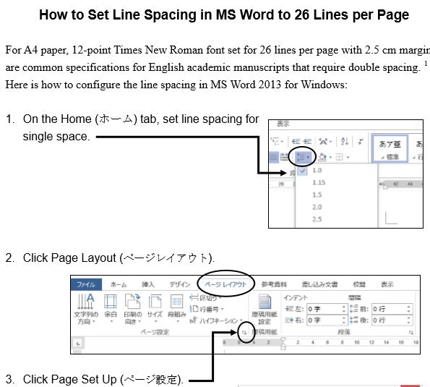

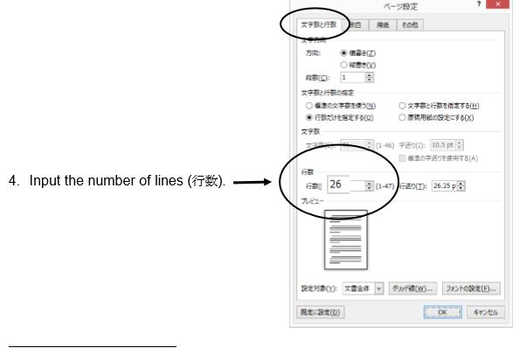

In addition, the students must put a page number and the title of the writing assignment in the upper right corner of the document. They need to put their name and student number on the first page.
Also, they will have to submit each IE Writing or Academic Writing assignment to the IE Program database where papers will be checked for plagiarism. An explanation of how they will upload their written assignments can be found at the end of this student booklet. Remind the students that before they submit an assignment to the database, they must remove their name and student number.

IE Writing and Academic Writing Database
Following extensive surveys and student interviews, we learned that as in many university departments around the world, there has been plagiarism in our students’ assignments. Beginning in the Spring of 2015, we established a database to which all students in IE Writing and Academic Writing must send their assignments. You must explain this to your students at the beginning of the semester. Copies of the instructions are in the student course booklets and in the Scope and Sequence documents for teachers of these courses. They are also printed at the end of this booklet. This multi-year database project has been funded by grants from the English Department and the Computer Lab and it will have a searchable database soon.

Plagiarism. As described earlier in this handbook, we are gradually implementing a department policy on this academic problem. This year, there is a statement about plagiarism in most teacher handbooks as well as in the IE Core and Student Writing guide. For the IEP, physical evidence of student plagiarism on a book report, a paragraph, a journal, or an essay (eg. The student’s work as well as the copied passage from the Internet, from a book, or from another student’s work) should result in the student failing the assignment. The instance should be brought to the student’s attention and the IEP coordinators notified immediately. The student should be warned about plagiarizing a second time. If the student plagiarizes a second time in the same course, as mentioned earlier, then you must fail them.
For these measures to work, students should be taught the difference between legitimately using and acknowledging sources, and the use of summary and paraphrase. Exercises and further discussion of plagiarism and of writing summaries and paraphrases may be found in the IE Writing Teachers guidebook and that for Academic Writing teachers.

Discipline. Generally students should be expected to be on time and be in their seats when the teacher is ready to begin class. Students should not be inattentive, chatting, sleeping, or working on other projects in class. Part of the students' grades can be based on class participation and students should be encouraged to be attentive and responsive in class. If discipline problems occur in the classroom which the teacher is unable to resolve on his or her own, please contact one of the IEP coordinators. If the problem cannot be resolved at this level, it will be referred to the English Department Chair.
Melvin Andrade has sourced a good video on the subject, "How to maintain classroom discipline: Good and bad methods" (1947 vintage film). The bad example starts at 00:00 and the good one starts at 7:38.
http://www.youtube.com/watch?v=gHzTUYAOkPM
Teachers' responsibilities

Annual Teachers’ Orientation. All teachers are expected to attend this meeting held at the beginning of the year (usually the first Saturday of April) to finalize plans for the upcoming year, pass out important papers, present new policies and procedures, and discuss ongoing issues. If it is absolutely impossible for you to attend this meeting, please notify one of the full-time teachers; you are still responsible, however, for finding out what went on at this meeting.

Attendance. We expect teachers to teach on all assigned days unless they are sick, have an emergency, or are on official business. Teachers are not permitted to be absent simply to accommodate travel plans or other personal activities. You must notify Kyomuka for all absences; do not make independent arrangements with students if you are absent. If you will be absent or late for class due to an illness or emergency, telephone Kyomuka directly at 03-3409-7830.
For other official absences (for example, to attend an academic conference), please notify both Kyomuka and your students in advance. If you miss more than two classes per semester, you are expected to give make-up classes for each missed class. Teachers are also encouraged to assign homework when classes are missed due to a teacher's absence. Please begin and end classes on time.

Class rosters. Official class rosters are to be picked up at Kyomuka on the 2nd floor of Building 17. Class rosters are usually made available several weeks after the semester has begun since students may change or withdraw from classes during that period. It is preferable for teachers to keep their own rosters until the official rosters are issued. If teachers would like to obtain a temporary roster on the first day of class, they must request one from Kyomuka in advance. Once the final roster has been given out for each semester it is not possible for students to change classes or streams. Teachers can also download their rosters by accessing the Aoyama Portal (see the Aoyama portal).

Assessment of students. For IEP courses, assessment should be based on the work that students do in class (see "Grading policy" above) rather than on their language ability. All quizzes and tests should be given during regular class time; no exams will be scheduled during the official examination period. If students are absent from a final exam in IE Active Listening or Academic Skills, then (1) make arrangements for the student to take the test in another teacher’s class; (2) assign a grade based on other criteria, such as class performance, projects, and previous quizzes given in class. Teachers may also give students a make-up assignment.

Reporting grades. Teachers are responsible for giving grades to their students for each of their classes. Since all courses are on a semester system, students must be given a grade at the end of each semester. Teachers should submit their grades online using the Aoyama Portal (see the Aoyama portal). Grade forms must be filled out completely; each student whose name appears on the grade form must be given a grade, even if that student did not attend your class. Grades must be submitted by the deadline for each semester. Grades may not be changed once they have been submitted, except in exceptional circumstances in which the teacher has clearly made an error in giving the original grade.
After grades have been reported to the students, students are permitted to ask teachers to give an explanation for why they received the grade that they received. Such requests are made directly to Kyomuka, which then sends the teacher a form asking for an explanation of the student's grade. After filling in the form, the teacher must return the form to Kyomuka, which will then forward the form to the student. Teachers who plan to be away during the holiday period after each semester should give Kyomuka their contact information in the event that any questions arise about their grades.

Conduct towards students. Teachers are expected to have a positive and encouraging manner in dealing with students. We encourage informal contacts between teachers and students but also expect teachers to be thoroughly professional in their relations with students. Of course, the same professionalism should also be extended to other faculty members, administration, and staff. In all cases avoid any form of behavior that could be interpreted as sexual harassment or power harassment.

Practices to be avoided. Do not send students outside of the class on a regular basis to do other work in lieu of regular class participation. Do not send some students outside of the class while conferencing or meeting with others. While we recognize that there are students of varying levels in each class, please be resourceful in dealing with this situation, which is common to all of us. No private or "independent" studies, please. Teachers should never take students out of their assigned classrooms without special permission. Only under special circumstances, such as library assignments, is it possible to take students outside of the classroom.

Employment policies

Salary and transportation costs. Your salary will be paid on the 20th of each month (or on the first preceding business day if the 20th falls on a holiday), based on the number of classes you are teaching. You will also be compensated for your transportation costs. As part of the information packet sent to all teachers in March (see "Information packet" below), you will receive a guidebook entitled 大学事務案内 (Daigaku Jimu Annai) which contains two forms: (1) a "Commutation Report" for reporting your transportation costs; and (2) a "Registration of Account for Transfers" for having payments made directly to your bank account. The latter form requires you to give the name of your bank, name of the branch, name of the account holder, and account number. Both of these forms should be returned to Kyomuka after you have completed them.

Updating Information. If there are any changes in a teacher's contact information (address, telephone number, etc.), the teacher should inform both Kyomuka and the full-time English faculty member who is in charge of part-time teachers. Other changes (bank account, transportation costs, visa status, etc.) should be reported directly to Kyomuka.

Annual contracts. Contracts for part-time teachers are reviewed on an annual basis before being renewed for the following year. The following criteria are taken into consideration:

- Highest academic degree obtained and field of study (normally an M.A. or higher
in linguistics, TESOL/TEFL, communication, or literature, plus three years of
university teaching experience.
2. Ability to teach effectively, to motivate students, and to work well with them.
3. Ability to teach the full range of courses in the section for which the teacher was hired. (all "A" teachers are expected to be familiar with TESOL / TEFL teaching methodology, media literacy, intercultural communication, and to have the ability to teach courses entirely in English; all B teachers are expected to be able to teach Reading and / or Writing courses they have been assigned to teach).
4. Ability to cooperate with one’s colleagues, the program coordinators, full-time
English faculty, administration, and staff.
5. Reliability in teaching one’s classes, starting classes on time, and seldom
missing classes.
7. A good record of fulfilling administrative responsibilities (turning in grades on
time, providing adequate notice about leaving the university’s employment,
or requesting changes to one’s timetable, attending the annual teachers'
meeting in April, keeping informed about relevant changes in the department,
responding to requests for information in a timely and cooperative fashion.
8. Evidence of ongoing commitment to teaching and scholarship through
participation in relevant academic associations, publishing, and presenting, etc.

Expectations. We expect teachers to fulfill all of their responsibilities through the end of the academic year in March. Teachers who are unable to fulfill their responsibilities due to health problems or other emergencies should immediately contact one of the IEP coordinators. If a teacher takes a leave of absence for health reasons, a document from the attending physician or other caregiver must be submitted upon the teacher's return, certifying the reason for teacher's absence and that the teacher is ready and able to resume teaching. (The precise nature of the illness need not be specified in the document; the document will not be kept on file nor become part of the teacher's record.)

Terminating employment. Throughout their term of employment at Aoyama, teachers should conduct themselves in a responsible manner and inquire about procedures if they are in doubt as to what is permitted. Teachers may be dismissed or their contracts may not be renewed for failing to observe university policies. Failure to show up for exams without proper notification; failure to turn in grades on time; failure to follow course descriptions or incompetence in teaching assigned courses; excessive tardiness or absences; absences arranged with classes rather than through Kyomuka; a consistent pattern of negligent or irresponsible behavior; failure to provide sufficient notice when dropping a class, or changing one’s schedule after signing a contract, inability to work effectively with students; discourteous or offensive behavior towards students, other faculty, or staff are all examples of behavior that may lead to termination of employment.

Dealing with teacher stress
Although stress is a part of life, it can become harmful. Here are a number of suggestions that a teacher in the program, Tom Anderson, made in 2014.
Attitude: Being positive about what you are doing can help you to relax and enjoy it.
Physical Health: Eating properly balanced meals at regular times is important as is avoiding caffeine and soft drinks. Exercise is also helpful and Aoyama Gakuin University has a fitness center that only charges ¥2000 for a one year membership as well as offering some discounts for fitness clubs in the area. Several teachers in the program cycle to the campus as there is a bicycle parking lot behind the high school. Sleep is very important. Preparation for sleep should be done two hours before going to bed. Try to avoid caffeinated drinks before bedtime and avoid reading in bed.
Mental Health: Journaling can be very useful. Once whatever is bothering you is down on paper it is no longer spinning in your head. Having hobbies that are enjoyable and relaxing can reduce stress. Working in a garden or with household plants can also be very relaxing. Allowing yourself some “goof-off” time can reduce stress, too.
Joining up: It is easy to become isolated, particularly as a foreign teacher in Japan, so finding a group to join can help a great deal.
It does not matter is the group’s focus is your hobby, vocation, or one with a cultural or religious aim.
Resources: First of all, it helps to make friends among other teachers who may be able to offer some practical advice about classroom challenges or even about getting things done in Japan. There are many websites, of course.
Three that are specific to Japan:
Meetup (http://www.meetup.com/cities/jp/tokyo/): This website lists all the groups meeting within the Tokyo area on such diverse interests as amateur theatre, politics, creative writing, and travel.
Metropolis (http://metropolisjapan.com/): Metropolis is an English language cultural magazine with current events, reviews of art exhibitions, films, music, restaurants, and classified ads.
Tokyo English Lifeline (http://telljp.com/): This website offers resources such as upcoming social and cultural events and an English contact directory for English-speaking doctors and lawyers and volunteer opportunities at TELL.

Part III: Facilities

General information

Information packet. In early to mid-March, Kyomuka will send a packet of information, in Japanese, to each teacher at the teacher's home address. The packet will include the teacher's teaching schedule, calendar for the academic year, maps of the campus, and other information. The information presented in this section supplements that packet. If you have any further questions do not hesitate to ask other faculty members or office personnel for assistance or the IEP coordinators.

Getting to the Shibuya campus. The Shibuya campus is approximately a ten-minute walk from Shibuya Station and a five-minute walk from Omote-sando Station. Since parking space is limited, teachers are encouraged to use public transportation instead of driving to the Shibuya campus. However, if special circumstances make it necessary for you to drive to the campus, you should obtain a parking permit from the Anzen Taisakuka at Somubu in the main administration building (Hombu), located in Berry Hall at the center of the campus. Any cars parked in the university parking area should also be fully insured. Note that if the university parking area is full on any given day, teachers will need to use a coin parking area off campus at their own expense.

Contacting the Shibuya campus. The Shibuya campus can be contacted by calling Kyomuka at 03-3409-7830. This is also the number you should use if you are going to be absent or late for class. Kyomuka can also provide assistance if you need to contact other individuals or offices at the Shibuya campus. If you need to contact Kyomuka for the English Department, the number is 03-3409-8111.

Identity card. A university identity card will be sent to each teacher at the teacher's home address at the beginning of April. Teachers should carry their identity cards with them while they are on campus.
An identity card is needed to enter and to check out books from the library; to use AV equipment in the classrooms; to use personal computers in the faculty lounges and computer room; and to check out DVDs from the AVL Library, Building 8, 1F.

Important places on campus

Kyomuka. Kyomuka is located in the Student Center on the second floor of Building 17. This office is our direct link between the administration and students.
You must notify Kyomuka if you will be absent or late for classes. If there are any other special communications to be given to a class, it is through this office that such arrangements are made. The telephone numbers for Kyomuka are given in the section, "Contacting the Shibuya campus," above.

Faculty lounges. Faculty lounges (koshi-hikaeshitsu) are located on the first floor of Building 1, the first floor of Building 8, and the second floor of Building 17. The lounges in Buildings 1 and 8 are open from 8:30 a.m. to 9:20 p.m. on Mondays, Wednesdays, Thursdays, and Saturdays, and from 8:30 to 9:40 p.m. on Tuesdays and Fridays. The lounge in Building 17 is open from 8:30 a.m. to 6:30 p.m. on Mondays through Fridays, and from 8:30 a.m. to 1:00 p.m. on Saturdays. Green tea is available for teachers and in the one in Building 17, there is a microwave. There are photocopiers and computers The lounges are equipped with shelves in which teachers can leave teaching materials. However, these shelves must be cleared out by the end of each school term.

Photocopy facilities. There are photocopy machines in the faculty lounges, which teachers are free to use. Teachers can also ask the receptionists in the faculty lounges to make photocopies for them if the material to be photocopied does not exceed ten pages and is submitted at least one week in advance. The receptionists will not make photocopies of copyrighted material, however, including excerpts from books, magazines, and newspapers. Teachers should not ask students to make photocopies in the faculty lounges, however, since students are not permitted to use the photocopy machines in those rooms.

Computer facilities. Teachers are free to use the personal computers in the faculty lounges in Buildings 8 and 17. A university identity card is needed to use these computers, however, and to enter the university portal, a PIN password must be obtained from the PC Support Lounge located on the first floor of Building 2. You must also obtain an e-mail address if you wish to use the campus e-mail system. Teachers may also use the personal computers in the computer room at the PC Support Lounge, although there is a time limit of 90 minutes. The PC Support Lounge office also has site licenses for software such as Microsoft Office and anti-virus programs. They will also assist you in changing the operating system of your tablet from Japanese to English if you need help in doing so. Finally, the entire campus is now wired, so that you can access the Internet everywhere.

Cafeteria, bookstore, clinic, library. Cafeterias are located in the basements of Buildings 7 and 11, and on the first floor of Building 17. (There is no separate cafeteria reserved exclusively for faculty members.) The campus bookstore, Kobaikai, is located on the first floor of Building 1. A clinic is located on the first floor of Building 7. Teachers may use the campus library, but a university identity card is needed both to enter the library and to borrow books.

Audio-visual equipment

Foreign Language Laboratory. The Foreign Language Laboratory (FLL) office is located on the sixth floor of Building 15 (Goucher Memorial Hall). To contact them from off campus, the direct line is 03-3409-7938; to contact them on campus the extension number is 12557. You can sign out video equipment from them and use their video editing room. There is also a special preparation room located on the sixth floor of Building 15, which teachers who have classes in CALL classrooms may use and where audio-visual materials may be previewed.

AV Library. The AV Library is located on the first floor of Building 9. The AV Library has a substantial collection of videos, DVDs, laser disks, and cassettes.
Teachers are welcome to use as resources for their classes. Audio-visual materials for some textbooks are also available in the AV Library. All available materials are catalogued on the Aoyama Gakuin University Library website at <http://www.agulin.aoyama.ac.jp/opac/>, accessible in both English and Japanese. Audio-visual materials may also be previewed at the AV Library.

Ordering new materials. Teachers should try, to the extent possible, to use materials that are currently available at the AV Library. For audio-visual materials that accompany a textbook, the teacher should first ask the publisher to supply a complimentary copy of the materials (many publishers will provide free audio-visual materials to teachers if the teachers have their students buy the corresponding textbook). If the teacher cannot obtain a free complimentary copy, however, it may be possible to ask the FLL office to order the materials. Teachers who wish to use other audio-visual materials not already available at the AV Library may make a request directly to the FLL to order these materials. Please note that all requests to order materials are subject to both budgetary constraints and the approval of the FLL Committee; therefore, there is no guarantee that such requests can be fulfilled.

Placing materials on reserve. Materials may be placed on reserve at the AV library for the use of students inside the library by filling out the appropriate form (called kadai shitei) at the FLL office; these forms are available at the AV Library.

Dubbing materials. Materials for which copying privileges have been granted may be dubbed by both teachers and students. Teachers should consult with the FLL office first to make sure that the university has copying privileges for the materials they would like to have dubbed. Teachers should ask the FLL office to dub the materials for them at least one week in advance of the time that the material is needed. Students may only dub materials with the prior approval. For students to dub materials, the teacher must first fill in a form at the FLL office giving their approval, then the students must take a blank CD, or DVD to the FLL office for the materials to be dubbed on.
The FLL will not accept requests to copy or edit audio-visual materials for which copying privileges have not been granted.

Policies for using materials. Duplicating audio-visual materials without the permission of the copyright owner is a breach of the Copyright Act. For this reason, the following policies have been adopted for how materials may be used at the AV Library:

- The AV Library will not stock audio-visual materials without the permission of the
copyright owner (including recorded TV programs).

- The FLL will preferentially buy audio-visual materials with permission from the
copyright holders so that all faculty members and students of Aoyama Gakuin
University can use them at the AV Library.

- AV materials may be used by all faculty members of Aoyama Gakuin University at the AV Library. Teachers should pick up the materials on the day that they will use them in class and return them on the same day.
If teachers need time for preparation, please consult with the AV Library for details on how the materials may be used in advance of the time that they will be used in class. In all cases, however, the materials must be returned to the AV Library immediately after they have been used in class (note that this rule is strictly followed with no exceptions).

- In some cases there are restrictions on which materials students can use at the
AV Library. Unrestricted materials may be used by students of Aoyama Gakuin
University at the AV Library, but students are not permitted to use these materials
outside of the AV Library. Students may use restricted materials only in the following cases:
- Students of Aoyama Gakuin University may use restricted materials if they
have been placed on reserve by a faculty member of Aoyama Gakuin
University (see "Placing materials on reserve" above)
- Students of Aoyama Gakuin University who wish to use restricted materials
for a course being taught by a faculty member of Aoyama Gakuin
University need an application form from the FLL to the teacher.
If the materials are indeed relevant to the course, then the teacher may
sign the application form, authorizing the student to use the materials.

CALL classrooms. CALL (Computer Assisted Language Learning) classrooms are located on 4th, 5th, and 6th floors of Building 15 (Goucher Memorial Hall) and are equipped with VHS players, DVD/CD players, headphones, and personal computers with Internet access for each student and also the teacher. No keys are needed to access this equipment, but teachers need their university identity card to activate the teacher's personal computer; students can activate the PCs on their desks by using their own identity cards.
At the beginning of each academic year (usually the first week of April) there is an orientation which new teachers using CALL classrooms are strongly advised to attend. New teachers will receive a notification directly from the Foreign Language Laboratory about this orientation. Each teacher who attends will also receive a manual in English about how to use the CALL system, which they can take home with them; copies of this manual are also available at the FLL office. Other teachers may also attend the orientation by making a reservation at the FLL office in advance (no prior notice of the orientation will be sent to these teachers, however).
Equipment in other classrooms. Equipment available in the other (non-CALL) classrooms varies, although the following is a general guide. Regular classrooms are equipped with VHS, DVD, and CD players, with either projectors and screens, or in some cases, TV monitors; almost all of the regular classrooms have connections for using a PC although you will need to pick up the PC itself at the appropriate faculty lounge for the building you are teaching in. All of the classrooms in Building 17 are equipped with Blu-Ray players (which can also play DVDs and CDs); teachers need their university identity cards to access this equipment. PC classrooms are equipped with VHS players, DVD/CD players, and personal computers with Internet access for students and also teachers, but no headphones. Teachers need their university identity card to activate the teacher's computer in the PC classrooms; students can activate the PCs on their desks by using their own identity cards.
In some classrooms, keys are needed to access the equipment; keys can be picked up in the appropriate faculty lounge. Additional equipment, such as microphones, PCs for classroom use, tape recorders, overhead projectors, and slide projectors, can be also picked up in the appropriate faculty lounge if any of these items are not already in the classroom you are teaching in. Be sure to return the key and / or equipment after teaching. If you have questions about the equipment available in the classroom you are teaching in, please ask the staff at the appropriate faculty lounge.

Faculty lounge Keys and equipment for classrooms in:
Building 1, first floor Buildings 1, 2, 3, 4, 5, 6, 7, 11, and 14
Building 8, first floor Buildings 9, 15, and 16
Building 17, second floor Building 17

Getting assistance. The staff is very helpful in showing teachers how to use equipment and locate materials. There is a telephone in each classroom if problems arise during a class. For regular classrooms dial extension 12127 (Housouchouseishitsu, or Broadcasting Control Room); for CALL classrooms dial 12557 (CALL classroom assistance). A staff member will come quickly to assist. Experienced teachers with classes on the same day are also usually able to help you learn how to use equipment.

Accessing Internet materials

AFP World Academic Archive. The AFP World Academic Archive (AFPWAA) has a large collection of archived videos (including current new videos) that are especially appropriate for use in Media Literacy, Internet English, and Current Events, although teachers are not obligated to use the AFPWAA for these courses (i.e., you are free to chose other materials on your own for these classes). The instructions below introduce the basic steps needed to access and use these materials. For further information on how to access these materials, please consult the following documents, which are available in both English and Japanese and can be picked up at the counter of the AGU Library (i.e., the regular library, not the AV Library):

1. AFP World Academic Archive: How to Create Your Own Account: This document will guide you through the steps necessary to set up an account to use this website.
2. AFP World Academic Archive: Basic User Guide: This document give further instructions on how to access and use the website.

Before you start. Before accessing the AFPWAA you need to go the PC Support Lounge on the first floor of Building 2 to do the following:

1. Obtain an e-mail address which enables you to use the Aoyama Gakuin University e-mail system.
2. Register a PIN password in order to access the AFPWAA from computers on campus which have a card reader for university identity cards. (This is the same pin number that you need to access the Aoyama Portal.)
3. Register a separate LDAP password in order to access the AFPWAA from your home computer or any other computers which do not have a card reader for university identity cards. (This is the same LDAP password that you need to access the Aoyama Portal.)

Accessing the AFPWAA. You can access the AFPWAA anytime and anywhere from computers both on and off campus.

1. If you are accessing the AFPWAA from a computer on campus which has a reader for your university identity card, please follow these instructions:
a. Enter your PIN password into the field marked "PINを入力".
b. Go directly to the AFPWAA by typing in <http://www.waa.afp.com>.
2. If you are accessing the Aoyama Portal from your home computer or from any other computers which do not have a card reader for university identity cards, please follow these instructions:
a. Go to the AGU Library Website at <http://www.agulin.aoyama.ac.jp>
b. Click on the box アルファベット順一覧.
c. Scroll down and click "AFP World Academic Archive".
d. Enter the number on your university identity card into the field marked "ID".
The first digit of the number on your university identity card must be converted to a small-case t. For example, if the number on your university identity card is 000392, you should type in t00392.
e. Enter your LDAP password into the field marked "PASSWORD". You will now be in the AFPWAA website.

Registering with the AFPWAA. Once you are inside the AFPWAA website, you will you will need to create an account by following these instructions:

1. Click on the pink box marked "ログイン".
2. Click on the box "First time users".
3. Click on "English" to see the instructions in English.
4. Enter the e-mail address which you obtained from the PC Support Lounge (see "Before you start" above) in the box marked "Your e-mail".
5. Enter the e-mail address again in the box marked "Mail (confirm)".
6. Enter your LDAP password in the box marked "Your password".
7. Enter the letters in the box above the words "Subscribe now!" in the box marked "Validation string".
8. Click on the words "Subscribe now!"
9. Close the AFPWAA website and open your Aoyama Gakuin University e-mail account.
10. Open the e-mail from the AFPWAA in your in-box and click on the URL in the e-mail. You are now registered with the AFPWAA.

Logging in to the AFPWAA. After you have registered with AFPWAA you can login at any time by repeating the steps explained in the section above, "Accessing the AFPWAA," and then doing the following:
1. Enter your e-mail address in the box marked "User".
2. Enter your LDAP password in the box marked "Password".
3. To access videos from the AFPWAA website click on the words "Video Forum" on the far left side of the screen.

The Aoyama Portal

Using the Aoyama Portal. Teachers must use the Aoyama Portal to download class rosters, to submit grades, to request classrooms with AV equipment, including CALL rooms though these are hard to book as these rooms are limited and are very popular. Teachers of elective classes need to use the Aoyama Portal to upload course descriptions (course descriptions for required courses in the IEP and for Oral English 1 and 2 will be uploaded by the IEP coordinators) and to reply to exam questionnaires (to give students and Kyomuka the details of any final exams or reports for your class). Further instructions in Japanese for using the Aoyama Portal will be sent by the university. Please visit the PC Support Lounge on the first floor of Building 2 if you need further assistance.
There are also several very detailed English manuals online which we have created for teachers. They explain how to access the portal, and to update your curricula. They are archived on the Aoyama Portal, but for ease and convenience, these manuals can be downloaded from the IE Texts Web Page:
http://www.cl.aoyama.ac.jp/~dias/ListeningDownload.html

The following instructions are a very basic summary of the steps you need to take to access your records.

Before you start. Before accessing the Aoyama Portal you need to go the PC Support Lounge on the first floor of Building 2 to do the following:

1. Register a PIN password in order to access the Aoyama Portal from computers on campus which have a card reader for university identity cards. (This is the same pin number that you need to access the AFP World Academic Archive.)
2. Register a separate LDAP password in order to access the Aoyama Portal from your home computer or any other computers which do not have a card reader for university identity cards. (This is the same LDAP password that you need to access the AFP World Academic Archive.)
3. Register a matrix pattern for accessing the site (regardless of the type of computer you plan to use).

Accessing the Aoyama Portal. To access your personal information on the Aoyama Portal, the following steps must be taken:

1. If you are accessing the Aoyama Portal from a computer on campus which has a reader for your university identity card, enter your PIN password into the field marked "PINを入力". You will automatically be directed to the Aoyama Portal.
2. If you are accessing the Aoyama Portal from your home computer or any other computer that does not have a card reader for your university identity card, follow these steps:
a. Enter <https://aoyama-portal.aoyama.ac.jp/> into your Internet browser.
b. Enter the number on your university identity card into the field marked
"ログインID". The first digit of the number on your university identity card must
be converted to a small-case t. For example, if the number on your university
identity card is 000392, the number you should enter into the field marked "ログインID" is t00392.
c. Enter your LDAP password into the field marked "LDAP パスワード".
d. Enter the numbers from the matrix based on the pattern you registered with
the PC Support Lounge.

Uploading and downloading. To upload and download information from your personal records, use the following instructions:
1. To download class rosters:
a. Click the section marked "講義ツール".
b. Click "選択" for the appropriate class.
c. Click "PDF形式 (印刷用)" to see the class roster.
2. To upload and edit course descriptions:
a. Click the section marked "教員事務WEB" and then click on the characters
"講義内容入稿".
b. At the top of the page click the appropriate characters:
(1) "全て表示": allows you to see all of your course descriptions
(2) "本年度分のみ表示": allows you to see your course descriptions for the
current academic year
(3) "次年度分のみ表示": allows you to see your course descriptions for the next
academic year
(4) "入力必要分のみ表示": allows you to input data for the courses displayed
c. To preview a course description click "プレビューする".
d. To edit a course description click "入稿する" and then click on "編集" for the
section you would like to edit. (You can copy and paste information into each of
the sections or type it in directly.)
e. When you have finished editing your course description, click "OK" at the
bottom of the section and then click "入力完了" at the bottom of the page.

A Manual for the WEB-grading System
- How to access the WEB-grading system 成績入力

- Login to the AOYAMA-portal（https://aoyama-portal.aoyama.ac.jp/）
To access the WEB-grading system, start by a login to the
AOYAMA-portal. To create a password or to change your existing
password, visit the PC Support Lounge.
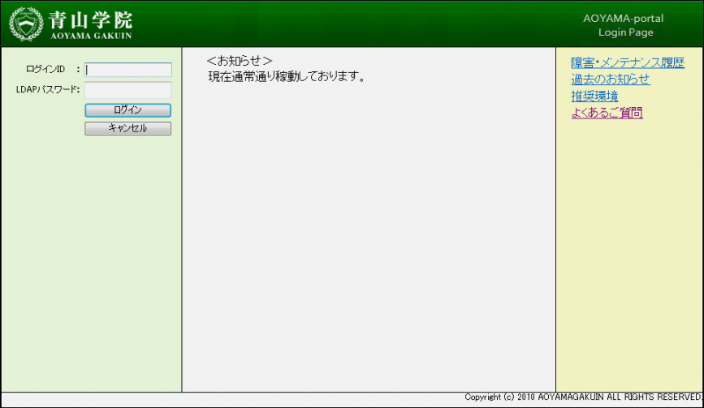

※If you cannot login to the AOYAMA-portal, please refer to page 12 to learn how to contact the PC Support Lounge.
- Click 教員事務ＷＥＢ (“Instructor administration WEB”)
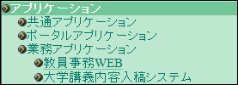

- Click 成績入力 (“Enter grades”)
After the MENU page, click on the link marked 成績入力 (“Enter grades”).
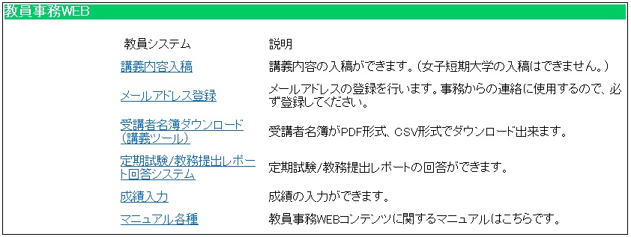

- How to use the WEB-grading system 成績入力
1. TOP page of the WEB-grading system
A list of courses for which you need to submit grades will appear on your TOP page.
Select the course by clicking the 選択 (“select”) button. A Student ID column will appear where you can enter student grades.
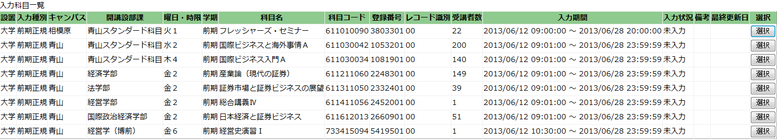
※If any of your courses do not appear on the list, please contact the academic affairs office.

2. Basic operation of WEB-grading system
※ 4 patterns are listed below. Please follow these instructions.
To input grades directly on the Web.
To download class rosters and then grade and upload CSV data.
To upload grades with class roster CSV data.
To upload grades with your own students’ list data.

Refer to instructions (A)
Refer to instructions (B)
Refer to instructions (C)
Refer to instructions (D)

＜Sample image of Student ID column page＞
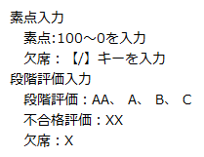
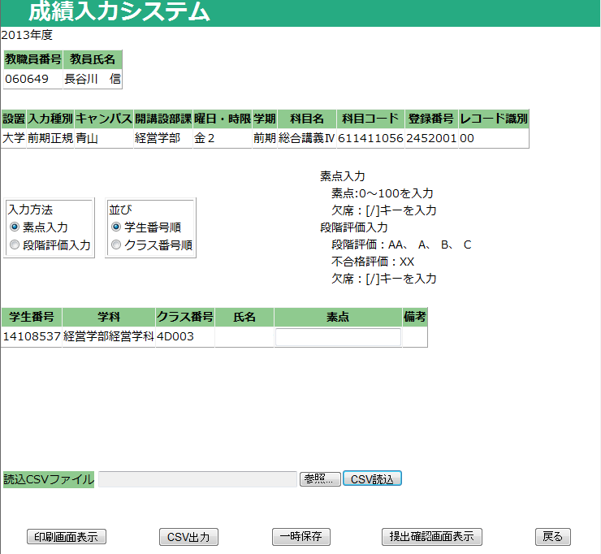

（A）Inputting grades directly on the WEB
- Choose the method to input grades.
Grades may be entered either by 素点入力 (“numeric score”) [i.e. a number from 0 to 100] or by 段階評価入力 (“letter grade”) [i.e. AA, A, B, C, X, or XX]（The default setting for inputting grades is by numeric score).
※ Once you begin inputting grades, YOU CANNOT CHANGE from a numeric to letter grade method or vice versa. If you do, any grades you have already input will be erased.
※ Some courses will only allow you to input grades with a numeric score.
※ Grades for graduate schools courses (except for those in the “Graduate School of Science and Engineering” or the “Graduate School of Social Informatics”) must be entered as a numeric score.

- Choose the order for displaying student names.
Student names may be displayed on the screen numerically by「学生番号順」(“student ID”) or by「クラス番号順」(“class number”).（The default is display the students by their ID).

- Input grades directly into the column.
Once you have completed steps ① and ②，you can begin inputting grades one at a time directly into the grade column. Both number and letter grades should be entered. For inputting letter grades, you can use either large or small-cap letters. When you press the Enter key, the cursor automatically moves to the next student in the column. Please BE CAREFUL to input each student grade in the correct place.

Jump to page 9, No 3 – 5 to learn how to save data, print grade sheets and submit the grades.

＜Sample image of Student ID column page＞
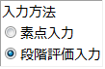
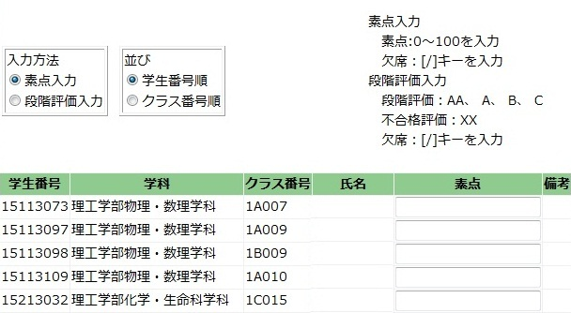
①
②
③

（B）Uploading grades with class roster CSV data
※You can download class roster data from 教員事務ＷＥＢ (“Instructor administration WEB”). Click 受講者名簿ダウンロード (“Download class roster”) on the TOP page to download the data. If you have already downloaded the class roster data (CSV formatted), please follow the instructions below. (Note: The instructions are based on a Microsoft Excel operation.)

- Open the student roster CSV data and input grades into any blank column.
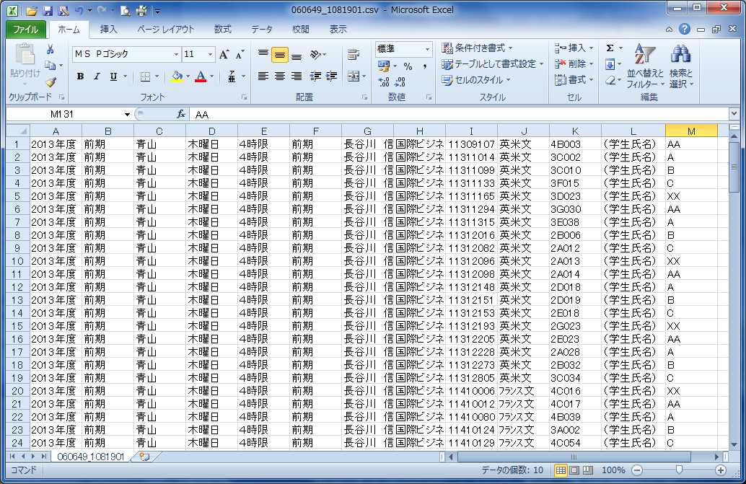
Input grades in any blank column.

- Select「File」→「Save as」 and name the file into which you have input grades. Save it in a CSV file format.（You can save it to any location on your PC.）

※ When you save the CSV data file, an alert message might appear.
Click YES to all alerts.

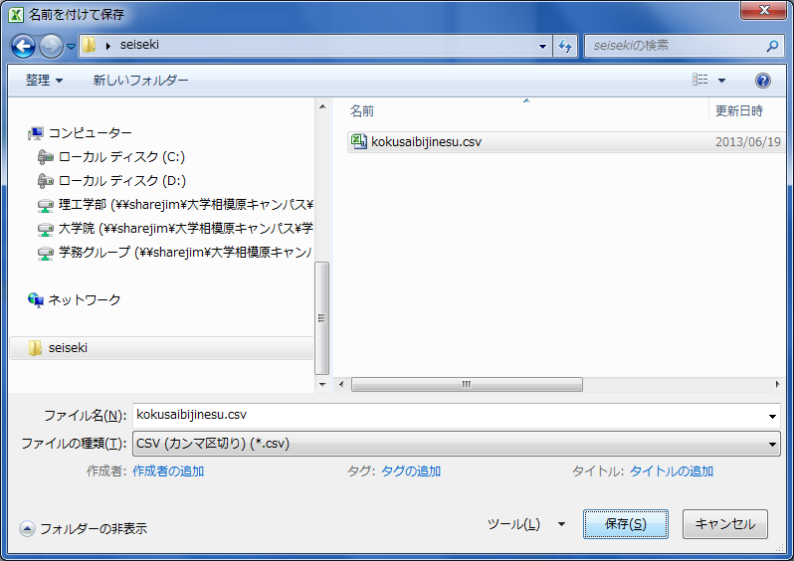

- TThe Kyomuka only needs two columns of data, one for “student ID numbers” and the other for “grades.” Process the data file as follows. First, erase all other unnecessary columns of data. Next, arrange the “Student ID numbers” into column A and “Grades” into column B.
「Save」the file and close Excel.
※After you save the CSV data file, alert messages may appear. Click YES to all alerts.
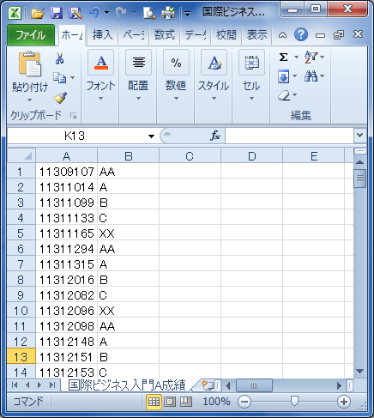
Arrange “Student ID numbers” in column A and “Grades” in column B.

- Open the Student ID column of the WEB-grading system and choose the method of grading, either by 素点入力 (“numeric score”) [i.e. a number from 0 to 100] or by 段階評価入力 (“letter grade”) [i.e. AA, A, B, C, X, or XX]（The default setting for inputting grades is by numeric score). Click the 参照 (“browse”) button which you can find on the bottom of the page. Then select the CSV file you processed in ①～③ and click the CSV読込 (“load file”) button.
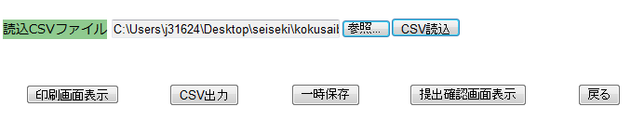

- If you have uploaded the data properly, grades will appear in the Student ID column as in the picture below.
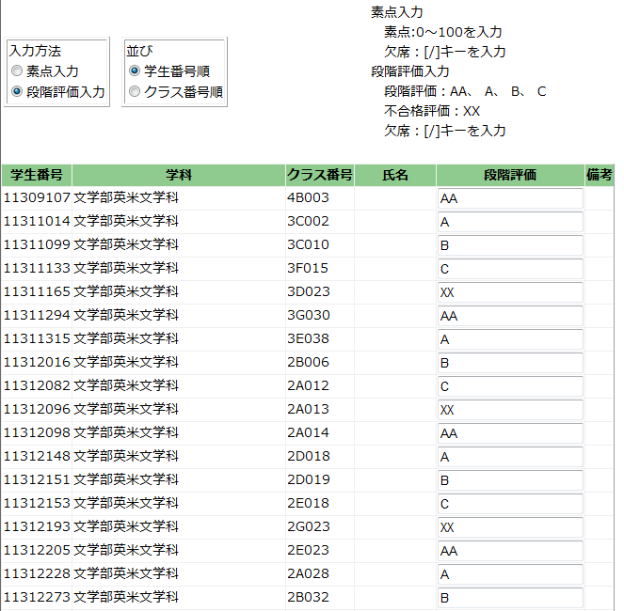

Jump to page 9, No 3 – 5 to see how to save data, print out grade sheets and submit grades.

（C）Uploading grades with your own arranged students’ list
※ If you already have downloaded the class roster data (CSV formatted) from 教員事務ＷＥＢ (“Instructor administration WEB”) and arranged it your own way, please follow the instructions below. (Note: The instruction is based on a Microsoft Excel operation.)

- Open your students’ data list and input the grades in any blank column and save the file.
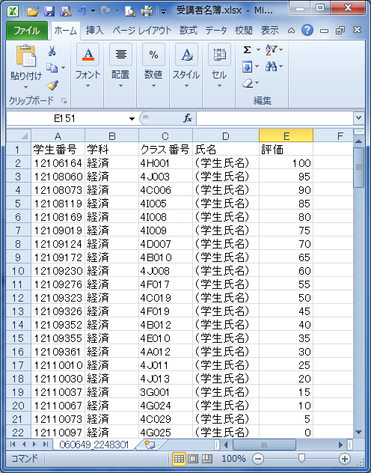
Input grades in any blank column.

- We only need two columns of data, one for “student ID numbers” and the other for “grades.” Process the data file as follows.
- First, erase all other unnecessary columns of data. Next, arrange the “Student ID numbers” in column A and “Grades” in column B.
No other data is needed.

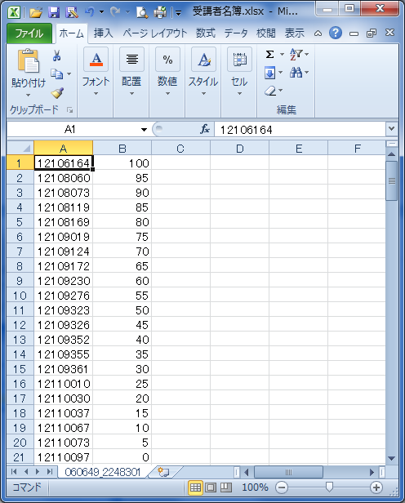
＜Attention points＞
・Should be arranged as: Student ID numbers in column A and grades in column B.
・No other data is needed.
（Erase all other unnecessary data other than Student ID numbers and grades.）

- Select「File」→「Save as」 and name the file you have inputted grades, save as CSV file format.（You can save the file to any location on your PC.）
- ※ When you save the CSV data file, an alert message might appear. Click YES to all alerts.
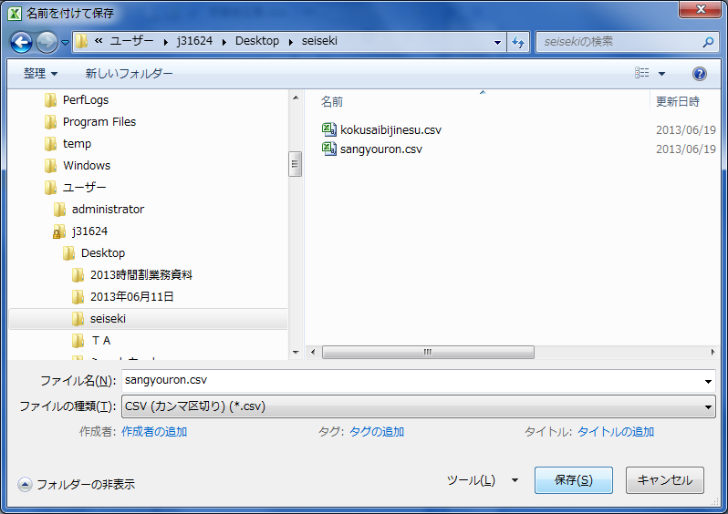
・Use alphabet and numbers.
・Save as CSV file format.

- Open the Student ID column of the WEB-grading system and choose the method of grading, either by 素点入力 (“numeric score”) [i.e. a number from 0 to 100] or by 段階評価入力 (“letter grade”) [i.e. AA, A, B, C, X, or XX]（The default setting for inputting grades is by numeric score). Click the 参照 (“browse”) button which you can find on the bottom of the page. Then select the CSV file you processed in ①～③ and click the CSV読込 (“load file”) button.

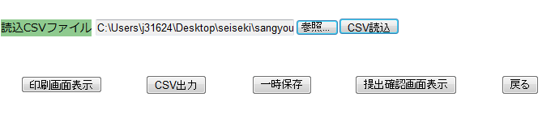

- Grades will appear in the Student ID columns as in the picture below when the data is uploaded properly.
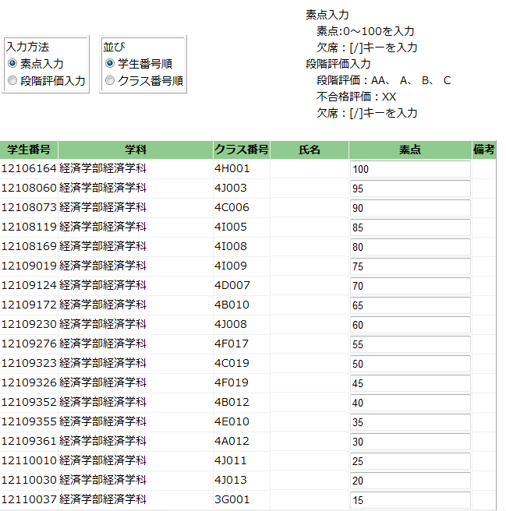
Jump to page 9, No 3 – 5 to see how to save the data, print grade sheets and submit grades.
（D）Downloading the students list in a CSV file from the WEB-grading system and grading, then uploading the data.
- First, open the Student ID column of the WEB-grading system and choose the method of grading, either by 素点入力 (“numeric score”) [i.e. a number from 0 to 100] or by 段階評価入力 (“letter grade”) [i.e. AA, A, B, C, X, or XX]（The default setting for inputting grades is by numeric score). Next, click the CSV出力 (“CSV output”) button which you can find on the bottom of the page.

- A “File download” window will appear. Click 保存 (“save”) to save the file.（You can save the file to any location on your PC.）
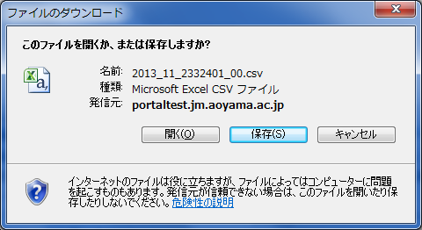

- Open the file which you have saved in ②.
（Note: The instruction is based on Microsoft Excel operation.）
1) Student ID numbers will appear in column A. Input grades in column B and save the data.
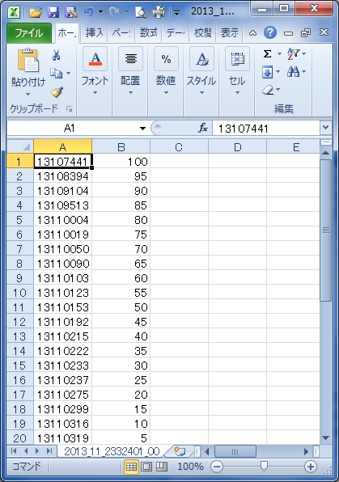
Student ID numbers will appear in column A.
Input grades in column B using half-width characters.

2) Go back to the WEB-grading system and click the 参照 (“browse”) button which you can find on the bottom of the page. Then select the CSV file you input grades in and click the CSV読込 (“load file”) button.
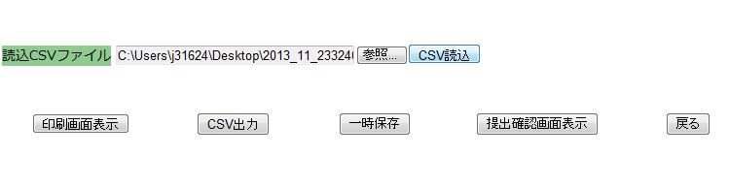
3) Grades will appear in the Student ID column as in the picture below when the data is uploaded properly.
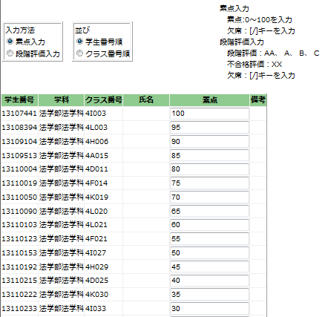
Follow the instruction below No 3 – 5 to see how to save the data, print out grade sheets and submit grades.

3. How to save grades temporarily
If you like to save grading data temporarily, click the 一時保存 (“save draft”)
button that appears on the bottom of the page.
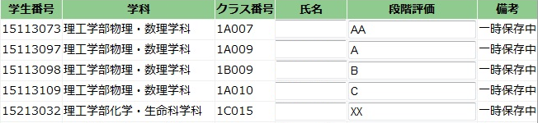


If you want to change the grades again, input new grades in the column and click 一時保存 . Data will be overwritten.

4. Trouble Shooting
The following notes cover some possible errors that might occur. If an error message appears, it means the “grading data is not complete”. Please note that you cannot submit grades without completing all the necessary data.

1) If there are any blank cells;
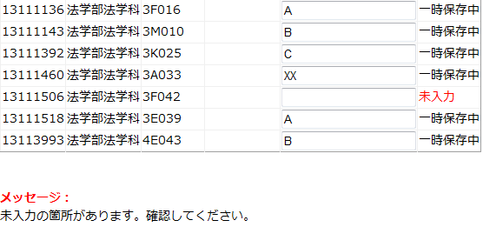
Example: Choosing the numeric scores method of grading but inputting a letter grade
2) If the grades are not input correctly;
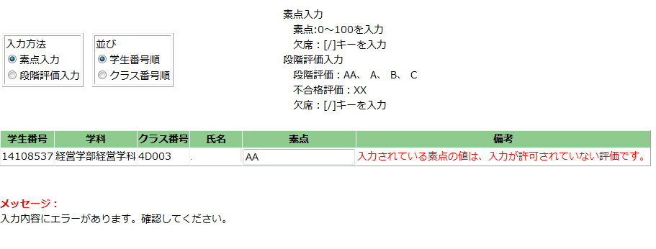
Example: Choosing the letter method of grading but inputting a letter which is not used for grading
（”S”,”D”,”F” etc.）

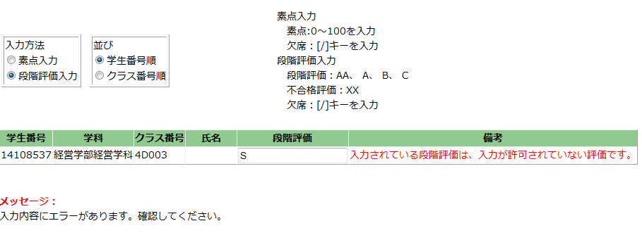

5. Printout Function
Click the 印刷画面表示 (“show print screen”) button which you can find on the bottom of the page. Print preview screen will appear. Click the “Print” option from your Internet browser to print a grade sheet out.

[Warning!] Please save your data before printing out. In other words, click the 一時保存 (“save draft”) or 提出 (“submit”) button FIRST! If you click 印刷画面表示 (“show print screen”) before you save your data, all the grades will be erased.
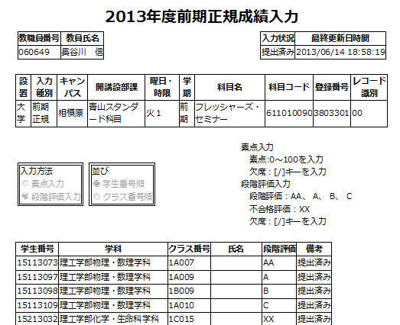

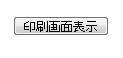

You can print out a grading sheet as above.
To print these sheets, use the “Print” function of your Internet browser.

6. Submitting Grades
- When you finish grading all the courses, click the 提出確認画面表示 (“show submission confirmation screen”) button on the bottom of the page. A confirmation screen will appear where you can check that the grading data is completed correctly. Please ensure that you check the data before submitting it. Click the 提出 (“submission”) button on the bottom of the confirmation screen to submit the data.
[Warning!]
Once you have submit the data, you CAN NOT CHANGE/CORRECT any grading data.
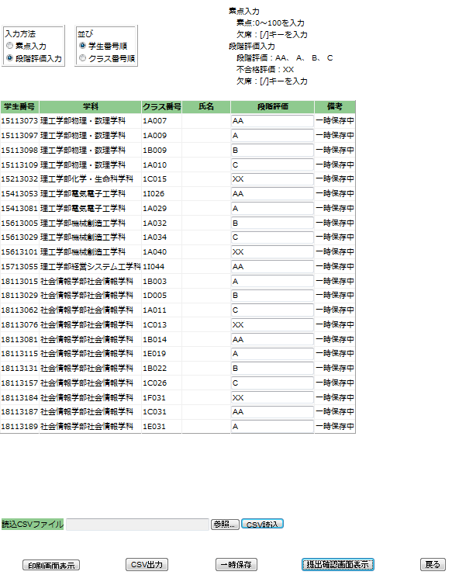
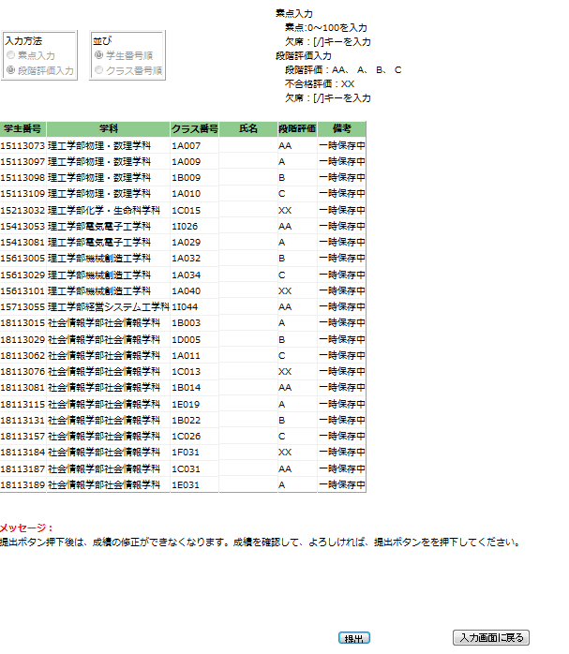

- After you submit the data, the message listed below will appear on the bottom of the page.You will also receive an e-mail letting you know that the data has been submitted to your Aoyama Gakuin email address. (tXXXXX(X:5 lower digits of your ID No )@aoyamagakuin.jp)
You can also check whether or not you have submitted the data properly on the TOP page of the system.
If the letter appeared in the status section as「提出済み」(“submitted”), it means you have submitted the grades.

＜Courses of Aoyama Campus＞
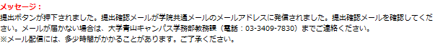
＜Courses of Sagamihara Campus＞
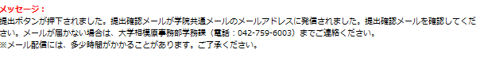

- If you have any inquiries regarding the grades you have submitted, please review the section listed in “6. References / Contacts” as soon as possible.

7. References / Contacts

＜Inquiries regarding grades and WEB-grading system＞ (Schools and Graduate Schools)
Aoyama kyomu-ka (undergraduate and graduate school office)
Sagamihara gakumu-ka (undergraduate and graduate school office)

＜If you cannot login to the AOYAMA portal＞
- Please refer to the よくある質問 (“FAQ”) section of the login page of the AOYAMA portal.
- If you still have inquiries regarding how to login to the AOYAMA portal, please contact the PC Support Lounge.

PC Support Lounge Aoyama Campus (1st Floor, Bldg. 2) TEL:03-3409-7850

PC Support Lounge Sagamihara Campus(4th Floor, Bldg. B) TEL:042-759-6047

※Please bring your Aoyama Gakuin identity-card with you when you visit the PC Support Lounge.

Using the Writing Database
From the spring semester of 2016, all students in IE Writing and Academic Writing will be required to upload the final draft of their written assignments to the new “Database of Student Writing.” In this way, we will rapidly build up a collection of student writing as a deterrent against plagiarism.

All students in IE Core are required to upload the final draft of their book reports to the “Database of Student Writing” which was established in the 2015 academic year. Students in all levels of IE Writing will have to upload the final draft of their paragraphs and essays to the database, as well.

In addition, since the autumn semester of 2015, Academic Writing (AW) students have uploaded the final draft of their 1,500-word AW thesis. With this rapidly accumulating collection of student writing, it will be increasingly difficult for students to intentionally (or inadvertently) plagiarize from each other.

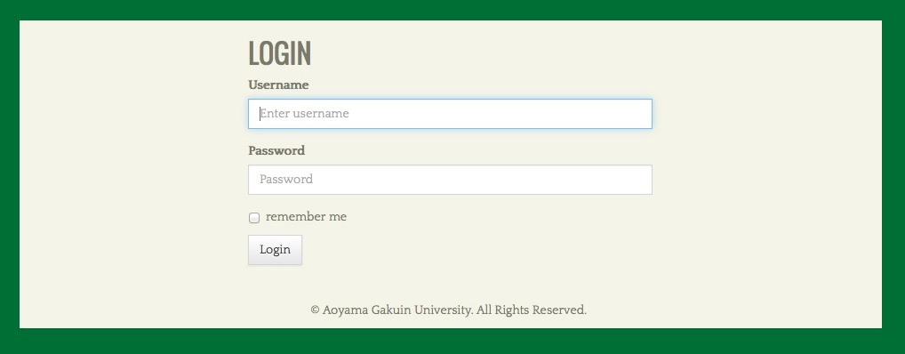
The way it works is that…
- Students upload their papers to a particular website after logging onto it.
- After the paper has been successfully uploaded, a unique “reference number” is generated that students must print out and give to their teacher.
- With that “reference number,” the teacher is able to download the paper and, at the same time, confirm that it was not plagiarized, either in part or entirely.

How students use the database for submitting written work

Students begin by going to this web page:
The URL will be supplied later since the hosting server will soon be changed. (See Fig. 1).

The student will log in as follows:
Username : student
Password : tGpUU5Cv
Fig. 1
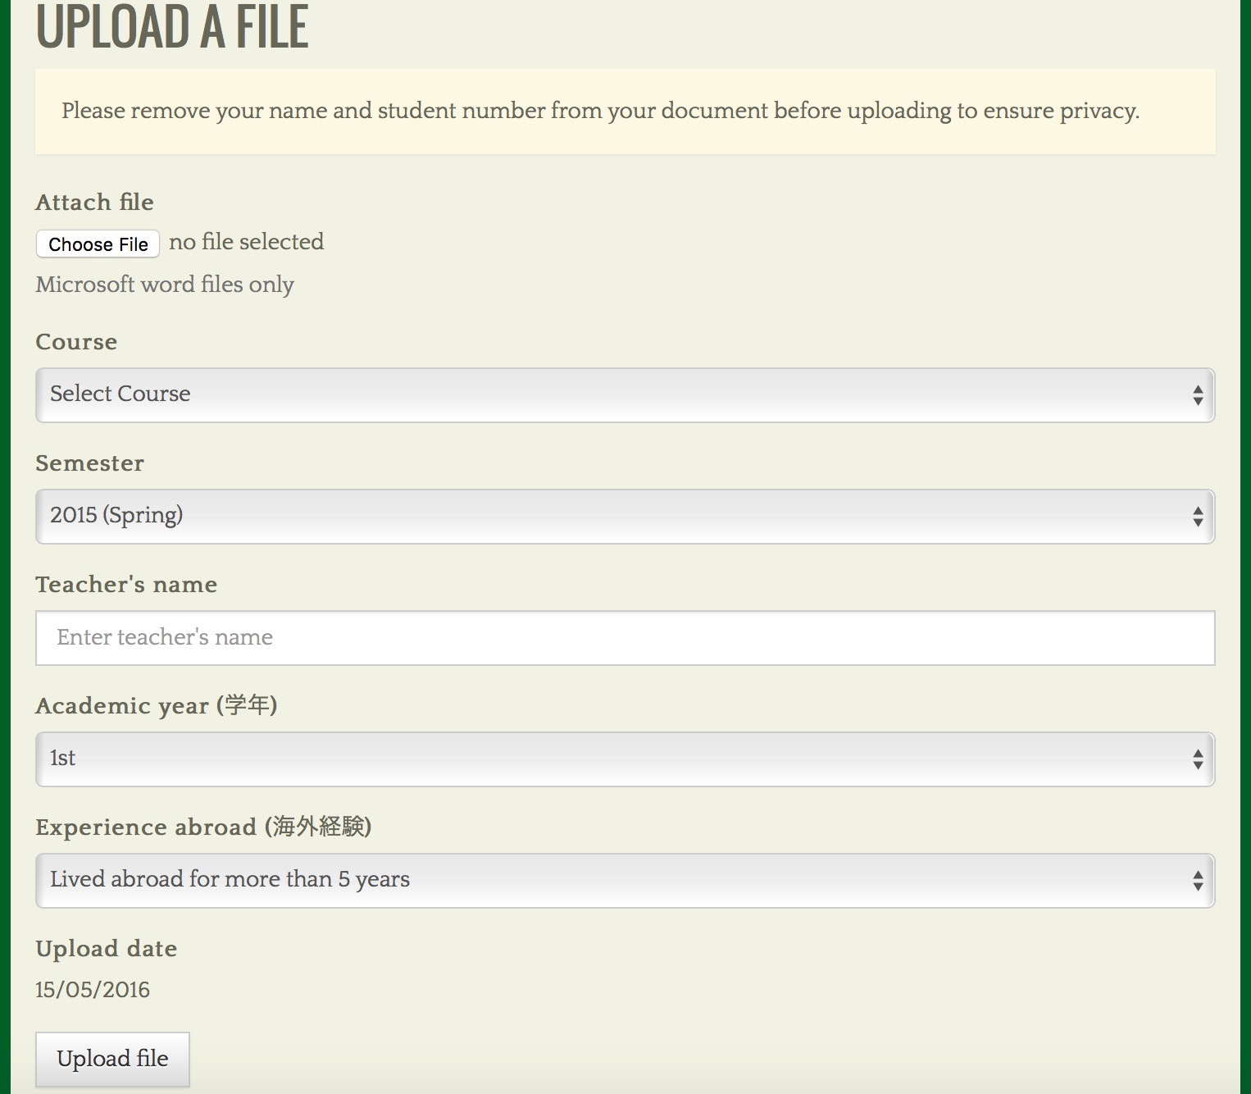
Fig. 2
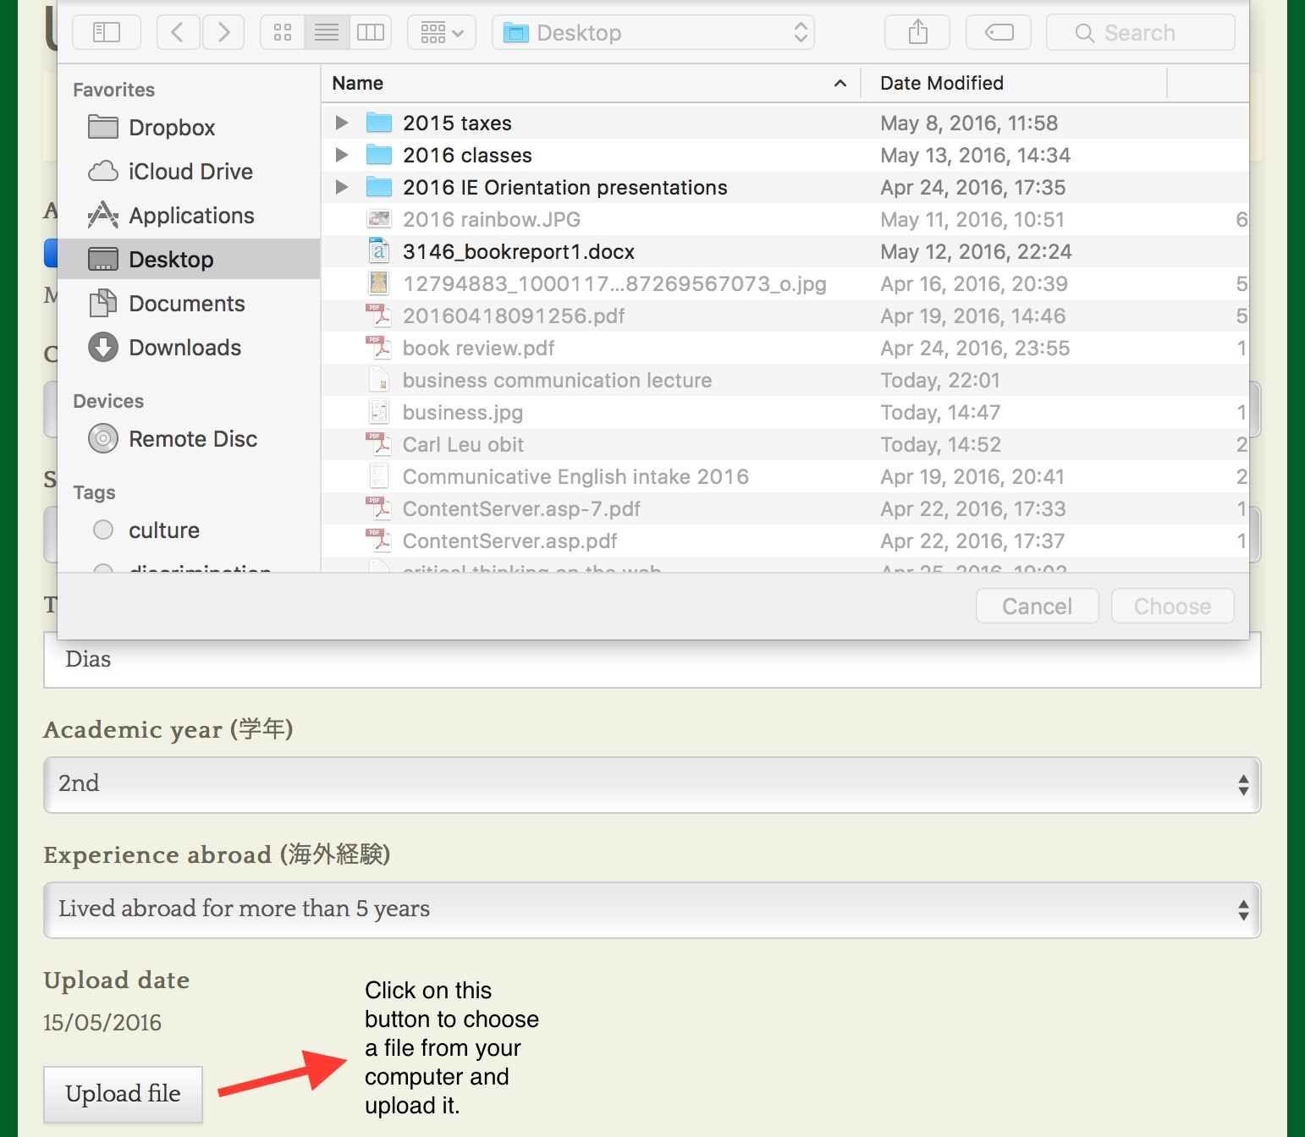
Fig. 3
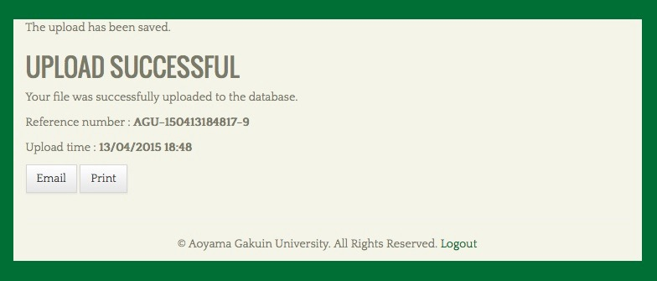

Fig. 4

After the student has selected the appropriate file on his/her computer and clicked the “Upload file” button, the file will be uploaded within a few seconds. Upon successfully uploading the file, a page will appear with the phrase “UPLOAD SUCCESSFUL.” On that same page, a unique reference number will be provided along with the time and date of submission.
Students must print out the “UPLOAD SUCCESSFUL” screen (which includes their file’s unique reference number--See Fig. 4) and present it to their teacher along with a hard copy of that written work. Students must not be given credit for an assignment if they have not shown evidence that they uploaded it to the “Database of Student Writing.” That evidence will be a print out of the “UPLOAD SUCCESSFUL” screen.

How teachers will use the database/plagiarism detection system

The MS Word files of the students’ submitted written work can be accessed at:
http://www.ap.agu4u.org/users/login.
[See Figure 5.]
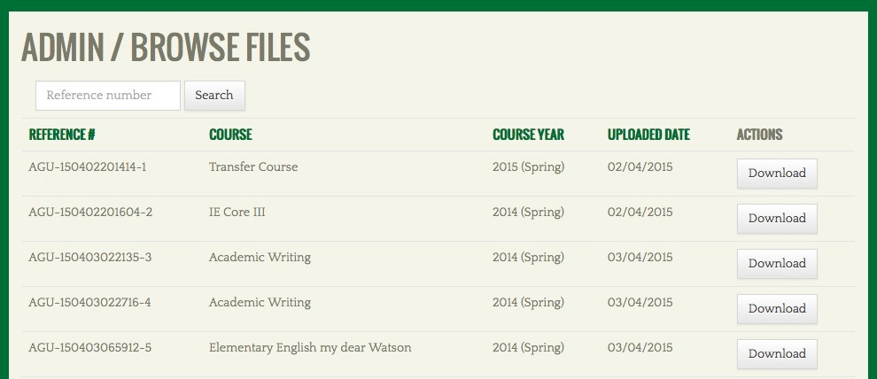
Fig. 5

Teachers should login as follows:

Username : admin
Password : [ ASK DIAS FOR IT ]
[Teachers wishing to access the electronic files of their students’ work should ask the IE Program coordinators for the administration password.]
Fig. 6
Finally, when a teacher does detect clear and indisputable evidence of plagiarism in student writing, (s)he is asked to report it to the IE Program coordinators at:
http://tinyurl.com/mum2goq

The plagiarism reporting page is a Google Form that looks like this (See Fig. 7):
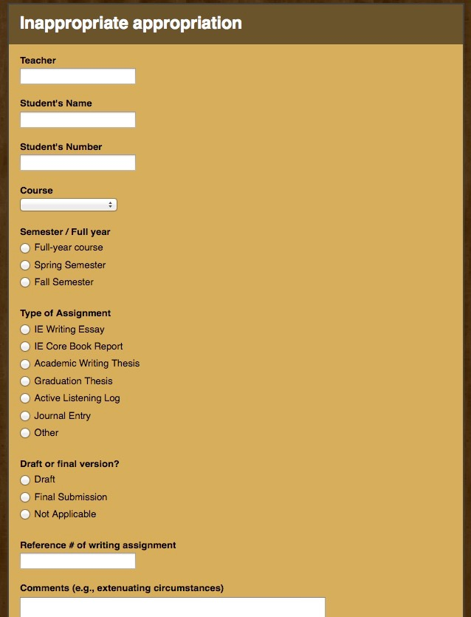

Fig. 7

The administration area of the database (See Fig. 6) will allow teachers to access a student’s work by searching the database using the unique “reference number” provided to them when the student uploads the file of his/her written work.

Teachers will be able to search for strings of words that a particular student’s work might share with other entries in the database.
The system will also facilitate Internet searches for particular phrases used in a student’s writing which are deemed suspicious by the teacher.

When the students submit the print out of the “reference number” corresponding to their uploaded work, be sure that they include their name with the printed reference number. That way, the teacher will be able to match a student to a particular submitted file (essay). This is important as students are asked to strip the electronic versions of their papers of any personal information in order to maintain their privacy. In other words, individual teachers will be the only parties able to match uploaded files to particular students due to the privacy safeguards built in to the system.

At this point in its development, the database is mainly intended as a deterrent to plagiarism rather than as a highly effective tool for detecting it. But, we should be able to detect particularly egregious cases of plagiarism of work previously submitted to the database by classmates, or even work submitted by the same student for different classes. The system will also facilitate Internet searches of strings of words/ phrases judged to be suspicious by the teacher as the search terms put in the search field of the database will automatically be fed into the search field of an Internet search engine.

It remains important for teachers to follow their intuitions and question students when their written work seems beyond their capacity or inconsistent with previously submitted samples. The database search tools will not catch all cases of plagiarism and may generate “false positives” when appropriately quoted passages are flagged as possibly being plagiarized.

