IE III Core: Xreading Virtual Library
There are a number of reasons why we are testing Xreading. First, the convenience to students in signing out books through mobile devices which they can access any place and at any time. Next, Xreading has a very powerful learning management system (LMS) that enables teachers to easily track how many words, and how many books that a student is reading. Finally, there are some aspects of the program such as the student ratings and suggested titles that will help a student find more to read in their area of interest and according to their reading ability. However, in case the program doesn’t bear up, then by testing it at the IE III level, we can easily abandon it without students at other levels of the program expecting to use it.

Certain features of Xreading will help us to encourage students to become more fluent readers, with some students, over a year, reading some 200,000 words. (This number has been identified by some researchers as the quantity necessary for students to realize improvements in their reading speed, comprehension, and even writing ability). If successful, we are planning to integrate Xreading and extensive reading into IE I and IE II Core classes and OE 1 and 2 classes; in the first case, to replace reading strategy teaching which is currently being undertaken in the Reading 1 and Reading 2 courses for freshmen and sophmores.

Figure 1#: Xreading website

I.(a) Assessing Students’ Reading Speeds
An important part of our Xreading trial is to determine in which ways it may improve our students’ reading skills.
The research literature points to a number of benefits, but many of these such as an enlarged vocabulary and improvements in student writing are time-consuming and difficult to measure, so we are only looking at reading speed, and then at the end of the trial, a student questionnaire. Therefore, we are asking all IE III teachers to do a vocabulary test and a speed reading test. Some classes will serve as the control group and others who are doing the classroom trial will be part of our experimental group.

i) Vocabulary level check.
To begin, give all your students papers and ask them to write down their names and class and the scores that they get on the vocabulary test. Then ask your students to google www.er.uqam.ca.nobel/r21270/levels/. This is the only way to get to the address.

Tell them it will test them their vocabulary level. The test is one of several developed by Paul Nation, well-known for his work on vocabulary. His tests are available from a website associated with the University of Wellington, New Zealand. Because of his stature in the field of ELT, these tests have a lot of face validity in testing reading.

The test will only take a few minutes for each student to do. Ask the students to try the test at the 2000 word level. Once the students have completed it, tell them to scroll down to the bottom of the lefthand side and see their scores. Get them to write down their scores on the papers and collect the papers.

By a show of hands, determine if more than 75% of the class scored between 50% to 83%. If so, have them try the speed reading test at the 2000 word level. If most of the class scores below 50%, then they are reading about the 1000 word level.

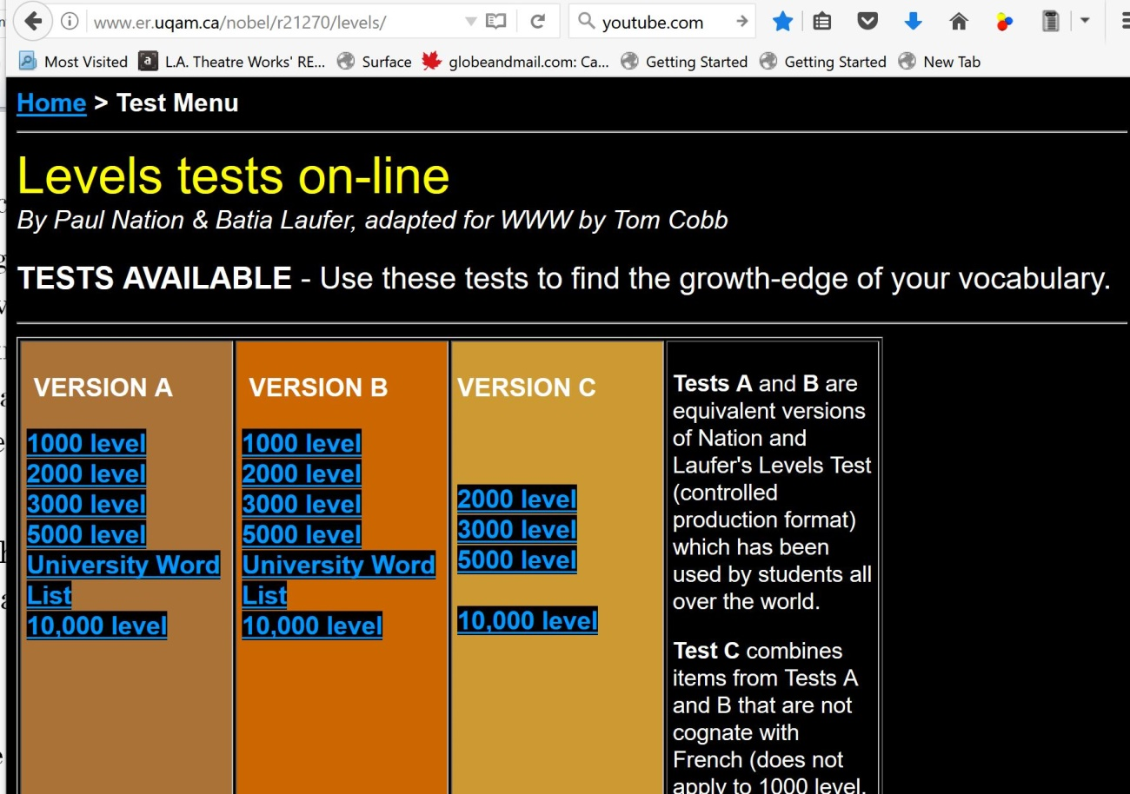
Figure 2#: Vocabulary Knowledge Test

Figure 3# shows where the students’ scores will appear. Again, it is in bottom lefthand corner.
I will provide you with copies of the reading speed test, either at the 1,000 or the 2,000 word level, as appropriate for your students. Hand the papers out and keep them face down. Students should put their names on the back of the papers.

Put a large 0 on the blackboard which will serve as your counter. Tell the students that they are to record the time when they are finished reading and have answered all the 10 questions after the reading. They should put their time score and their name on the front page.

Give the command for the students to start reading and answering the questions.
Figure 4# Finding Students’ Scores
Change the score every 10 seconds, slowly raising it. Students who have stopped must not talk or make noise to disturb the other students. Once all the students have finished test, collect all the test papers. The control groups are now finished. The experimental groups will continue with the Xreading trial.

I.(b) IX.(b) Students Registering for the Course
Students join the class by purchasing a six-month or year access card from the school bookstore. On the back of the access card are directions in both English and Japanese (See Figure 47#). Also, there is a tutorial available on the website itself under the Information tab explaining how they join a class.
Figure 5#: Student Access Card

Xreading: Creating a Class
Once you have logged into the xreading.com site, you will need to create a class.
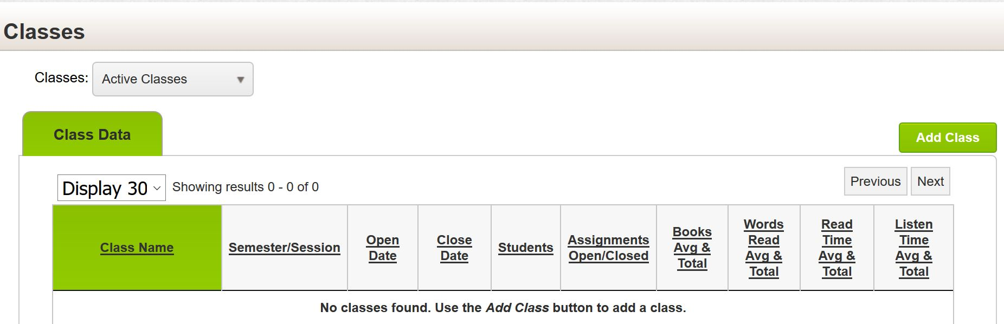
Figure 6#: Creating a class: Use the Add Class button.

In the same menu shown in Figure 5#, you input the date when the course begins and when it finishes in late July.

Students in the Integrated English Program or taking the Oral English 1 have been tested using the paper version of the ITP, the Institutional TOEFL Placement test. Their average score is 543 placing them as EFL students at the Upper Intermediate level. This suggests that they should be able to read books with a headword count of between 1501 and 2100. A headword is word related to a group of words with similar meanings (ie. work, works, workers, working, worked).

However, this is an averaged score, so we are asking teachers to restrict the readers at the elementary level (ie. those with headwords from 301-800) on their class settings for Xreading. as in Figure 7#.

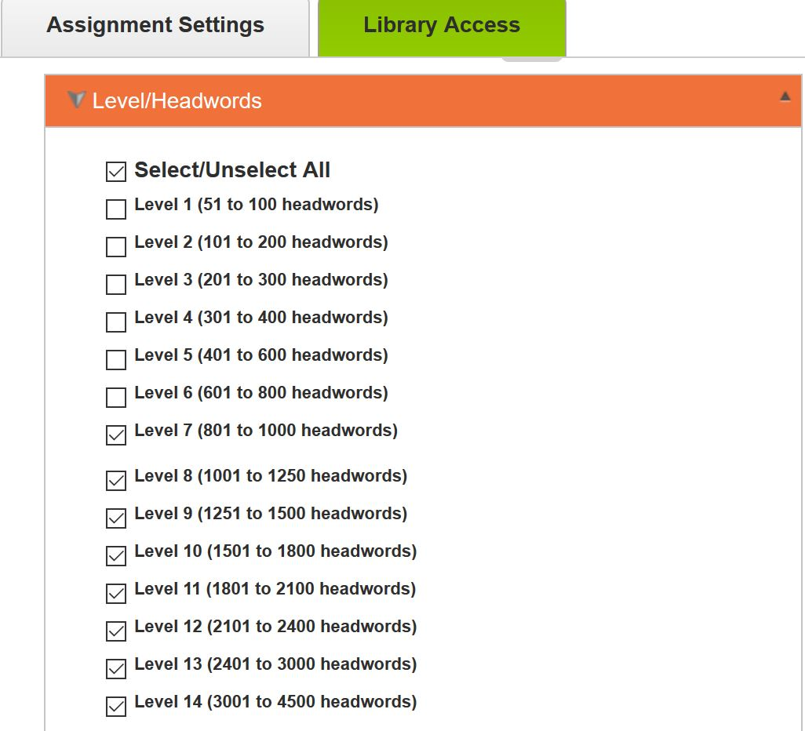
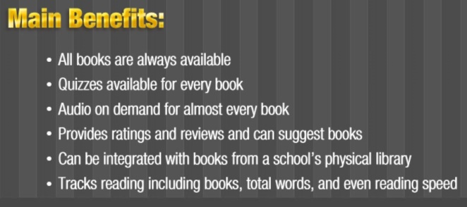
Figure 7#: Settings for Each Class and List of Publishers of the Readers
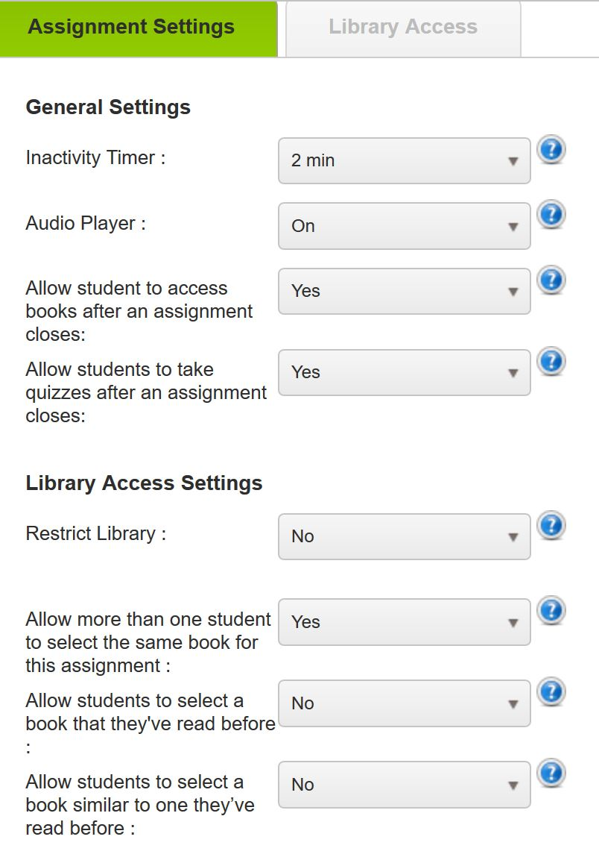
Figure 8#: Assignment Settings and Viewing a Graded Reader on Multiple Devices

In Figure 8#, you can see another setting “inactivity” which means that if a student doesn’t swipe his phone or tablet to turn the page, the system will become inactive. Other settings mean that the audio player is enabled and students can listen to the book being read, that more than one student can read the same book, and that students can take quizzes any time after reading a book.

The following chart is an overview of reading levels (http://erfoundation.org/wordpress/graded-readers/erf-graded-reader-scale/). The levels on the scale were made by an analysis of hundreds of graded readers. It ranges from knowing the alphabet to near-native ability (ie. 18,000 headwords).

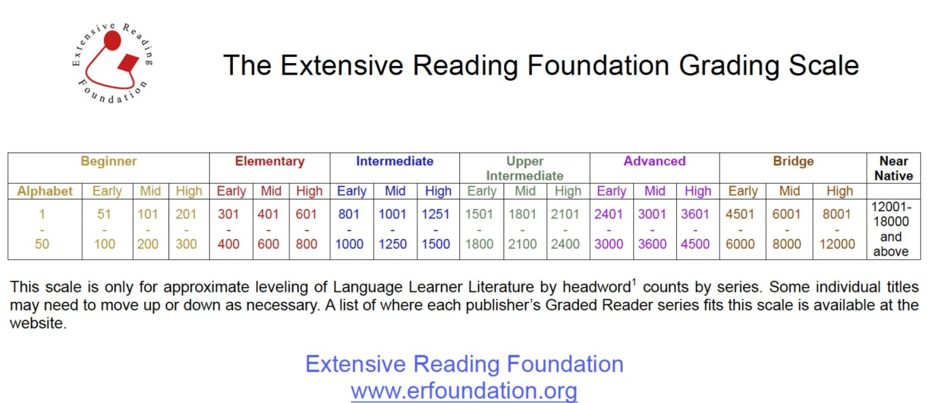
Figure 9#: ERF Grading Scale.

In the 1st class, you should have your students try reading a few books at different levels in order to find the appropriate level for them. The following chart will help them as well because when using a graded reader, a student should be able to comprehend almost every word on the page. Some researchers put the figure anywhere from 95% to 98%.

As they read, they should ask themselves these questions.
- Can I read it without a dictionary?
- Am I reading it quickly?
- Do I understand almost everything? (Over 95%)
If the answer is yes to each of these questions, then that book is their level or they could try a higher level. If the answer is no to even one of the questions, then they should go down levels until they have 3 yes answers.
It is important to explain the purpose of extensive reading and how they are supposed to read for speed, and not to look words in a dictionary, for example. A very conservative estimate of their reading speed is that each student is able to read a minimum of 100 words per minute at present.

I.(c) Weekly Book Talks and Ratings
Therefore, with 15 minutes of class time set aside for OE 2 and IE 3 students to read, and an additional 45 minutes of reading for homework, students should be reading about 6,000 words per week, some 84,000 words over 14 weeks. Certainly, on the first few times that students use Xreading, you should make the rounds and ensure that all the students understand how to use Xreading and that they are engaged in reading and not texting or reading e-mails. Afterward, try to do some reading online, too..

But in order to achieve this goal, you will need to monitor the students and mention how the best are doing and to try to develop a competition between students. As noted elsewhere in this guide, achieving 84,000 words would entitle a student to a 75% or B score for this part of their grade; 100,000 is the minimum for 80%; 120,000 is the minimum for 90% as well as in the top 10% of class readers.

As a further encouragement to student readers, you should set aside 15 minutes every class for students in groups of three and four to meet and discuss the books that they are currently reading. Each week, the students should form different groups. Once the 15 minutes has finished, use a projector to display the following potential questions about a reading. Give the students a few minutes to think of what question or questions they would like to address when describing their book to partners.

I. RESPONDING TO THE PLOT (Without telling the ending of the book):
a) If you were a character in the story, what would you do differently?
b) If you were the author, what would you change in the book?
c) Is there a character especially inspiring, depressing or even frightening? Explain why.
d) Which incidents in the novel did you find wonderful, surprising, comical, or even shocking?
f) Are there any parts of the plot that you found too predictable or unbelievable? Why?
g) How did what you expect to happen in the book compare with what actually happened?

II. REFLECTING ON THE STORY (Without telling the ending of the book):
a) How does the character’s life compare to your own?
b) How does the environment in the story compare to that in your own country?
c) If the book has been made into a film, how would you compare the film with the book?
d) If you have read another of the author’s books, how does this one compare?
e) How does this book compare to books with a similar theme?
f) Do you agree or disagree with the author’s view of people and life? Support your opinion.
h) What is something you learned from the story?
i) Have you changed your ideas about anything after reading this book?

I.(d) Teachers’ Weekly Observations
In order to assess both the potential value of Xreading to our students and to determine the obstacles to implementing it effectively, we are asking teachers in the trial to make weekly observations on student use of Xreading. These observations potentially will form part of an article for the English Department journal as well as for two presentations at local conferences.

Therefore, at the same time each week, after classes, we are asking teachers in the Xreading trial to make notes about how students responded to using Xreading in class, and also to monitor students’ progress in terms of words read per minute, total time spent on reading, and books read. This observation should take the form of two descriptive paragraphs, perhaps with the names of students who are doing particularly well or badly (these names will later be redacted and pseudonyms take their place). The paragraphs should also contain some observations about what the teacher will do in the next class to improve the students’ utilization of Xreading, and how to help individual students with their learning. These teachers’ notes will serve as data for their part of any future presentation or article.

Finally, if we go ahead with introducing Xreading into the OE courses and into IE I and IE II Core classes, the teachers involved in this trial will help in its implementation and in mentoring other teachers. Further questions to include in weekly observations may be drawn from the following:

- What are the chief obstacles to student use of Xreading?
- What overview would you make of Xreading?
- How would you describe student engagement with Xreading?
- How are you trying to encourage competition between students and student groups to get them to read more?
- What other inducements to engage with Xreading might work?
- What comments do you have about Xreading software?

