2018 Active Listening
Scope and Sequence
Improving students’ listening comprehension is a difficult challenge. First of all, improvement occurs over long periods of time and through extensive exposure to the target language. Secondly, some listening classes in the Integrated English Program have as many as 30 students, so it is difficult to organize a class. A third challenge is to maintain student interest in extensive listening over a term.
Needs analyses were undertaken on earlier versions of this listening course. These involved large scale student surveys and interviews. Students responded that they were unhappy with activities in which they were passive learners and they sought more choice in their listening and more individualized instruction.
In 2009, we introduced a new course based on blended instruction that combined traditional instruction with new technologies such as streaming video on the Internet, and access to self-access with the reallyenglish website. At the same time, we tried to make listening more interactive through requiring students to undertake tasks that integrated listening to materials from the Internet with writing and speaking. This was behind our very popular listening “interactions.”
In 2017, recognizing that some students are finding three semesters of reallyenglish to be tedious, we introduced EnglishCentral into IE 3 Active Listening. This program offers short video sequences, vocabulary work, and speaking practice through voice recognition software, and spaced retrieval to remind students of words that they have forgotten. See the Appendix 6, (p.50) for more details on it.
This teacher guide was prepared by Gregory Strong and Joseph Dias with material from Kazuko Namba, and Keiko Inouye and suggestions from other listening teachers. (15 March 2018).

- Course Objectives …………………………………………...3
- Breakdown of Grades ……………………………………...9
A Sample Lesson Plan ………………..…….…….……...10
- Interactions and write-ups ……………..……………..14
- Teaching IE 3 Presentation Skills ………….…..……20
- Appendixes
- Sample Course Outlines ….………………………….25
- Sample Student Interaction Questions ……….32
- Sample Student Listening Reports ………………….35
- Sample Movie Listening Log …………………………..37
- reallyenglish Information
a) Issuing registration keys …………………………….39
b) Program features ……………………………………….55
IX. EnglishCentral Overview …………………………………58

Active Listening 1 | Active Listening 2 | Active Listening 3
Themes:  Memories & Childhood, Urban Life, Food, Travel | Themes:  Changing Times & Technology, Workplace, Autobiography, Geography | Themes:  Psychology & Relationships, Intercultural Communication, Environment & Living Spaces, Media
Tasks:  30-34 units (80%); 35-39 (90%); 40-45 units (100%)reallyenglish  4 listening reports  3 Interactions (large classes do 2 and 1 extra report) | Tasks:  30-39 units (80%); 40-49 units (90%); 50 units or more (100%) reallyenglish  4 listening reports  3 Interactions (large classes do 2 and 1 extra report) | Tasks:  60 videos watched, learn 840 words learned, and 70 lines spoken (80%) EnglishCentral  4 videos watched weekly; 40 lines spoken, 80 vocabulary words read  5 listening reports  2 Interactions  Group presentation task (large classes do 1 Interaction and 1 presentation and 1 extra report)

Course Objectives for IE Active Listening Levels 1, 2, 3
- Through exposure to authentic listening materials on the Internet and to the interviews and features on Summit TV, students will learn vocabulary, idioms, and conversational styles of speakers of English.
- Through participating in “Interactions,” students will improve their abilities at small group discussion including the use of eye contact, gestures, questioning, and follow-up questions.
- Through making question sheets for the “Interactions,” students will become more aware of the value of pre-listening and post-listening strategies in developing listening comprehension
- Through listening tasks such as making oral and written reports on high interest audio downloads at websites and through listening to contemporary movies, students will improve their language skills and become more familiar with the APA style for citations.
- Through lessons at reallyenglish in IE Level 1 and 2, students work on listening units to improve their comprehension and test-taking skills.
- Through exposure to a variety of listening genres – interviews, news features, narratives, and drama, students will learn some features of genre from each.
- Through varied activities in a single class, and a different tasks over the term, teachers will create an active classroom and sustain student interest.
- In IE Level 3, students using the videos on the EnglishCentral website, students will improve their listening to a variety of materials, including commercials, news items, and speeches.
- Also, in IE Level 3, students in groups will create a presentation that demonstrates a coordinated group effort, introductions, effective visuals, use of eye contact, and fluent speech (without reading).

IE 1 Active Listening
 | Memories Childhood | Urban Life | Food | Travel
(A) IN-CLASS  Supplementary materials can be drawn from the old IE Listening Program | SUMMIT TV 1-1#: On-the-Street: “How Would You Describe Yourself?”  SUMMIT TV 2-1#: On-the-Street: “Dreams and Goals”,  SUMMIT TV 1-8#: Short Documentary: “Being a Better Parent (Discipline), | SUMMIT TV 1-5#: On-the-Street: “How Do You Feel About Living in the Suburbs?”  SUMMIT TV 2-4#: Short Documentary: “Handling Anger” | REAL TALK: “John Robbins: Diet for a New America” (For the video and questions, see: http://www.aogaku-daku.org/diet-health-and-the-evironment/) | SUMMIT TV 2-6#: Short Documentary: “Air Travel: Travelers Beware!”
(B)INTERACTIONS  Homework/in class—choose 3 | INTERACTION: Introduce a favorite song on YouTube to some classmates | INTERACTION: Report on a news item on a social issue | INTERACTION: Find the best unusual recipe to share with some classmates | INTERACTION: Choose a city and present a weekend itinerary
C) TEACHER-MONITORED SELF ACCESS  Homework | Course completion is set at 30 units (an 80% grade). This part of the course is homework. In order to keep up with the class, students get a point (perhaps for participation) for meeting weekly deadlines of 1 unit, and by finishing 8 units by the fourth week of the course, 12 units by the 8th week, and 16 units by the 12th week. The teacher should prepare screenshots/printouts of each weekly deadline and in class show students their relative progress or lack of progress. |  |  |  | 40-45 units  35-39 units  30-34 units  20-24 units  25-29 units | 100%  90%  80%  70%  60%
(D) SELF-DIRECTED LISTENING  Homework | Students should complete 4 reports (or 2 reports and 1 movie listening log). In large classes (over 25) students only do 2 interactions, and do 5 reports. For every assignment, whether movie or report, students note the listening site or movie according to the APA style. Each listening report should relate to a theme in IE 1 Active Listening: memories-childhood, urban life, food, and travel.  Stone, C. (Director). (2007). How to remember people’s names [Online video clip]. Video Jug.com. 10 March 2016. Retrieved from <https://www.youtube.com/watch?v=7Q74cJtVpkA>. [Access it from YouTube.]
Participation marks are for attendance, completing reallyenglish units, vocabulary tests, in-class effort. Please note that the units for reallyenglish must be finished by the last class.

IE 2 Active Listening
 | Changing Times & Technology | Workplace | Autobiography | Geography
(A) IN-CLASS Supplementary materials can be drawn from old the IE Listening Program | SUMMIT TV 2-9#: On-the-Street: New Technology  “The problem’s not with the technology” | SUMMIT TV 1-3#: On-the-Street: “Saving Money”  SUMMIT TV 1-10#: “Work and Leisure” | SUMMIT TV 2-3#: On-the-Street: “Frightening Experiences”,  SUMMIT TV 1-2#: Short Documentary: “Beck, Musician”  REAL TALK: Cornel West | SUMMIT TV 2-2#: Short Documentary: “Dr. Torstveit’s Vacation”  REAL TALK: Oxford RAs
(B)INTERACTIONS  Choose 3/4  Homework | INTERACTION: Introduce the funniest/best commercial (Note in APA Style) | INTERACTION: Explain how to write a resume, find a job, take an interview, etc. (Note in APA Style) | INTERACTION: Celebrate a hero  (Note in APA Style) | INTERACTION: Describe an example of Human Population, Cultural Geography, etc. (Note in APA Style)
C) TEACHER-MONITORED SELF ACCESS  Homework | Course completion is set at 30 units (an 80% grade); for a 50% or a pass, students must complete 15-19 units; 10-14 units is 40%; 5-10 units is 30%; 3-5units is 20$; below this is a failure. This part of the course should be done as homework. Students get a point (perhaps for participation) for meeting weekly deadlines of 1 unit, and by finishing 8 units by the fourth week of the course, 12 units by the 8th week, and 16 units by the 12th week. You should prepare screenshots/printouts of each weekly deadline and in class show students their relative progress or lack of progress. |  |  |  | 50- units  40-49 units  30-39 units  25-29 units  20-24 units | 100%  90%  80%  70%  60%
(D) SELF-DIRECTED LISTENING  Homework | Students should complete 4 reports (or 2 reports and 1 movie listening log). In large classes (over 25) where students are only doing 2 interactions, they should do 5 reports. For every assignment, whether movie or report, students should note the listening site or movie according to the APA style. Each listening report should relate to one of the themes in IE 2 Active Listening: changing times-technology, workplace, autobiography, geography.  Stone, C. (Director). (2007). How to remember people’s names [Online video clip]. Video Jug.com. 10 March 2016. Retrieved from <https://www.youtube.com/watch?v=7Q74cJtVpkA>. [Access it from YouTube.]
Participation marks are for attendance, completing reallyenglish units, vocabulary tests, in-class effort. Please note that the units for reallyenglish must be finished by the last class.

IE 3 Active Listening
 | Psychology &  Relationships | Intercultural Communication | Environment & Living spaces | Media
(A) IN-CLASS  Supplementary materials can be drawn from the old IE Listening Program | SUMMIT TV 2-7#: On-the-Street: “Strengths and Weaknesses: I’m Really Good At…”, SUMMIT TV 2-5#: On-the-Street: “Phobias and Superstitions”, SUMMIT TV 1-4#: Short Documentary: “Selling Them Short” | SUMMIT TV 2-8#: Short Documentary: “The Simpsons” | SUMMIT TV 2-10#: Short Documentary: “The Ndoki Rain Forest” | SUMMIT TV 1-7#: On-the-Street: Advertising:  “I think there’s too much”;  SUMMIT TV 1-9#: On-the-Street: News: “I don’t believe everything I read”  REAL TALK: Philippe, a Photographer in Japan
(B) STUDENT PROJECTS  Choose 3/4  Homework | INTERACTION: Describe a self-help video after a search on YouTube, ie. the “video jug channel,” then choose one  on becoming more confident, etc. | PRESENTATION: Introduce a video on an aspect of intercultural communications. | PRESENTATION: Prepare an environmental brief “for action” on an environmental problem. | INTERACTION: Introduce an English movie trailer at imdb.com or YouTube and ask questions of the group
C) TEACHER-MONITORED SELF ACCESS  Homework | For an 80% mark on this part of the course, students need to complete 4 videos, speak 40 lines, and study 80 vocabulary words each week on EnglishCentral for a total of 60 videos, 600 lines, and 840 vocabulary words. If students have 2/3 of this, ie. 70 videos, 500 lines, and 1,500 words, then they should drop 5%; 1/3, then they drop 10%. This part of the course is done for homework. To encourage the students, please track their weekly progress and give them an extra point for participation, if they achieve their weekly progress. |  |  |  | 80; 680; 1,000  70; 640; 920  60; 600; 840  50; 560; 760  40; 520; 680 | 100%  90%  80%  70%  60%
(D) SELF-DIRECTED LISTENING  Homework | Students should complete 5 reports (or 3 reports and 1 movie listening log). In large classes (over 25) where students are only doing 1 interaction, and 1 presentation, and they should do 6 reports. The teacher should prepare screenshots/printouts of each weekly deadline and in class show students their relative progress or lack of progress. For every assignment, whether movie or report, students should note the listening site or movie according to the AP style.  Stone, C. (Director). (2007). How to remember people’s names [Online video clip]. Video Jug.com. 10 March 2016. Retrieved from <https://www.youtube.com/watch?v=7Q74cJtVpkA>. [Access from YouTube.]

Participation marks will be given in class for attendance, completing the weekly targets for EnglishCentral, and in-class effort.
IE 3 TRANSFER Active Listening
 | Psychology/ Relationships | Intercultural Communication | Environment/ Living spaces | Media
(A) IN-CLASS  Supplementary materials can be drawn from the IE Listening Program | SUMMIT TV 2-7#: On-the-Street: “Strengths and Weaknesses: I’m Really Good At…”, SUMMIT TV 2-5#: On-the-Street: “Phobias and Superstitions”, SUMMIT TV 1-4#: Short Documentary: “Selling Them Short” | SUMMIT TV 2-8#: Short Documentary: “The Simpsons” | SUMMIT TV 2-10#: Short Documentary: “The Ndoki Rain Forest” | SUMMIT TV 1-7#: On-the-Street: Advertising:  “I think there’s too much”;  SUMMIT TV 1-9#: On-the-Street: News Sources: “I don’t believe everything I read”  REAL TALK: Philippe, a Photographer in Japan
(B) STUDENT PROJECTS  2 Interactions  1 Presentation | INTERACTION: Describe a self-help video after a search on YouTube, ie. the “video jug channel,” then choose one on becoming more confident, etc. | PRESENTATION: Introduce a video on an aspect of intercultural communications (Note in APA Style) | INTERACTION: Introduce an English movie trailer and assign questions to the group (Note in APA Style) | PRESENTATION: Prepare an environmental brief “for action” on an environmental problem (Note in APA Style)
C) TEACHER-MONITORED SELF ACCESS  Homework | For an 80% mark on this part of the course, students need to complete 5 videos, speak 50 lines, and study 100 vocabulary words each week on EnglishCentral for a total of 70 videos, 750 lines, and 1,500 vocabulary words. If students have 2/3 of this, ie. 70 videos, 500 lines, and 1,500 words, then they should drop 5%; 1/3, then they drop 10%. This part of the course is done for homework. To encourage the students, please track their weekly progress and give them an extra point for participation, if they achieve their weekly progress. |  |  |  | 90; 950; 1,900  80; 850; 1,700  70; 750; 1,500  60; 650; 1,300  50; 550; 1,100 | 100%  90%  80%  70%  60%
(D) SELF-DIRECTED LISTENING  Homework | Students should complete 5 reports (or 3 reports and 1 movie listening log). For every assignment, whether movie or listening report, students should note the listening site or movie according to the APA style. Each listening report should relate to one of the themes in IE 3 Active Listening: psychology-relationships, intercultural communication, environment-living spaces, media. A sample of APA Style:  Stone, C. (Director). (2007). How to remember people’s names [Online video clip]. Video Jug.com. 10 March 2016. Retrieved from <https://www.youtube.com/watch?v=7Q74cJtVpkA>. [Access from YouTube.]
Participation marks will be given in class for attendance, completing the weekly targets for EnglishCentral, and in-class effort.
Breakdown of the total grades for AL 1:
(B) STUDENT PROJECTS - 3 INTERACTIONS (Only 2 INTERACTIONS in large classes) | 30%
(C) TEACHER-MONITORED SELF ACCESS (30 units for 80%) | 25%
(D) SELF-DIRECTED LISTENING | 20%
Participation (completing reallyenglish on schedule, vocabulary quizzes) | 5%
IE Listening Final Test | 20%
Breakdown of the total grades for AL 2:
(B) STUDENT PROJECTS - 3 INTERACTIONS (Only 2 INTERACTIONS in large classes) | 30%
(C) TEACHER-MONITORED SELF ACCESS (30 units for 80%) | 25%
(D) SELF-DIRECTED LISTENING | 20%
Participation (completing reallyenglish on schedule, vocabulary quizzes) | 5%
IE Listening Final Test | 20%
Breakdown of the total grades for AL 3 and AL 3:
(B) STUDENT PROJECTS - 2 INTERACTIONS (Only 1 INTERACTION in large classes) | 20%
(B) STUDENT PROJECTS – PRESENTATION | 15%
(C) TEACHER-MONITORED SELF ACCESS (60 videos; 750 lines, 840 words for 80%) | 20%
(D) SELF-DIRECTED LISTENING | 20%
Participation (completing englishcentral on schedule, vocabulary quizzes) | 5%
IE Listening Final Test | 20%
In the Active Listening courses, students will not be given marks for attendance. Students should be attending classes and participating in them. Instead, students will lose marks if they are absent from class without a legitimate excuse. Legitimate excuses consist of serious illnesses (with a doctor’s note), or family-related absences such as attending a funeral. Please warn students of this policy in the first class and identify students who begin to show a pattern of absences and tardiness and warn them appropriately. Remind them also that they must pass all three IE courses to obtain credit for IE Level 1, 2, or 3.
Deducting Marks for Absences
Absences | Maximum Grade
1 | * No effect on grade
2 | Final grade cannot exceed 89%
3 | Final grade cannot exceed 79%
4 | Final grade cannot exceed 69%
5 or more | Fail (unless legitimate absences)

A Plan for the First 2 Classes of IE Active Listening 1, 2, or 3
Class | Lesson | Homework
1 | - Course outline, description of the 4 components: A, B, C, D, participation, and the final test.  --In advance of the class, print out registration keys for your students – generate 10-20 extras for the numbers.  This precaution is for those numbers that don’t work or to re-register students who forget their keys, etc. Direct the students to register at https://ac.reallyenglish.com/aoyama/register  Then students will have to create an identity and a password – have them write these down (and e-mail them to their e-mails, or even send you a record of them because some students always seem to forget their passwords). Have students log-in to the reallyenglish website. Show them how to to trouble-shoot log-in problems through using the FAQs and each student’s “My Page”. Use the exact URL or you will not be able to login.  Direct students to take the reallyenglish assessment test. Afterward, the website will generate an for each student. Unless you are teaching an IE 3 Active Listening class for returnees, tell the students to do 80% of the listening units rather than reading or another type.  -Make sure that every student in the class has taken the test and logged onto the website to try a lesson.  - Allow 15 min of class time for students to work on a reallyenglish unit. Ensure that all students have registered and know how to use the FAQs and “My Page”. Use this time to assist students having trouble logging in, etc.  Help students to log-in to EnglishCentral. Direct students to take the Vocabulary Levels Test. Once they have done this, Their results will suggest a level of vocabulary unit to study (from 1-7). The vocabulary units consist of the core vocabulary list (more commonly used words) or academic vocabulary (for students of higher language ability). Students In class, have the students try a bit of each of the three different parts of the lesson – the listening part, then speaking the lines from the unit, and finally studying the 100 words. Assign them the homework of listening to 5 videos per week, speaking 50 lines, and learning 100 words.  - Describe how an INTERACTION (B) will be done. (Refer to the Appendix to find the websites and instructions for Internet resources for the video sequences). Ask students to pick 3 possible videos from the website(s). | (C) log-in to reallyenglish, begin units  (B) work on INTERACTION
  IE 1 and IE 2: Reallyenglish
  IE 3: EnglishCentral
2 | - Allow 15 min of class time for students to work on a reallyenglish unit. Use this time to assist students who have lost their password or to help any students who missed the first class and need to log on and take the test.  - For the INTERACTIONS, circulate a sign-up list for dates and topics (do not allow students to choose the same ones). INTERACTIONS which should start in 2 weeks.  - Show the list of language learning websites (D) and the report form and explain these. Set due dates for each report.  - IN-CLASS, Summit TV lesson (A) in remaining class time | (A), (B), (C), (D)
A Plan for the First Class of IE Active Listening 3
Class | Lesson | Homework
1 | - Course outline, description of the 4 components: A, B, C, D, participation, and the final test.  - Assist students to log-in to your class URL at the EnglishCentral website and demonstrate how they do a video unit. Take the class through one video together and do the “Watch,” “Learn,” and “Speak” stages. Then demonstrate how they can monitor their progress. Explain how you will be able to monitor their progress as well and set the target of 5 videos each week. | C) log-in to EnglishCentral, listen to 5 videos  (B) work on INTERACTION

Written assignments:
Students should format their papers to 12-point Times New Roman at 26 lines per page. In addition, they must put a page number and the title of the writing assignment in the upper right corner of the document
The following diagram shows how to change the line spacing in the Japanese version of MS Word. All of the university laptops come loaded with this program, so this should be easy for you to show to your students.
In addition, the students must put a page number and the title of the writing assignment in the upper right corner of the document. They need to put their name and student number on the first page.
This will be particularly important to show to freshman students in the Spring semester. An explanation of this can also be found on page 70 of the students’ IE Core and Writing booklet.

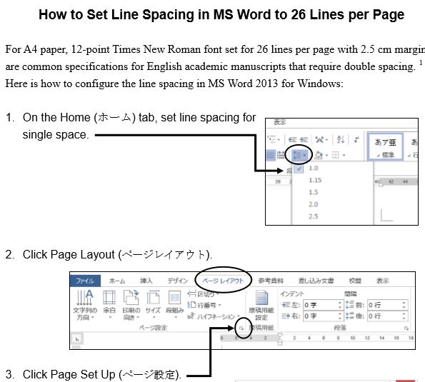

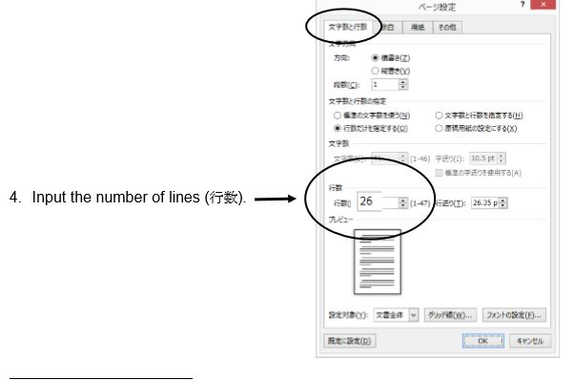
Student “Interactions”:
To do an interaction, each student leader must find an online video suitable to the unit theme. They are supposed to listen to it a number of times, making notes to prepare a question sheet for their classmates.

You need to provide a short demonstration in class of using an online website. Please note that students can activate a closed caption (cc) function on many YouTube videos. As in the following example, the boxed cc in the lower righthand corner means that captioning is available. The screenshot shows the sequence with captioning function operating.
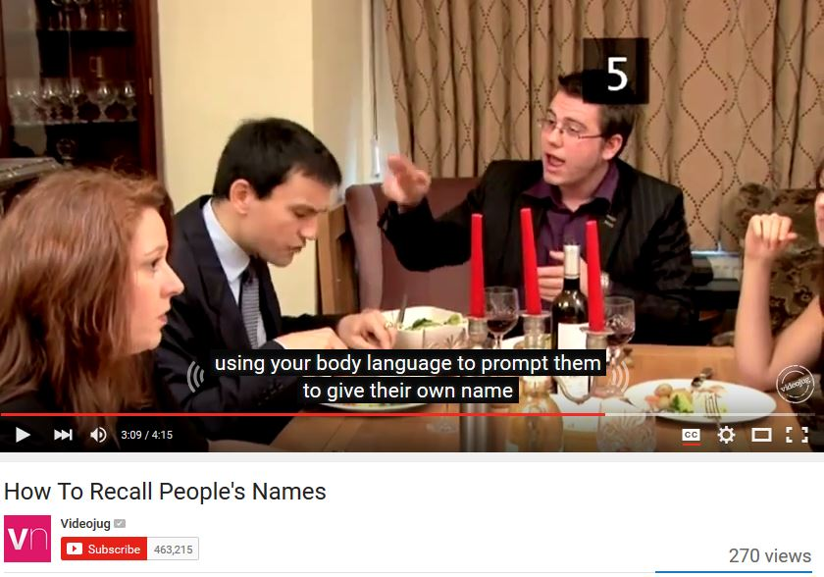
Student “Interactions” Question Sheet:
After note-taking on the video, students must create a question sheet to assist them in doing the Interaction and as a record of their work. Later, the teacher collects the question sheet and marks it. The question sheet should follow the format of this example.

Pre-Listening Questions:
Stone, C. (Director). (2007). How to remember people’s names [Online video clip]. Video Jug.com. 10 March 2016. Retrieved from <https://www.youtube.com/watch?v=7Q74cJtVpkA>.   | NAME _____________  NUMBER __________
- How do you remember people’s names?
- What do you do when you cannot remember the name of the person you meet?
- What methods do you use to remember names?

Key Vocabulary Words
- Repetition- the act of repeating
- Ludicrous- causing laughter because of absurdity; ridiculous.
- Distinguish- to mark off as different
- Discreet- show judgment in ones conduct or speech
- Cement it- memorizing it, glue on to your brain

Get Some Skills
Shock, ________, their names has completely disappeared from their memory. Repetition. Repetition. Repetition. The _________ is to do this without noticing. Association. During your first conversation, subtly study their ________ and __________, paying particular attention to any distinguishing features. Find a rhyme. Alternatively, try making a _________ rhyme out of their name. However, no-one is perfect, and if you find yourself unable to remember a name, don't fret. ___________ has the answers.
Post Listening Questions
- How effective is association for you?
- What did you think about using ludicrous rhymes?
- What do you do when all else fails and you can’t remember a name?

Interactions Leader’s Opinion – In a paragraph describe your opinion of the clip. Think of the following points: Why did you choose it? What do you think of the clip? How easy was it to understand?

Each student needs to show where the material comes from (using the APA Style), and to create pre-listening questions, key vocabulary words, the “get some skills” section, post-listening questions, and finally, a paragraph describing their opinion of the video clip.
To get students to properly cite their material, you need to show them the format in the question sheet. In addition, you should show them one of two online websites (easybib.com and son of citation).
These websites help you to create citations, even websites and media.
[This website, the more sophisticated of the two, allows you to add/delete URLs, date of publication, etc.] http://www.easybib.com/
http://www.citationmachine.net/apa/cite-a-film/manual
[The iPad version cuts out the ads] (iPad) http://tinyurl.com/cm-mla

Following your earlier demonstration of finding an online video, ask each student in class to find a video themselves and to create an APA reference for it using the Son of Citation website. DO THIS IN YOUR FIRST CLASS so that you can walk among the students and guide them through the activity. They can check one another’s work as well. Do not depend on the students IE Core or IE Writing teacher to do this. They will likely tell the students of the website, but these teachers do not have a CALL classroom where the teacher can demonstrate and supervise students using the website to create APA style references. We are counting on IE Listening teachers like you to show students how to do this.

The students just input the information and choose APA.
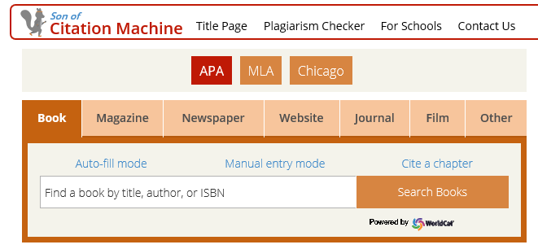
Now you choose the correct media. Enter the information as prompted. The following is the Diane Rehms show, “Friday news roundup” on National Public Radio.
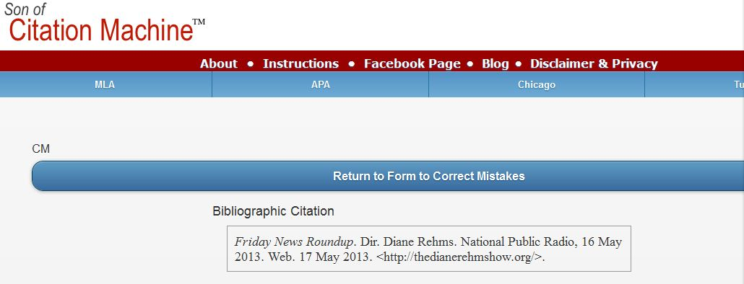

Remind the students to indent the second line of the entry:
Rehms, D. (2016). Friday news roundup. [audio clip]. National Public Radio.com,
16 May 2013. Retrieved from Web. 17 <http://thedianerehmshow.org/>.
Organizing “Interactions” in class (See Appendix)
- Form groups of 4 or 5 students; 6 or 7 in a class of 24; 10 groups of 4 or 5 students in a large class. All the students should log onto a computer.
- Ask one INTERACTION leader to go to each group. The leader logs into a computer. The leader tells the group members to go to the site. He or she asks some pre-listening questions/introduces the topic.
- The leader asks each group member to play the video on the site and to listen to it. The group also does some listening questions.
- Depending on how difficult the group finds the video, and the level of the listening class, the leader may re-play the video 2 or 3 times.
- After the group has listened to it, the leader asks some post-listening questions.
- The INTERACTION leader moves to another group and logs onto a pc.

Interactions: Oral and Written Checklists
INTERACTION oral checklist

Student | Date
Topic |  | Score
1. Used appropriate eye contact and gestures with the group

2. Avoided reading, and spoke clearly and enthusiastically

3. Kept the group using English for the whole INTERACTION

4. Asked good questions and used follow-up questions

5. Kept the group focused on their work on the INTERACTION

INTERACTION written work checklist

Student | Date
Topic |  | Score/10
1. Noted the url, date, etc. for video (APA style), pre-listening questions

2. Included at least 5 key words and definitions

3. Made a paragraph summary or summary with questions of the video clip

4. Created during-listening, and post-listening questions

5. Handed in a typed, well-presented written report

Teaching IE 3 Presentation Skills
- 1st class HW
- Introduce self --produce a transcript of
- Choose emcee the video
- Teacher provides list of Internet
sites on the Internet
- Select video

- 2nd class
- Choose graphics HW
- Devise survey questions --prepare note-cards at
and listening questions home
- Decide on the recommendations

- 3rd class HW
- Show the class the marking criteria -- students practice at
- Finish preparations home; time their work
- Groups all practice in pairs of students

- Presentation Day
- Remind them of the marking criteria
IE 3: A Simple Rating Scale for the Presentation
GROUP PRESENTATION (10 points)

Students: |  | Date | A | B | C | D | E
Topic:

Non-Verbal  /2 points | 1. Good posture, appropriate eye contact with  audience. Gestures such as pointing to the slides or  visuals.
Fluency  /2 points | 2. Spoke fluently, and confidently, referring to note  cards only occasionally. Used a clear and attractive  tone of voice with few pronunciation errors.
Materials  /2 points | 3. Chose pictures, slides, and other visual aids well.
Content  /2 points | 4. Details such as names, numbers, and other  description details were provided. Used several transitions, such as “first of all,” “another,” “next,” or “in comparison,” “for example,” etc.
Framework  /2 points | 5. Had a self-introduction providing the student’s  name, and topic, and the student’s partners. The  conclusion had a short summary and a closing  remark about the topic.
Comments: (Possible Group score) /10 |  |  | Final Scores  /10

IE 3: A Peer Review form for the Presentation
Peer Review for Presentation
Reviewers
Date
Group No.
Title
Good Points
Constructive advice
What have you learned?

IE 3: Peer Outlines and Rankings for the Presentation
Presentation Outlines (IE) Name _____________________________
During the presentation, take notes and make an outline. This will be collected.
name/ group | Outline and Note-taking

☆_______________ is the best because _______________________________________
Appendix 1(a): SAMPLE COURSE OUTLINES
IE 1 Active Listening: Teacher: Taro Aoyama (taro@gmail.com)
 | Memories Childhood | Urban Life | Food | Travel
(A) IN-CLASS  Supplementary materials can be drawn from the old IE Listening Program | SUMMIT TV 1-1#: On-the-Street: “How Would You Describe Yourself?”  SUMMIT TV 2-1#: On-the-Street: “Dreams and Goals”,  SUMMIT TV 1-8#: Short Documentary: “Being a Better Parent (Discipline),  REAL TALK:  Duffy, music | SUMMIT TV 1-5#: On-the-Street: “How Do You Feel About Living in the Suburbs?”  SUMMIT TV 2-4#: Short Documentary: “Handling Anger” | REAL TALK: Robbins & Vegetarians | SUMMIT TV 2-6#: Short Documentary: “Air Travel: Travelers Beware!”
 | INTERACTION: Introduce a favorite song on YouTube to some classmates (Note in APA Style; below) | INTERACTION: Report on a news item on a social issue (Note in APA Style) | INTERACTION: Find the best unusual recipe to share with some classmates (Note in APA Style) | INTERACTION: Choose a city and present a weekend itinerary (Note in APA Style)
C) TEACHER-MONITORED SELF ACCESS  Homework | Course completion is set at 30 units (an 80% grade); for a 50% or a pass, students must complete 15-19 units; 10-14 units is 40%; 5-10 units is 30%; 3-5units is 20$; below this is a failure. This part of the course should be done as homework. Students get a point (perhaps for participation) for meeting weekly deadlines of 1 unit, and by finishing 8 units by the fourth week of the course, 12 units by the 8th week, and 16 units by the 12th week. You should prepare screenshots/printouts of each weekly deadline and in class show students their relative progress or lack of progress. |  |  |  | 50- units  40-49 units  30-39 units  25-29 units  20-24 units | 100%  90%  80%  70%  60%
(D) SELF-DIRECTED LISTENING  Homework | Students should complete 4 reports (or 2 reports and 1 movie listening log). In large classes (over 25) where students are only doing 2 interactions, they should do 5 reports. For every assignment, whether movie or report, students should note the listening site or movie according to the APA style. Each listening report should relate to a theme in IE 1 Active Listening: memories-childhood, urban life, food, and travel.  Stone, C. (Director). (2007). How to remember people’s names [Online video clip]. Video Jug.com. 10 March 2016. Retrieved from <https://www.youtube.com/watch?v=7Q74cJtVpkA>. [Access it from YouTube.]
In IE I Active Listening, we will do 4 types of listening: (a) In-class, (b) Student projects (interactions, and presentations), (c) teacher-monitored self-access, (d) self-directed listening.
We will be covering 4 themes in the course which are the same themes as in the IE Writing, and IE Core sections.

Breakdown of Grades:
(B) Student Projects - 2 INTERACTIONS | 20%
(B) Student Projects – 1 PRESENTATION | 10%
(C) Teacher-Monitored Self Access (30 units) | 25%
(D) Self-Directed Listening | 25%
IE Listening Final Test: July 10th | 20%

Attendance Policy
Absences | Maximum Grade
1 | * No effect on grade
2 | Final grade cannot exceed 89
3 | Final grade cannot exceed 79
4 | Final grade cannot exceed 69
5 or more | Fail
3 lates = 1 absence

COURSE CALENDAR
April 12
19
26
May 10 | *8 units reallyenglish
17 | Interaction 1#
24 | Interaction 2#
31 | --3 Listening Reports due
June 7 | *16 units reallyenglish
14 | Interaction 2A#
21 | Interaction 2B#
28
July 5 | Presentations
12 | Presentations *25 units reallyenglish, last Listening Reports due
19 | TEST—course evaluations

Websites for Listening Reports
1. Randall's Cyber Listening Lab: www.esl-lab.com
2. BBC Learning English: www.bbc.co.uk/worldservice/learningenglish
3. CNN Video: edition.cnn.com/video/
4. Voice of America Special English: www.voanews.com/learningenglish
5. English Listening Lesson Library Online: www.elllo.org/
Appendix 1(b): IE 2 Active Listening Kazuko Namba
- Seating plan
Alphabetical order, groups of 4~6 students

- Attendance policy
*Absence: one absence---no effect, two absences---final grade cannot exceed 89 %, three absences--- final grade cannot exceed 79 %, four absences---final grade cannot exceed 69 %, five or more absences---fail
*Excused absences: participation on one of the university’s official teams, a serious sickness such as legally-designated infectious disease, or a family-related matter such as a funeral. The appropriate documentation is required.
*Tardiness: Three late arrivals (up to thirty minutes) will be considered as one absence. If you are late more than thirty minutes you will be marked as absent.
*Excused tardiness: With an official verification slip from the transport company which shows date and time, you wouldn’t be marked late (up to two times).

- Breakdown of grades
Interactions (oral part and written report)---30 %, Reallyenglish---25 %, Online listening reports---20 %, Participation---5 %, Final test---20 %

- Reallyenglish: 30 units, 9/14~1/15
*Diagnostic test: (If you haven’t taken it in Spring semester)
*Dead lines and score: 10/12---10 units, 11/16---20 units, 12/21---30 units, 1/15--- extra units; one point off for missing a deadline; Those who complete 30 units will be eligible for a 85% (21 points) with the top 10% of this group scoring 100% for this part of their grade (25 points).
*Section: More than 80 % of the total units (24 units) chosen from the Listening section. The rest can be chosen from Listening, Reading or Grammar.
*Level: Refer to your adaptive focus
*Reallyenglish app (smartphone)
5. Interactions (TED Talks, YouTube, etc.) : 9/21~1/11
Topics, groups, sign-up sheet, flash cards, written report ( APA style), oral checklist, written work checklist, 3~4-minute-video, use of blackboard

- Online listening reports (APA style) : 10/12~1/15
*Deadlines: 10/12---Report 1 (4 points), 11/16---Report 2 (4 points), 12/21 ---Report 3 (4 points), 1/15---Movie listening log (8 points) / Report 4 (4points) and Report 5 (4 points), one point off for missing a deadline
*Themes and topics: Online listening report and Movie listening log should be related to one of the themes in IE ALII (Changing times / Technology, Workplace, Autobiography, Geography). Avoid overlaps with Interactions video segments.
*Sites: TED Talks, YouTube, esl-bits, CNN, etc.

- Summit TV: 9/14 ~ 1/11
Participation, work sheet

- Final test : 1/15

Appendix 1
A simple citation site: citation machine (http://www.citationmachine.net/)
A more advanced site: Mendeley (http://www.mendeley.com/)

Appendix 2
Vocabulary site: http://www.quizlet.com/

Appendix 1(c): IE 3 Active Listening
In IE III Active Listening, we will do 4 types of listening: (a) In-class, (b) Student projects (interactions, and presentations), (c) teacher-monitored self-access, (d) self-directed listening. We will be covering 4 themes in the course which are the same themes as in the IE Writing, and IE Core sections.
 | Relationships/Psychology | Intercultural Communication | Media | Environment
(A) IN-CLASS | DVD | DVD | DVD | DVD
(B) STUDENT PROJECTS | INTERACTION: Describe a video from YouTube, ie. the “video jug channel,” on becoming more confident, prepare for a date, make friends, etc. | PRESENTATION: Introduce video on an aspect of inter-cultural communications | INTERACTION: Introduce your favorite English movie trailer and questions | PRESENTATION: Prepare an environmental brief “for action” on a problem
(C)TEACHER-MONITORED SELF ACCESS  Homework | For an 80% mark, students need to complete 4 videos weekly on EnglishCentral for a total of 60 videos for the course. This part of the course is for homework.
(D) SELF-DIRECTED LISTENING  Homework | You should complete 5 reports or 3 reports and a movie listening log. You can view many movies and TV shows in the AV library, 1F, Building 8.
Breakdown of Grades:
(B) Student Projects - 2 INTERACTIONS | 20%
(B) Student Projects – 1 PRESENTATION | 10%
(C) Teacher-Monitored Self Access (60 videos, 600 lines, and 840 vocabulary words) | 25%
(D) Self-Directed Listening | 25%
IE Listening Final Test: July 10th | 20%
Attendance Policy
Absences | Maximum Grade
1 | * No effect on grade
2 | Final grade cannot exceed 89
3 | Final grade cannot exceed 79
4 | Final grade cannot exceed 69
5 or more | Fail
3 lates = 1 absence
COURSE CALENDAR
April 11
18 | EnglishCentral 5 videos
25 | EnglishCentral 5 videos
May 2 | EnglishCentral 5 videos
9 | Interaction 1# -EnglishCentral 5 videos
23 | Interaction 2# -EnglishCentral 5 videos
30 | --3 Listening Reports due -EnglishCentral 5 videos
June 6 | EnglishCentral 5 videos
13 | Interaction 2A# - EnglishCentral 5 videos
20 | Interaction 2B# -EnglishCentral 5 videos
27 | EnglishCentral 5 videos
July 4 | Presentations - EnglishCentral 5 videos
11 | Presentations *last Listening Reports due - EnglishCentral 5 videos
18 | TEST—course evaluations - EnglishCentral 5 videos

Choose one of the following topics for your INTERACTION on relationships:
- Prepare 5 Pre-listening Questions
- Based on the video, make up 5 True/False questions to ask your partners
- Choose 5 vocabulary words, idioms or expressions used in the video and ask your partners what they think they mean, then explain them
- Offer your partners several statements from the video and ask them to explain why they would agree or disagree with them.
Go to YouTube.com and for some suggestions, input: videojug channel.
Select any topic on the theme of relationships, here are samples:
- How to be the Perfect Girlfriend/Boyfriend
- How to Flirt with Women/Men
- How to Chat Someone up on the Train, Bus, or Tube
- How to Ask a Woman/Man on a Date
- How to Break up the Right Way
- How to Get Along With Your Boyfriend/Girlfriend’s Friends

Websites for Listening Reports
1. Randall's Cyber Listening Lab: www.esl-lab.com
2. BBC Learning English: www.bbc.co.uk/worldservice/learningenglish
3. CNN Video: edition.cnn.com/video/
4. Voice of America Special English: www.voanews.com/learningenglish
5. English Listening Lesson Library Online: www.elllo.org/
6. English Listening Lounge: www.englishlistening.com/englishlistening

Appendix 2: SAMPLE STUDENT INTERACTION: IE 3
Nolan, C. (Director). Batman begins. (2005). Online video clip, Imdb.com. 10 March 2016.
Retrieved from <http://matttrailer.com/batman_begins_2005.>
- Pre-Listening Questions
- What do you know about the super-hero “Batman”?
- One of the characters in the movie talks about developing “the powers of the mind.” What type of powers do you believe could be developed?
- Why do people become criminals?

- Five Vocabulary Words or phrases.
- criminal – a thief, or bad person
- will – the determination to do something
- “journey inwards” – the journey of the mind
- “no turning back” – no chance to change or stop the process
- “more than a man” – Batman will become a super hero

- Order the following sentences correctly as they are heard on the movie trailer.

- Criminal: Where are you?

- Henri: Your parents' was not your fault.
- Henri: The is nothing! But will is everything!
- Batman: Here.
- Henri: If you make yourself more than just a man. If you yourself to an . You become something else entirely. Are you ready to ?
- Henri: You have traveled the world. Now you must journey inwards - what you really is inside you. There is no back.
- Fill in the missing words in the sentences above.

- Post-Listening Questions
- Who is your favourite super-hero and why?
- If you could have a super power which one would you choose and why?
- On the humorous side, what would be some problems with being the boyfriend or girlfriend of a superhero?

- Describe your opinion of the video clip in a paragraph. (What you liked about it? What you were curious about? Whether or not it made you want to see the movie?)
Appendix 3 WEBSITES FOR LISTENING REPORTS
Sites for Student Listening Reports
For this assignment, you need to access one of the following sites. and write two paragraphs (about 10 sentences each) about your experience using it, and list 5 vocabulary words; their definitions and a sentence example for each:
- Report which part of the site you used, including the name of the piece you listened to. Give as many specific details about the listening as you can.

- Report on whether or not you liked the site, would recommend it to other students, and would visit it again. Give as many specific details as you can.
1) ESL Bits
http://esl-bits.net/
- Listen and read –a –long scripts, (b) read and fill in the missing closed word of one part of one classic film script

2) Japan Student Times
http://www.japantimes.co.jp/shukan-st/stories/stories.htm

3) Randall’s Cyber Listening Lab:
http://www.esl-lab.com/
- conversation, (b)general or basic listening quizzes, (c)language learning

4) Arlyn Freed’s ESL/EFL Listening:
http://www.eslhome.com/esl/listen/#nonauthentic

A B C D F Name: _________________

Online Listening Report
1. APA Reference – Online sources are difficult, but try to include as much of the following information as you can - Author, title, publisher, date published, date viewed, URL
2. Summary - Write a short summary of the program.
_____________________________________________________________________________________________________________________________________________________________________________________________________________________________________________________________________________________________________________________________________________________________________________________________________________________________________________________________________________________________________________________________________________________________________________________________________________________________________________________________________________________________________________________________________________________________________________________________________________________________________________________________________________________________________________________________________________________________________________________________________
2. Opinion - Give your opinion of the program. Think of the following points: What do you think of the program and website? How easy was it to understand? Was the program useful for improving your English? Was the topic interesting? Etc.
__________________________________________________________________________________________________________________________________________________________________________________________________________________________________________________________________________________________________________________________________________________________________________________________________________________________________________________________________________________________________________________________________________________________________________________________________________________________________________________________________________________________________________________________________________________________________________________________________________________________________________________________________________________
4. Vocabulary – Write 8 new or key words from the listening. Write the word, the meaning and an example sentence

SAMPLE LISTENING REPORTS
IE Listening Report #2:
“Secondhand Smoke.” (2003). Audio clip. National Public Radio. 24 March 2016. Retrieved from
<http://esl-bits.net/secondhandsmoke.>
I listened to a conversation from esl-bit.net for my report. Here, a woman named Debra is the interviewer, and talks to Dr. Fiore from University of Wisconsin about secondhand smoke. Before the phone connects to Dr. Fiore, there is a pre-talk about how secondhand smoke can damage your health. They say that non-smokers increase the chance of getting lung cancer by 20-30% if they stay around smokers for a long period of time. Dr. Fiore first starts off by talking about smoking and what tobaccos are. He says that smoke contains more than 4,000 chemicals and research proves that secondhand smoke is more harmful then smoking directly. Co-workers and families of smokers can get involved in this and increase the percentage of getting a heart attack if they stay around too long. He mentions that children are more likely to get their health damage easier than adults because they have sensitive lungs. Children could also get asthma, ear infections, and other diseases as well. To avoid breathing the smoke, you could open windows, use fans to blow; however, being smoke free is the best way to protect child. He says that today, many cities have taken away smoking areas in public spaces and outside the road to avoid second-hand smoke. Anyways, at last, the smokers must make the decisions by themselves to quit and the only thing non-smokers could do is to help them through support. There are therapies and medicine to make them quit as well. Lastly as a conclusion, he mentions that quit smoking can protect everyone in our environment.
I had the chance to listen to few of the conversations, and all of them were very interesting and easy to understand. However, it was hard to go through the site and find the links to listen to the topic. Once you get to the page, it was very easy to follow through because some pages provided the text version of the audio. You can also choose the listen speed so if you think the speakers are talking too fast, you can change the speed level as well. This piece made me think about second-hand smoke a lot because I breathe smoke everyday because there are many smokers around me. I recommend this site to people who are at an intermediate level of English because at the beginning it is a little bit hard to follow the links. Also the topics are mostly about world issues and global news, so sometimes hard vocabulary comes out. You can learn new things from this site so if you have the chance, you should try and access it once!

Appendix 4 SAMPLE MOVIE REPORT
IE Listening 3: Movie Listening Log

Movie Title and APA reference:
Verbinski, G. (Director). Pirates of the Caribbean - At World’s End. (2007). (DVD). Walt Disney.
Name:
Student Number:
Date:

Part 1. Paragraphs.
I rate this film as 4# because the first and second films of the Pirates of the Caribbean series are slightly better than this one. In terms of the computer graphic effect, this film is the most successful. On the other hand, the story was confusing. To me, what counts the most when watching movies is their suspense and simplicity and surprise.
Part 2. Choose two questions to answer.
- Which two characters did you like best in the film? Why?
- Were you surprised at the climax of the film?
- What is the theme of the film? How do some of the incidents in the film support the development of that theme?
- Which character did you like best? How is he or she like you?
- What is the setting of the film? What place that you have visited does the setting remind you of?
e) The setting of the film is the Caribbean in the 17th century. All the beaches in the film remind me of Australia where I have seen beaches just like those in the film with clear blue water, white sand and trees. I rarely see these in Japan. In this film, the sunset and sunrise are really important keys to the climax. Even in Japan, now I can’t help but look for a ship on the horizon at sunset and sunrise.
I was really surprised by the climax of the film, because Will Turner who hated pirates the most became the captain of the Flying Dutchman. That Jack Sparrow lost his ship “the black pearl” again in the end was also unexpected and it really pleased me because it meant that the film still continues. As everyone knows, the sequel just came out. I did a little research and learned that The Pirates of the Caribbean series will continue until a 6th episode. I really hope so.

Part 3. New Vocabulary and Expressions
Oi! | a British and Australian working class slang interjection used to get someone's attention, or to express surprise or disapproval. “Oi, mate,” he said. “We’ve got to get out of here!”
savvy | to understand, esp. shrewdly. I am savvy about travel.
leviathan | a sea monster. The whale is a leviathan.
Flying Dutchman | The legend of the Flying Dutchman concerns a ghost ship that can never make port, doomed to sail the oceans forever.
Parley | a discussion or conference, especially one between enemies over terms of a truce or other matters. The pirates parleyed with the navy.
fetch | to go to where somebody/something is and bring them/it back  He had to fetch a pail of water.
mad | having a mind that does not work normally; mentally ill, or a joke. The hospital was full of mad men.
pillage | to steal things from a place or region, especially in a war, using violence. Today, ISIS has pillaged archeological ruins in Syria.
plunder | to steal things from a place, especially using force during a time of war. The German Army plundered Russia in 1941.
shilling | a British coin in use until 1971, worth 12 old pence. There were 20 shillings in one pound.
superfluous | more than you need or want
immortal | that lives or lasts for ever
impersonate | to pretend to be somebody else to trick people or to entertain them

REALLYENGLISH KEYS
Appendix 5(a): Issuing Practical English Registration Keys
5a.1 Please follow the instructions in these screen shots to issue registration keys. Begin by logging in at http://ac.reallyenglish.com/aoyama/ .
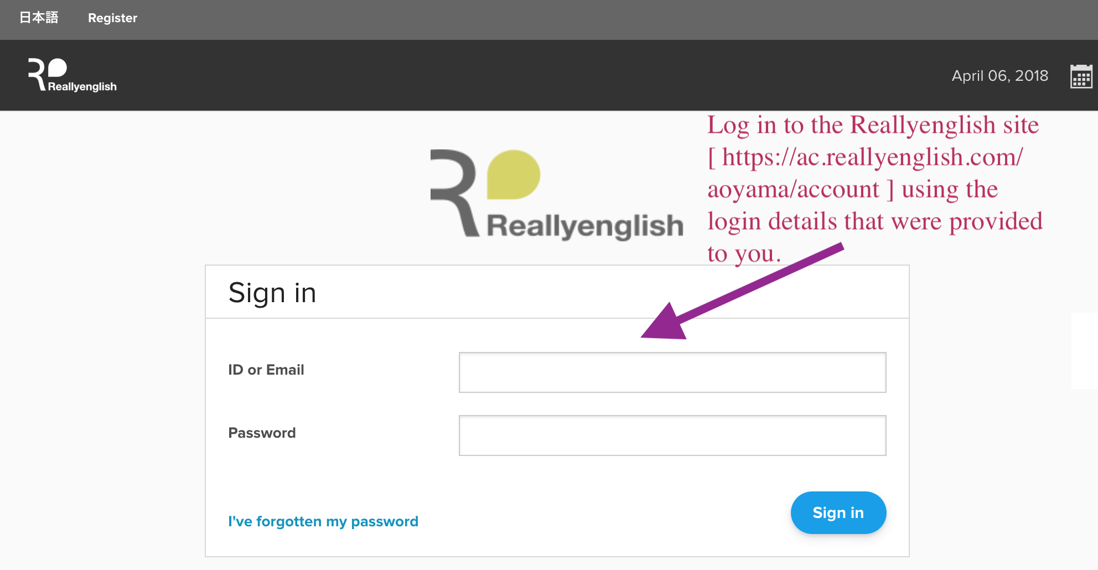
After logging in, click on the “Admin” menu, on the upper lefthand side of the window.
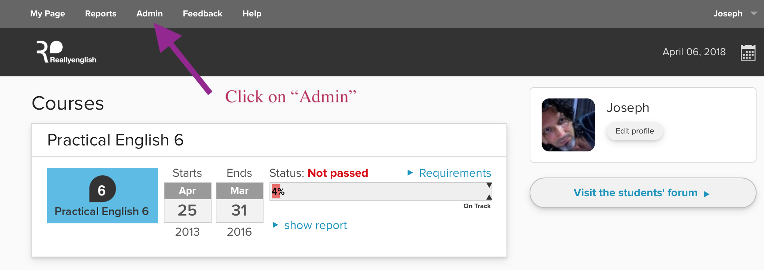
5a.2 Then, click on “Issue Keys.”

REALLYENGLISH KEYS
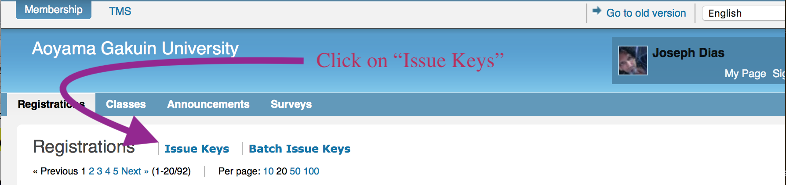
5a.3 Next, set the number of registration keys that you require.
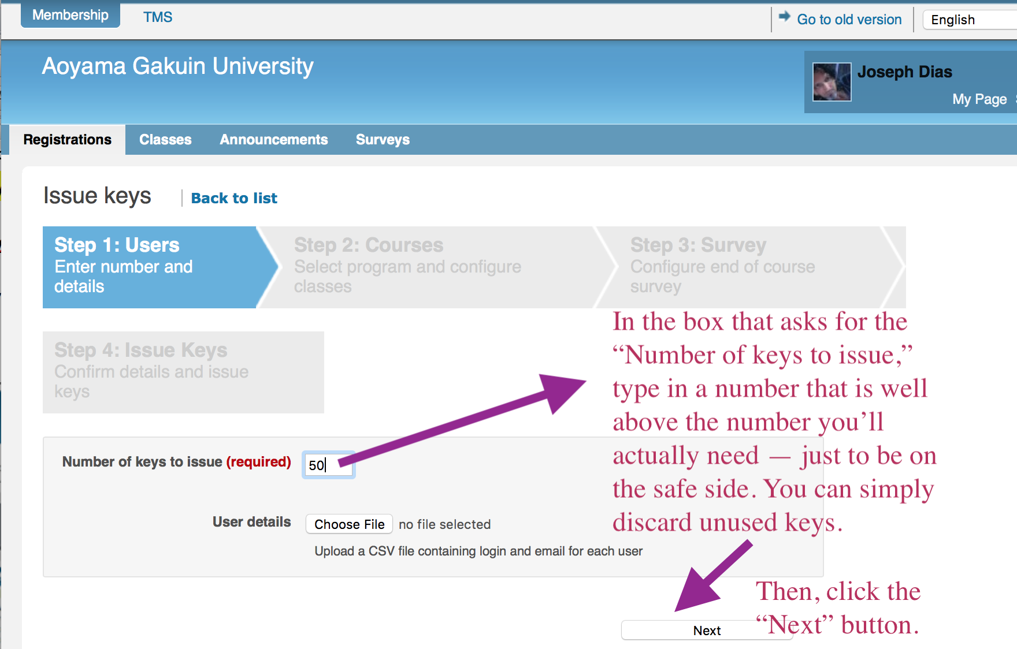
From a drop down menu which will appear, select the course and then click on the “Create new class” button.

REALLYENGLISH KEYS

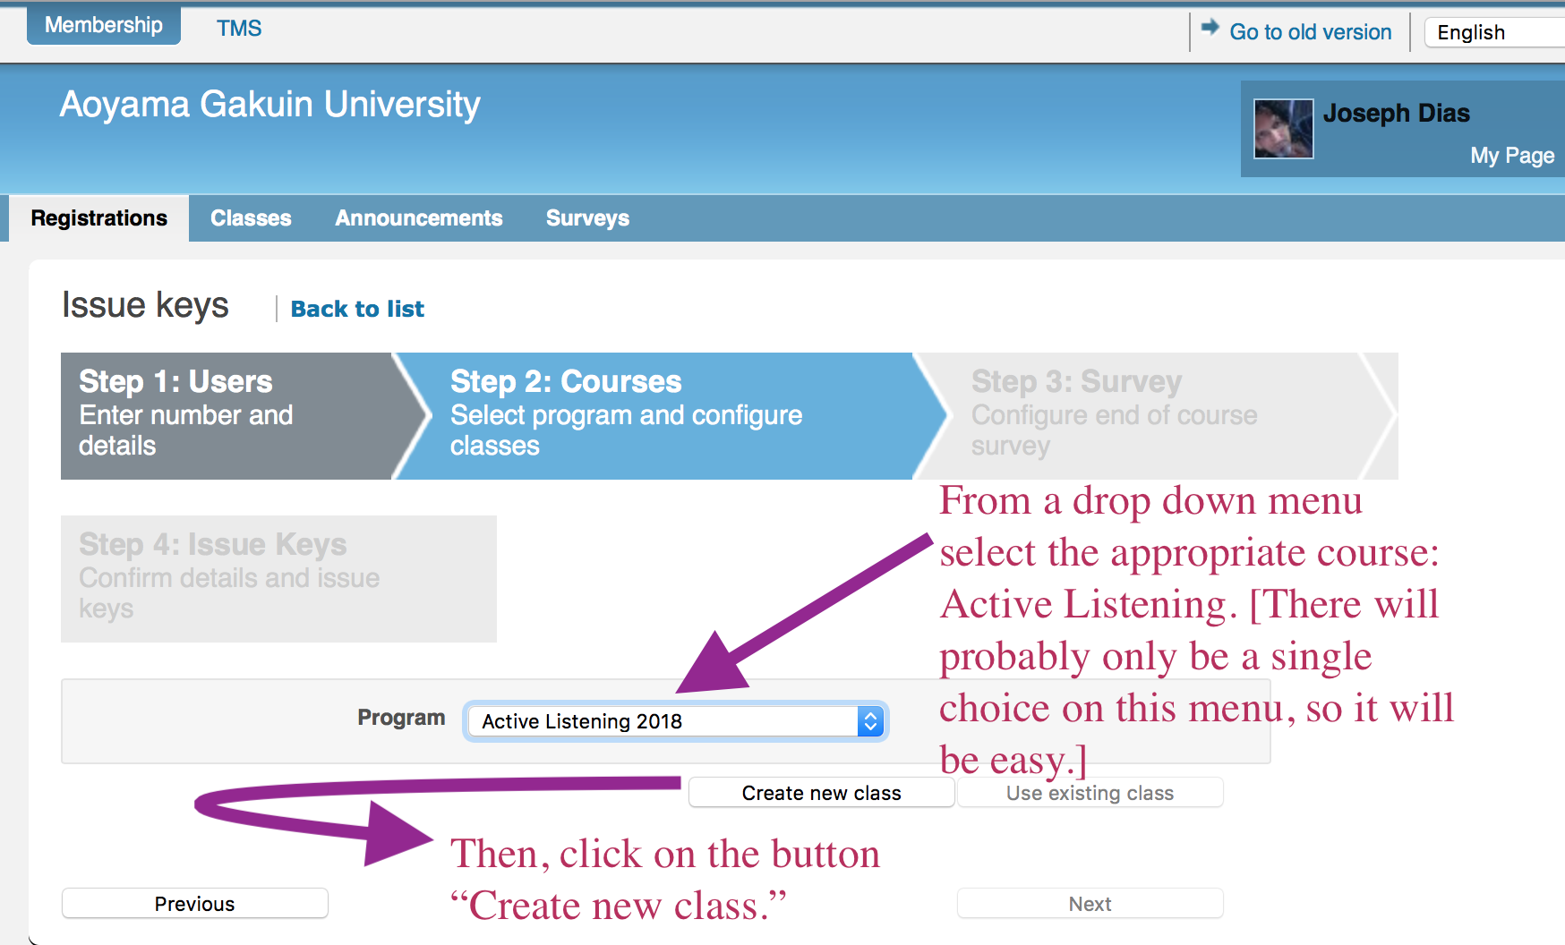
5a.4 Then choose the appropriate level and current semester from the next drop down menu. After that, click on “Create new class.”
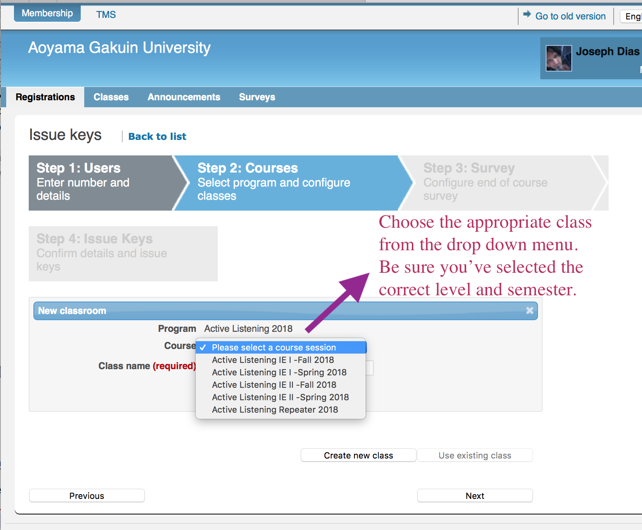
REALLYENGLISH KEYS

You will then need to create a name for your class by following the instructions in the screen shot.
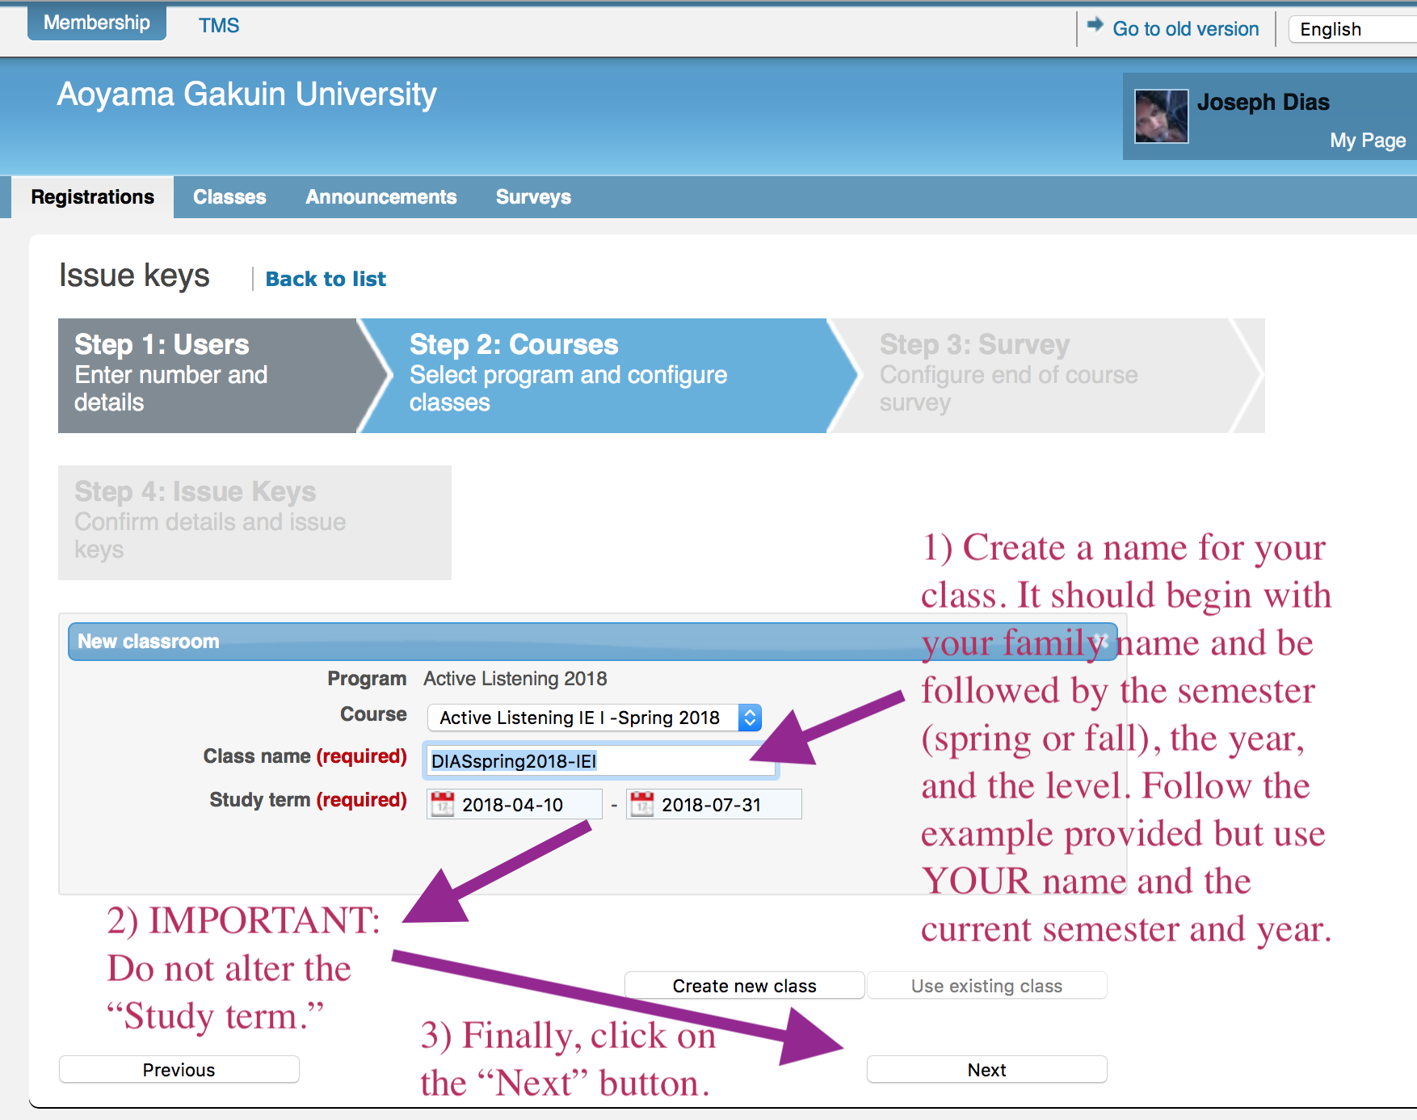
It is very important that you do NOT change the default period in the “Study term.” Finally, click on the “Next” button. In the following screen decline the invitation to create a survey.

REALLYENGLISH KEYS

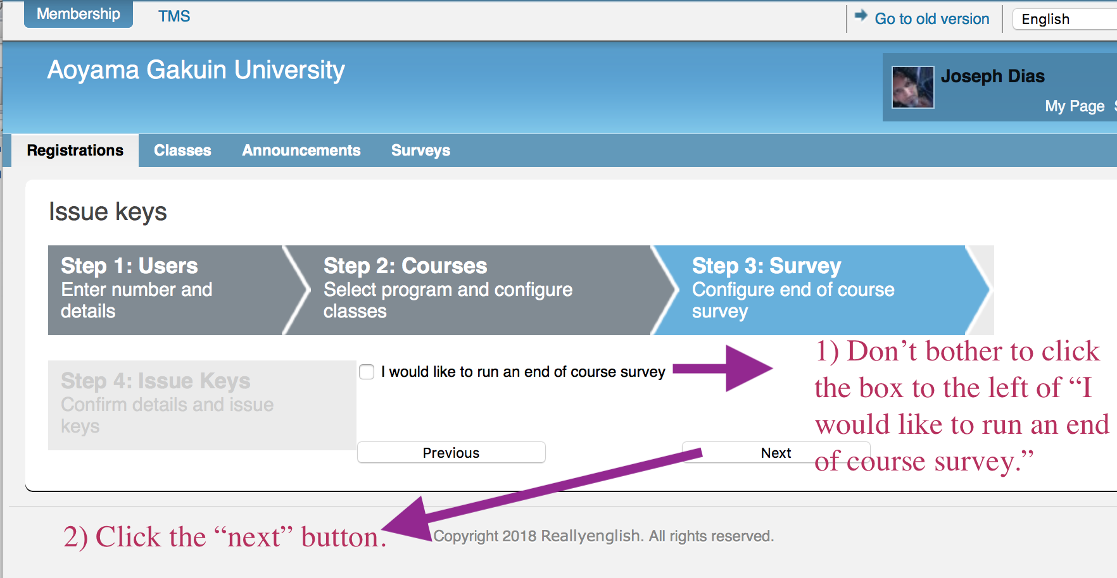
In the next screen you will be asked to confirm the information that you submitted previously. If it looks all right, click on the “Issue keys” button.
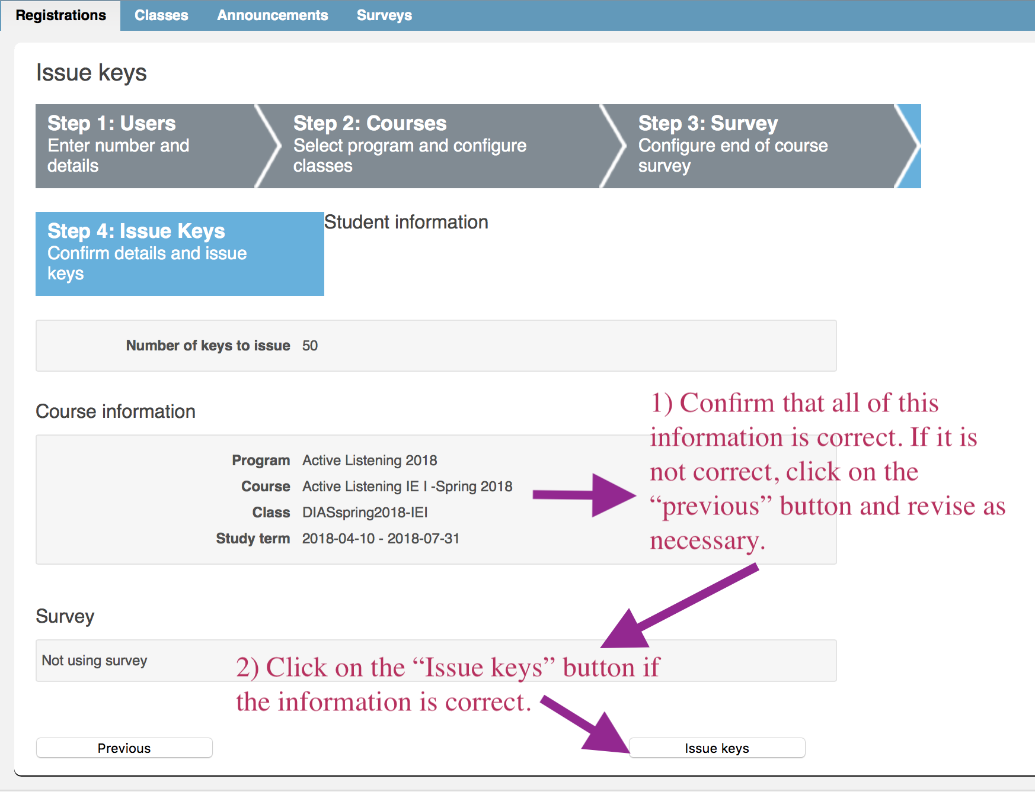
5a.5 Download the registration keys by clicking on the “Download details” button.
REALLYENGLISH KEYS

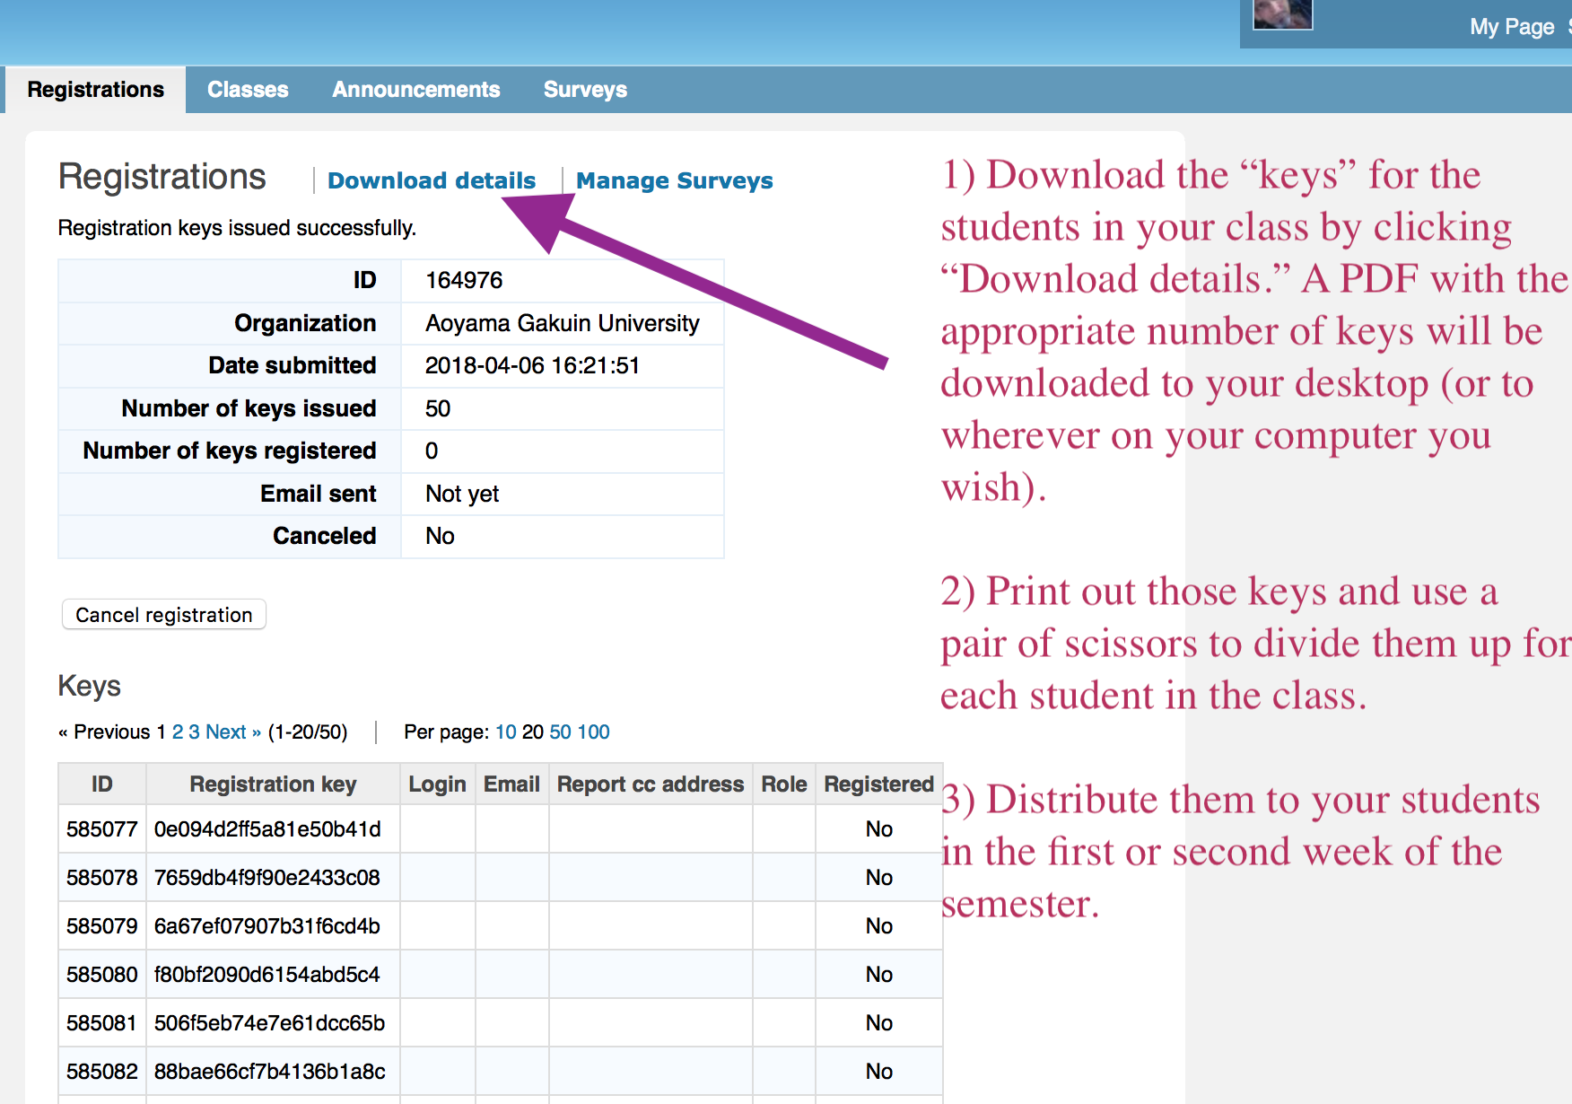
Print out the PDF of the keys and then using scissors, cut up the unique keys, one for each of your students.

REALLYENGLISH KEYS
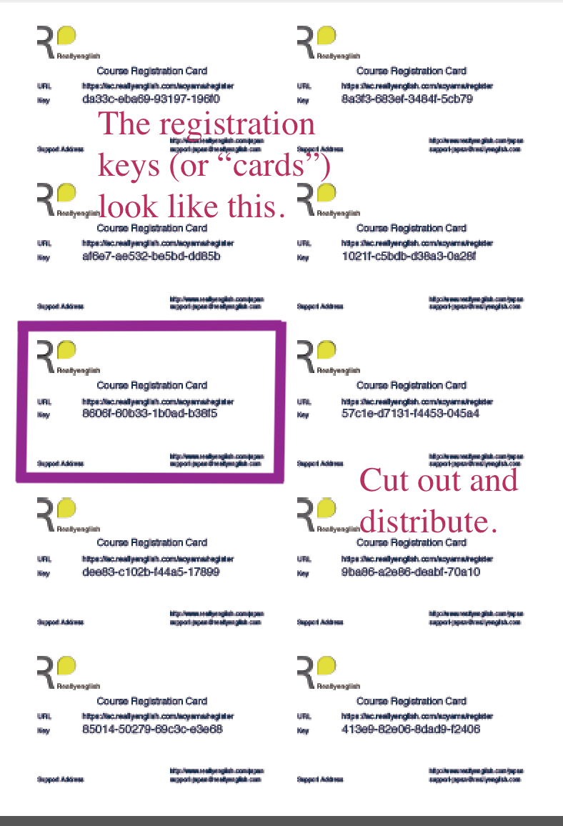
5a.6 【Key Issue Step 3 - Survey】
Our survey is used to evaluate the student’s opinions about the courses they have taken with reallyenglish. Based on your setting, the survey will appear for your students on mypage. Please check the ‘Use Survey’ checkbox. If you do not wish the survey, click ‘Next’ and go on.

5a.7 【Students Inputting Their Registration Keys】
Now students enter their key on a specific URL, http://ac.reallyenglish.com/aoyama/mypage/reg/
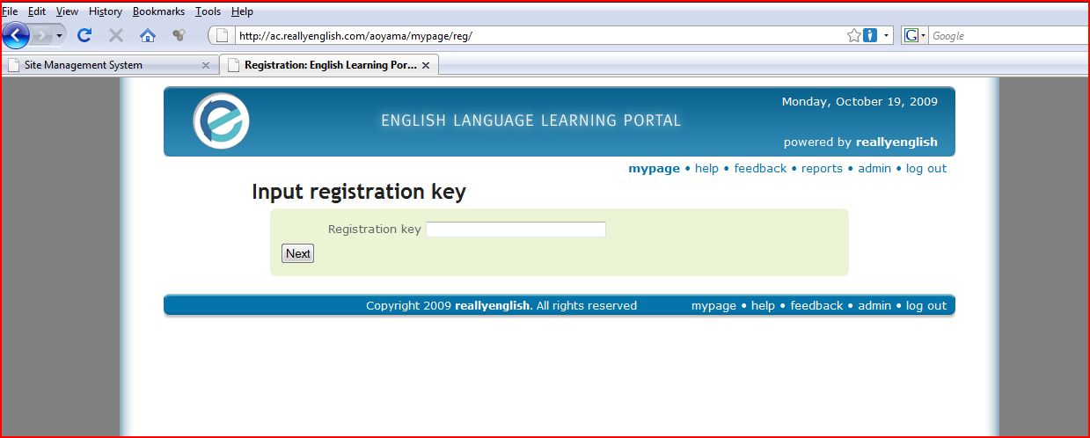

Appendix 5(b): reallyenglish REALLYENGLISH OVERVIEW
5b.1【Students working on units in reallyenglish】
After students have taken the diagnostic test, an “Adaptive Focus” (replacing the 2017 term “Learning Path” will be generated for them. Please show students how this works (See the diagram below). The Adaptive Focus shows three types of lessons: Reading, Grammar, and Listening. Although the students may choose units focusing on Reading, Grammar, or Listening, 80% of the required lessons they complete must be in "Listening," ie. 25 out of 30 lessons should be "Listening" ones. In order to get credit for a lesson, students must get score at least, 80% on it. The Adaptive Focus also enables students to re-take lessons that they have failed.
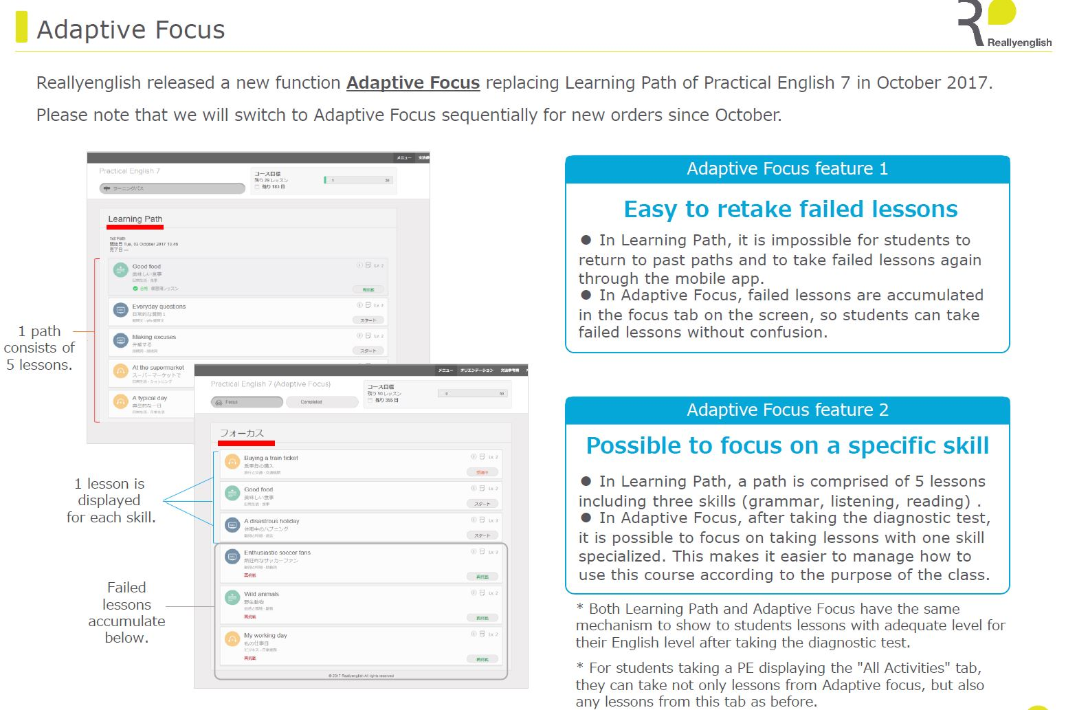
5b.2【Program Updates】
Reallyenglish now operates on cellphones. This should be demonstrated to students in the first class. An "Orientation" in the system explains what they need to do to get started. Please show students this feature in class. Here are the program updates from last year:
- 330 lessons (targeting around the TOEIC 280 level). Please tell students that these are supposed to be in a TOEIC style as well to give them practice in taking tests.
- The adaptive focus has changed from 10 lessons at a time to 5 lessons. This allows the system to adapt the adaptive focus more frequently to the learner's progress.
- reallyenglish has changed the overall look and feel of the course top page.
- reallyenglish has modified the lesson design by moving the next and back buttons, adding a black background, and small design touches.
- Users can change the user language from Japanese to English using the menu page (top right hand corner).
- Every lesson includes a lesson summary (pdf), while Listening lessons also include a podcast (MP3 file). They had these previously, but they can now be downloaded by clicking on icons next to each lesson title on the menu page.
- reallyenglish has improved the sort functions on the menu page--it's very easy to find the lesson by title, topic, etc. now.
The "Trainings" page, which allows teachers to view the progress of their students, also has some improvements. You can access a pie chart by clicking each star rating on the "Trainings" page. The "Training" page shows the progress of each class and is accessible from the "TRAININGS" tab on TMS. Moreover, you can download the progress data, along with the pie chart in excel format from "Create report" on the TOOLS tab. If you have questions about this, you can refer to the help page on TMS.
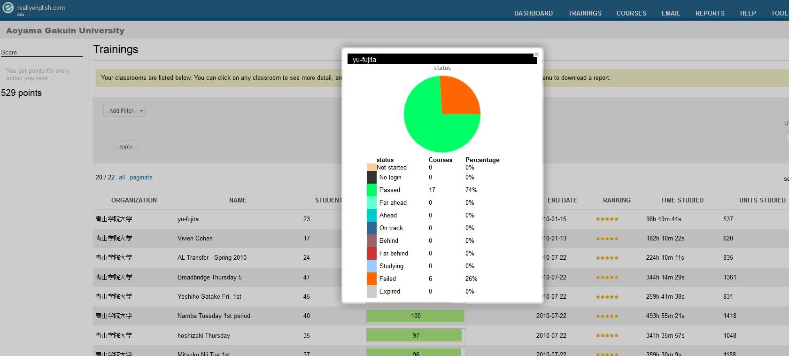
5b.3【Pacing your students】
As with many term-length assignments, many students will procrastinate. Even if a student was able to complete all 30 units in the last week of classes, the student would not get much benefit from them. They need to regularly work on these listening units over the term instead of cramming. Show the students printouts (screenshots of the reports once you access your class on the reallyenglish website) of their relative standing in the class at four weeks, eight weeks, twelve weeks, and fifteen.
We have found that students who work on the reallyenglish lessons regularly and sincerely benefit a great deal, particularly students who start at lower levels. One teacher so motivated her students that all of them did much more than the minimum 25 units and one student did more than 200 lessons in a single semester! There is no limit to the number of modules that the students can do. If they feel that their reading or grammar is weak and can be improved by the Practical English program, they may do extra units in those areas.
It is up to the teachers to provide students with incentives to do as many modules as they can. You will be able to see in the course management tools how many units, beyond the minimum, that the students have completed. Most teachers monitor students by giving them three or four deadlines during the term one at the end of each month. Students that don’t complete on time, lose a mark for the self-directed portion of their grades.
As part of your course requirements (Participation), you also can have students create their own vocabulary flashcards using apps and a free Web site: http://www.quizlet.com.

5b.4 Logging on
Time and again, we’ve had students who experienced difficulty in logging onto the site. Usually, these students have not been logging on regularly. Panicked as they end of term approaches, they just google the general website for reallyenglish. The general site will not allow them to get into realyenglish. They need to use the following URL. Have them bookmark it and also send them an e-mail with the URL . Have students mark your e-mail, post it.

https://ac.reallyenglish.com/aoyama/account

Appendix 5(c) : Logging onto reallyenglish and Sending e-mails to Students
You can also use reallyenglish to warn individual students that they are falling behind, and to encourage students who are doing well. You can send a single message to the whole class as well.
- Start with logging on.
- Once into reallyenglish, click onto reports.
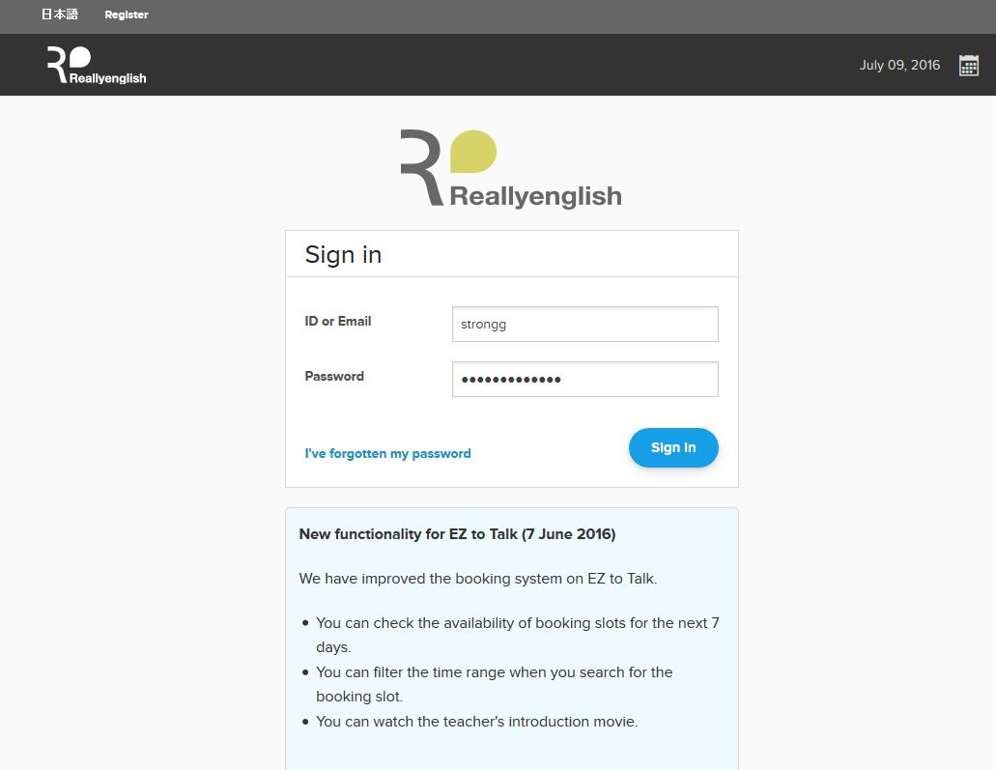
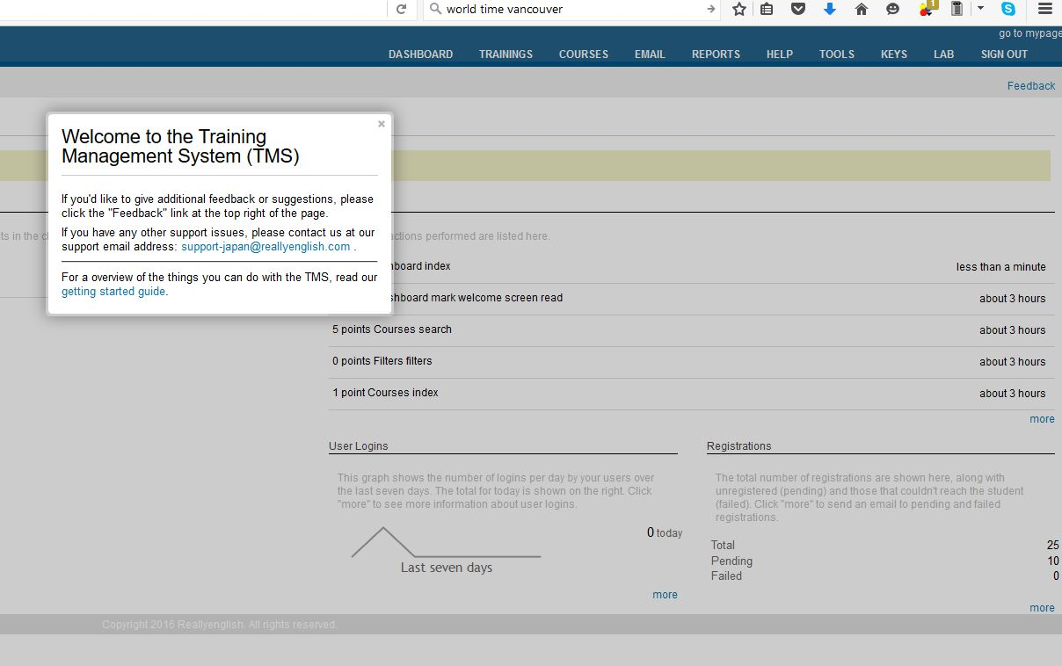

5c.1 Click on your class to view your students.
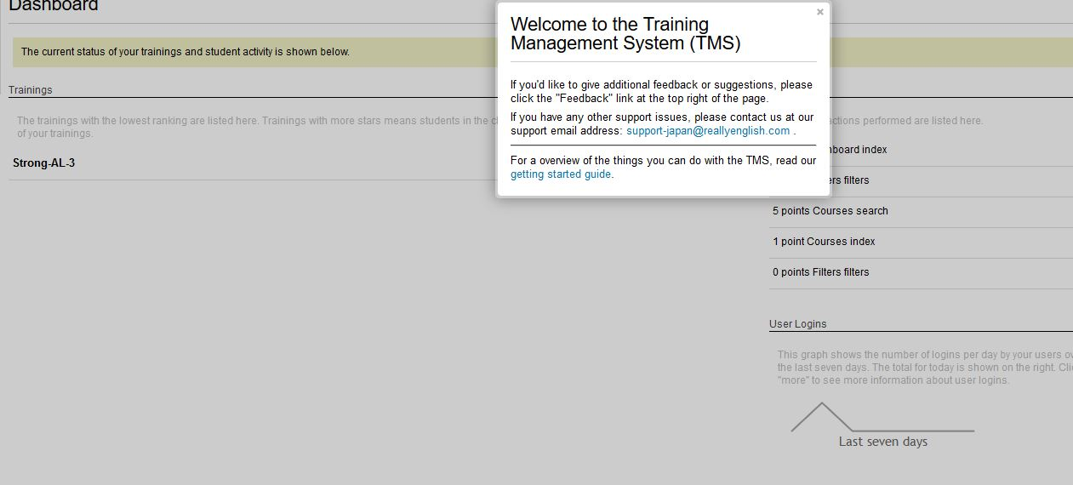
5c.2 Once you have the students in view, you have a snapshot of how they are doing in the course. I take a screenshot of the graph and print that out for my students. Then I call those up who are behind to advise them of their standing in the class. It’s very important to do this several times over the semester. From the past experience of Listening teachers, students who fall behind, then rush to do a lot of units, fail to get that much benefit from the course. 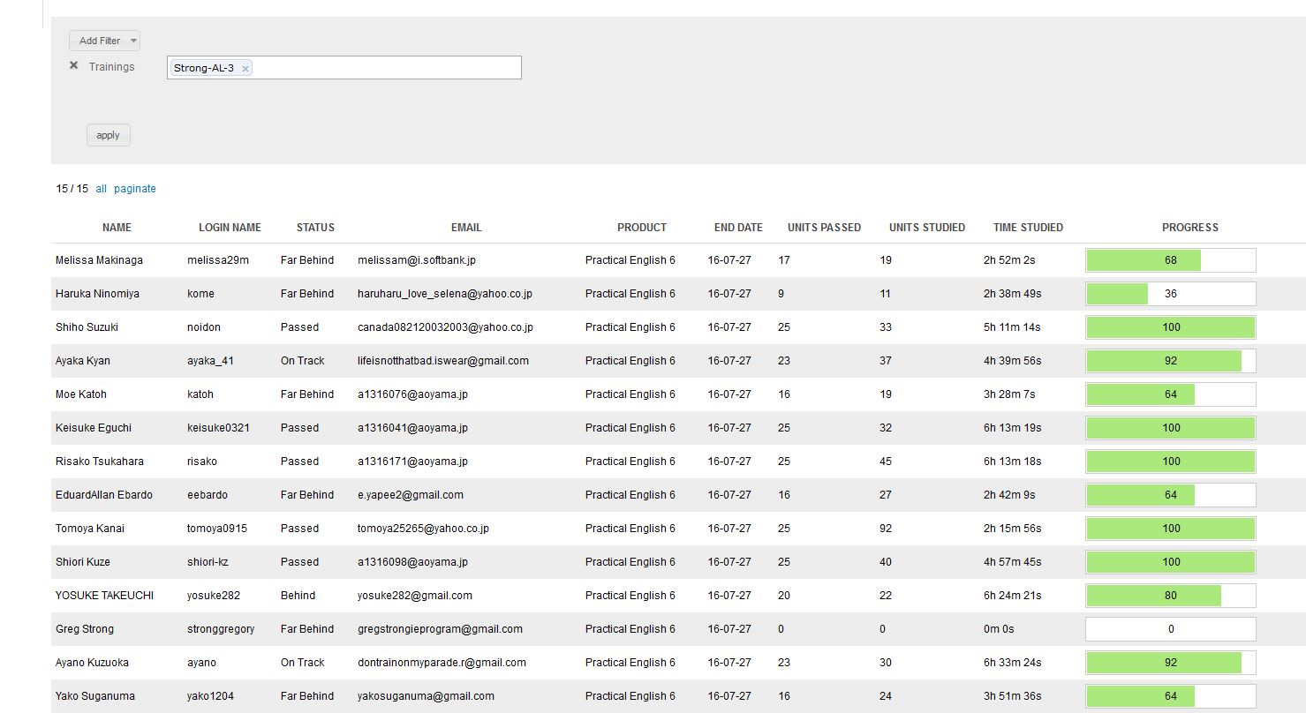

5c.3 Now, send an e-mail of “encouragement” or “praise to all your class or just to some students. You do this by going to the “Email” in the tool bar at the top of the page. Then you simply check the students you want to reach by a group e-mail. You can adjust the form letter by adding phrases.

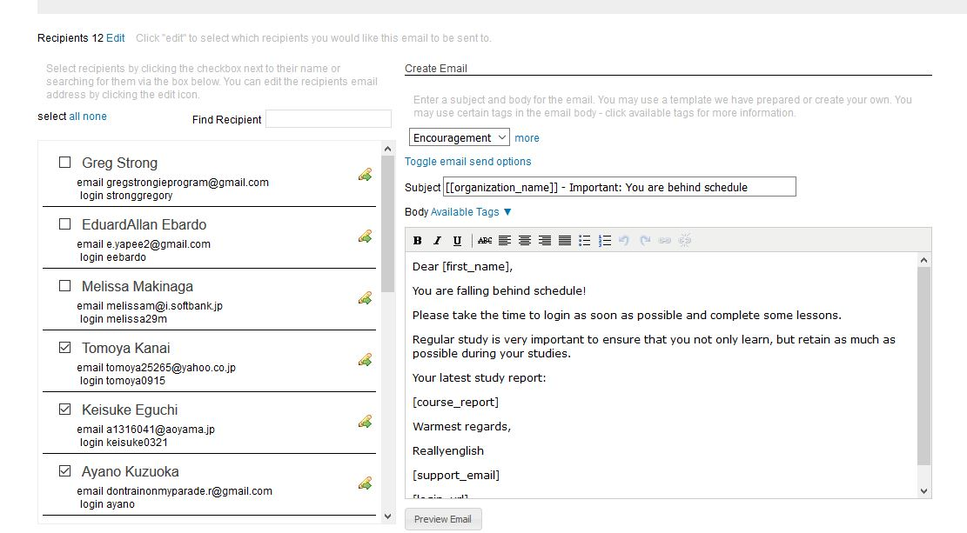

APPENDIX 6: EnglishCentral

EnglishCentral is an e-learning system with a library of short videos of one to three minutes length --commercials, lectures, news items, and dramatic scenes. Each video includes exercises in which students manipulate the words that they have just heard to complete a sentence, or re-order the words in a sentence. Next, the students speak lines from the video and their pronunciation is compared to standard speech. Finally, as of 2018, EnglishCentral includes vocabulary learning exercises based on the “Core Vocabulary List” and the “Academic Vocabulary List,” lists of words that appear most frequently on Englist texts. EnglishCentral also offers a freecellphone app which is not yet available in the Microsoft store, but can be found in the Android Play Store and the iOS App Store.
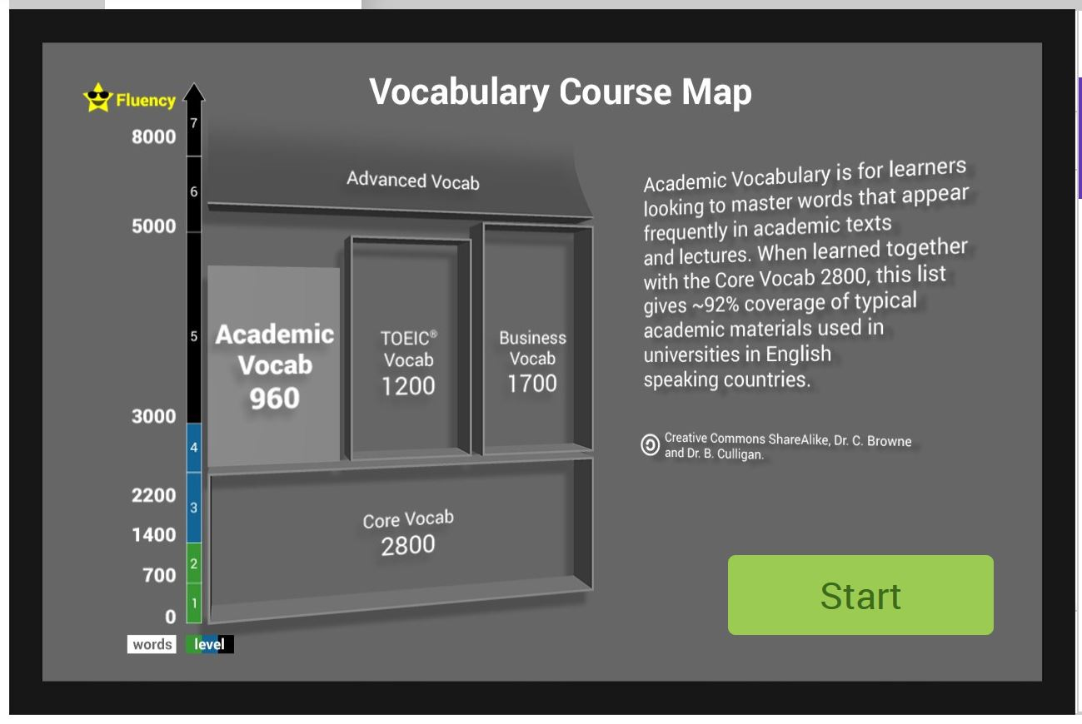
Go to the EnglishCentral website and log in. Your password and ID will be the same as last year. You will be given a class URL. Your students will go to the URL and log on.
They will create a password for future logging in (See below). Please have your students record their passwords in an e-mail to themselves, (and possibly to you, and to record their passwords on the course outline to ensure that they retrieve it).
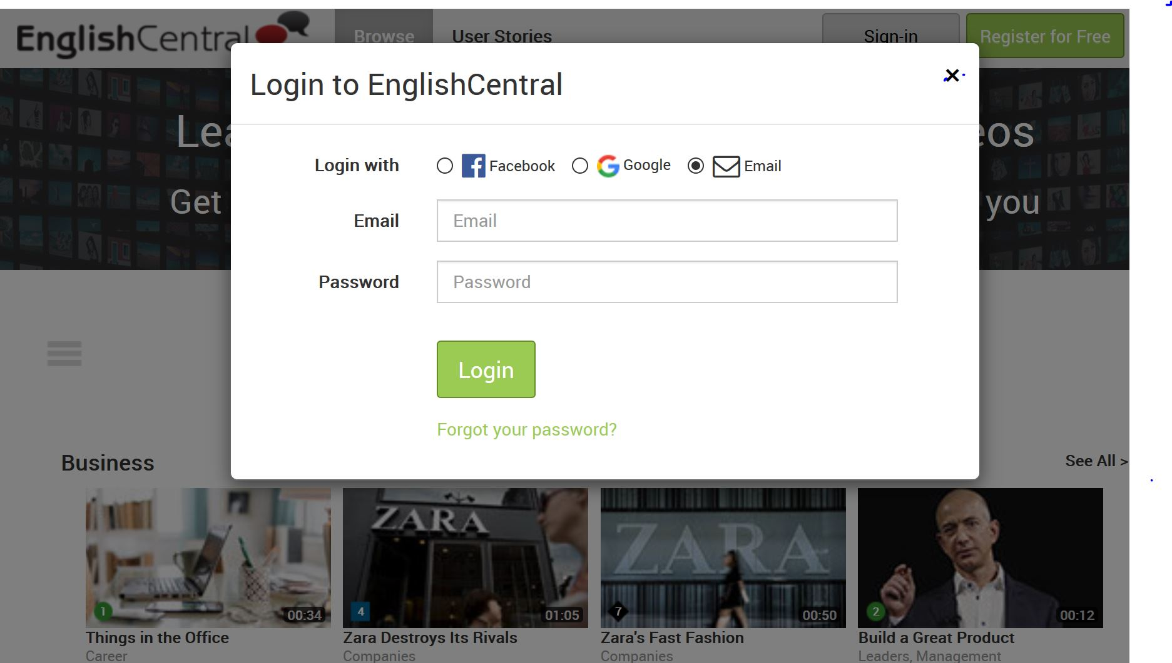
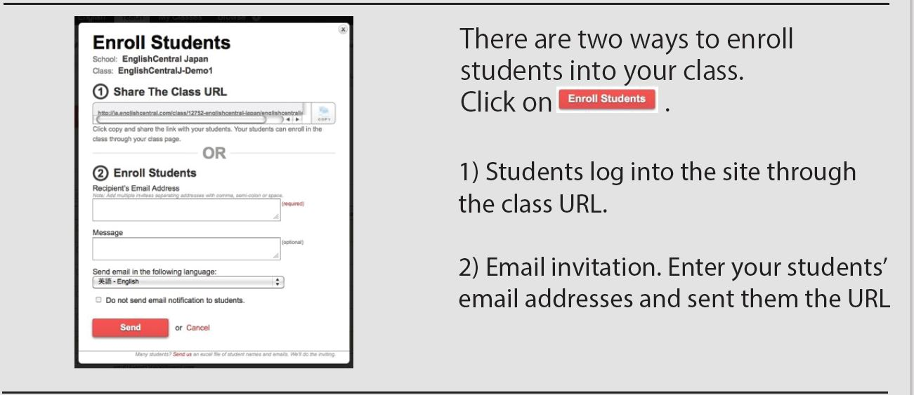
Once your students have logged into the website, they will see a tab with three options and they should choose “Class Courses.” The first of these courses is the Vocab Level Test and students take it to learn their vocabulary knowledge. Once they have determined their level, ie. Level 7, they do Core vocabulary or Academic vocabulary at levels 6 or 7.
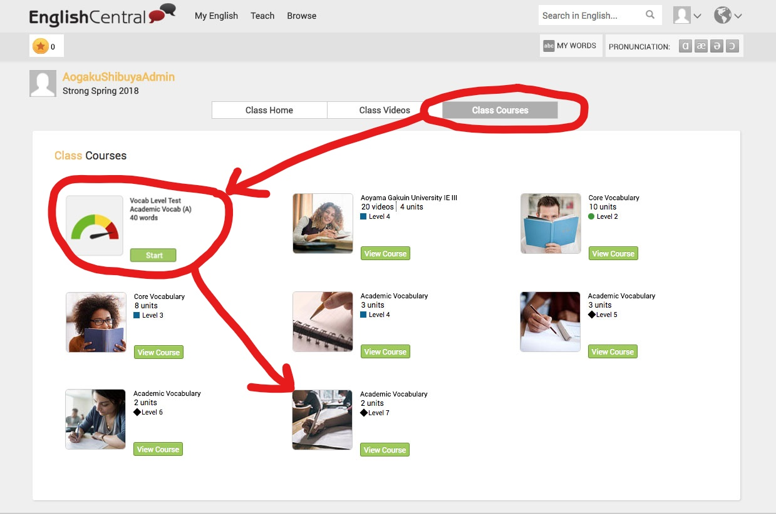
The core vocabulary word lists and the academic vocabulary word lists combined cover 92% of the academic materials used in universities in which the language of instruction is English.
We have already chosen videos for the students that fit the IE 3 themes and set the weekly goal for the course. The second button on the toolbar (See the screenshot below) enables you to choose additional videos for your students and (Step 1) set the goal/target. Active Listening 3 is 4 videos weekly. Students watch a 50 second – 2 min video – news items, commercials, etc., learn key words from the video, then speak lines and they are rated by voice recognition software. (Step 2) we are leaving the choice of videos to the students. Suggest videos on the 4 IE III themes but the students are not required to do them. As much as possible, they should access and study videos on the themes of psychology, cross cultural communication/ values, the environment, and the media, but they may select other videos that interest them as well. The important thing is that they choose content that interests them and that makes them want to study far beyond the required minimum.

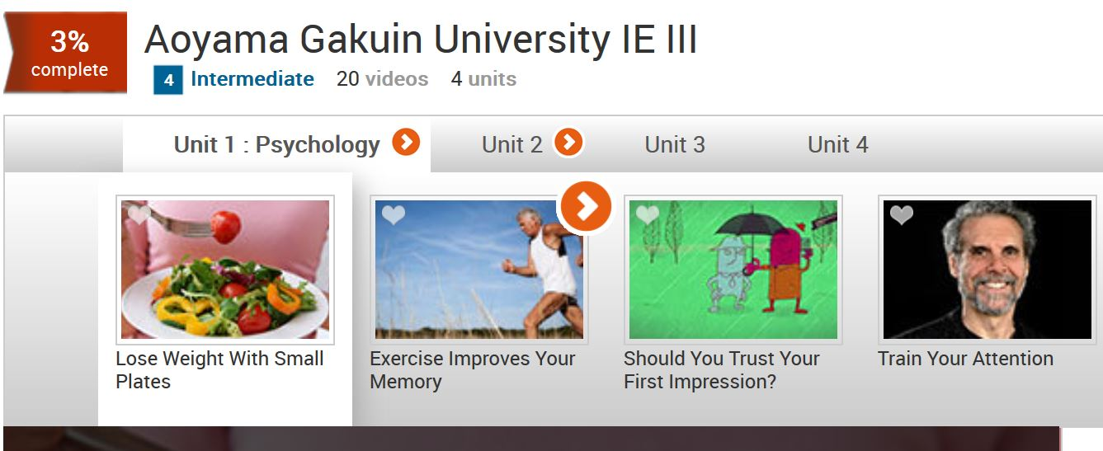
The following screenshots show how EnglishCentral operates. As mentioned already, the goals for the course have already been set.
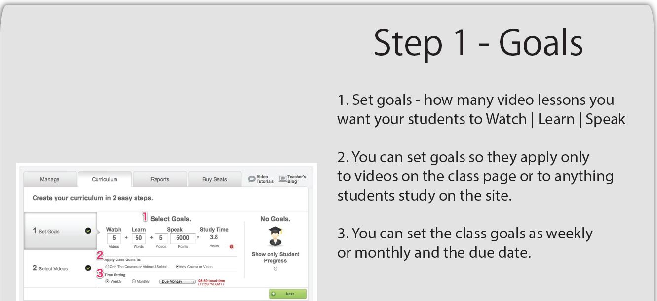
This button on the toolbar enables you to check on your students’ progress. They have exactly one week to watch the 4 videos, speak 40 lines, and view 80 words. Meeting this weekly deadline is part of their participation mark. To encourage the students, mention the current scores in class (but avoid identifying individual students by name).
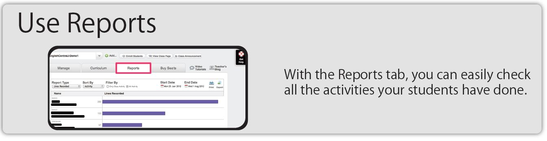
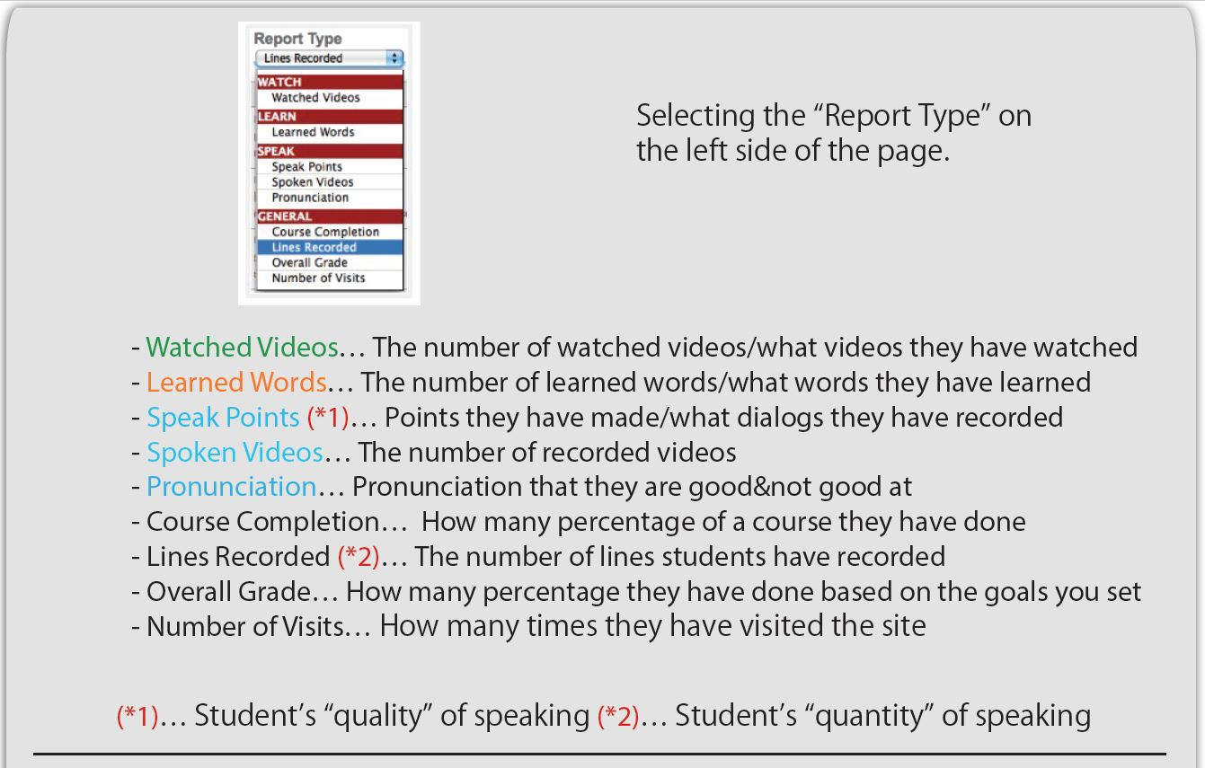
The class reports can be downloaded as a PDF to assist you in computing your students’ grade for this part of the course. You can even listen to recordings of your students’ trying the Speak portion of the program.
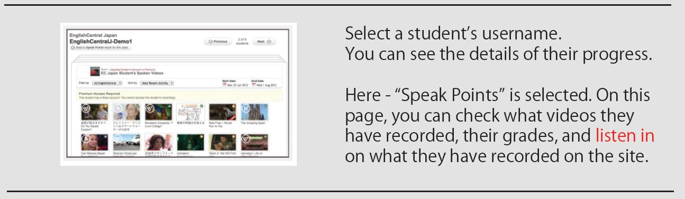
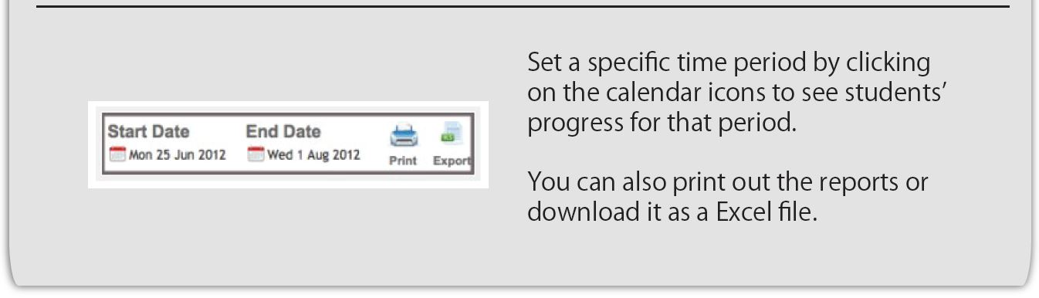
You can also check students’ progress on their vocabulary words. Students do vocabulary recognition exercises like the following where they choose sentence definitions for a word:
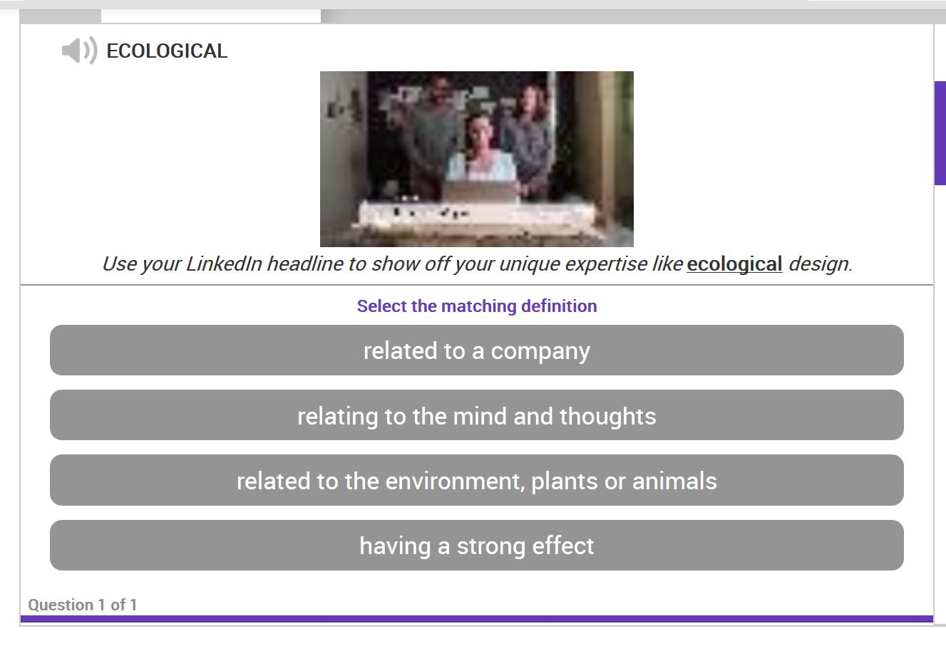
The vocabulary words are all added to the students’ log-in page under “My Words.”
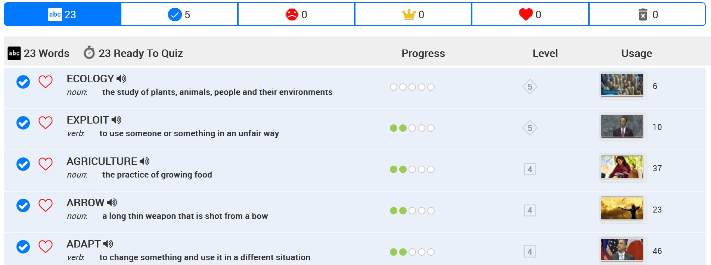
Each word will be repeated at spaced intervals when students click on “My Words” until they have viewed it five times (measured by green dots as in the screenshot below) and have achieved mastery on it. EnglishCentral has a Learning Management System (LMS).
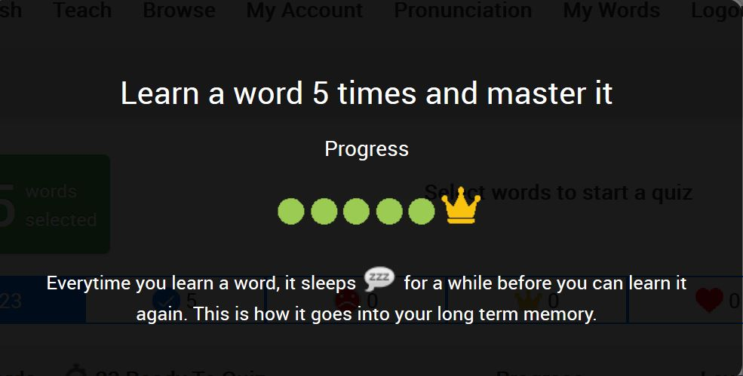
It shows weekly targets for video-watching, speaking lines, and learning vocabulary, so a teacher can log in and quickly determine if students are on target or not. We have set the system default at 4 videos per week, 40 lines, and 80 vocabulary words.
Additional Teacher Resources:
- To start, you can view the introductory video at the academic (teacher portal) this URL:
https://www.englishcentral.com/academic/index#/!
- A downloadable PDF taking you through class registration, setting class targets, and assessing your students’ work is at http://j.mp/EC-ENTeachers2
- A webinar https://www.englishcentral.com/video/25853/enjoy-language-learning

