Review: Capone’s in Alameda struggles to live up to swanky theme

- 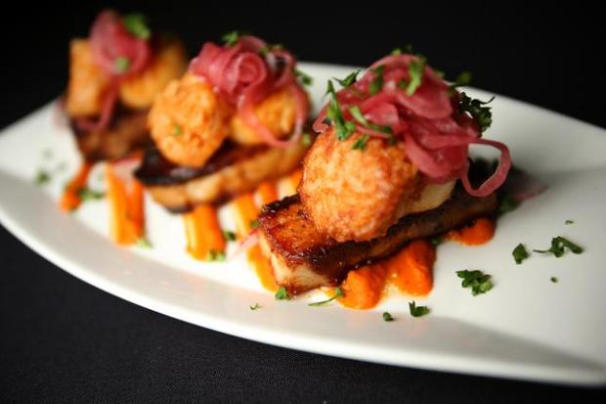
- 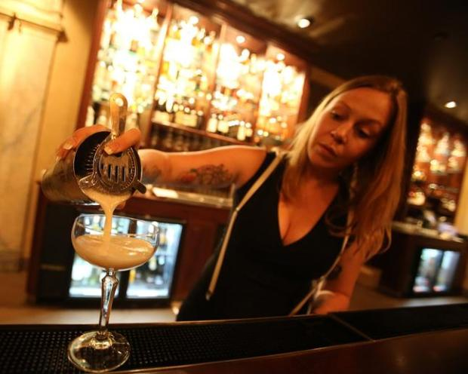
- 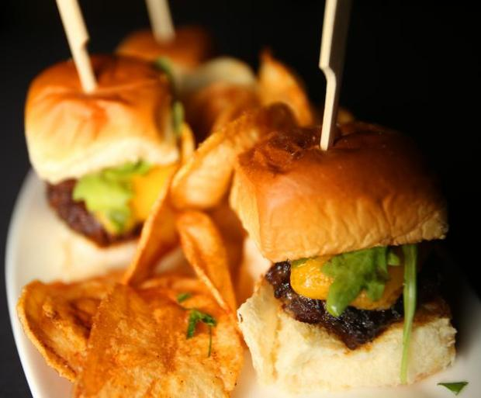

Bartender Megan Tappin makes a Swingin' Sour at Capone's Speakeasy on Wednesday, Dec. 10, 2014 in Alameda, Calif. (Aric Crabb/Bay Area News Group)

By DANIEL M. JIMENEZ | djimenez@bayareanewsgroup.com | Bay Area News Group
PUBLISHED: December 15, 2014 at 5:18 a.m. | UPDATED: August 12, 2016 at 6:49 a.m.
Step into Capone’s Speakeasy in Alameda, and you’ll sense a bit of Prohibition-era glamour: giant chandeliers hang overhead, long leather couches line the windows, bartenders wear the black-shirt gangster look.
Still, it’s a space that feels more like a modern nightclub than a restaurant trying to throw back to an iconic era in American history. There are tall bar tables scattered throughout the room, but no standard seating. Electronic music pumps insistently out of the sound system, even on a Sunday evening when clubgoers are nowhere to be seen. Thursday through Saturday nights, there’s a dress code: No baseball caps, shorts, shirts without collars, sneakers, sandals or baggy pants.
The gangster vibe will settle back in, though, when a few pricey cocktails and a mediocre menu come together, leaving you holding a check that’ll make you feel like you’ve been robbed.
Originally slated to open in April, Capone’s underwent several staffing changes before a tumultuous Labor Day weekend opening that put co-owner Mark Strachan in the spotlight (he was arrested on public intoxication and other charges). The original opening menu promised small plates focused on seasonal, local, organic ingredients.
The menu on our recent visit was … not that menu. It wasn’t the “subject to change” menu on the website, which had my wife revved up for the prospect of a San Marzano tomato bisque with caramelized onions, served with a toasted cheddar and Gruyere sandwich on brioche ($15); that pairing wasn’t listed on the menu when we got there.
In fact, that wasn’t even the fairly limited menu that we were handed when we sat down. Upon trying to order the Mac & Cheese appetizer ($7), we were told they were out of it. After one of our group ordered the Petite Filet Mignon with Lobster Mashed Potatoes ($24) the chef came out to inform us that the plate would have to come without mashed potatoes; they had the lobster ready, just not a batch of potatoes, he said. Would we like a rice cake instead? (We agreed to wait and got the plate as advertised.)
There were only four entrees from which to choose: the filet, Stuffed Chicken ($16), Capone’s Sliders ($17), and Sizzling Pork Belly & Pan Seared Scallops ($20). The three sliders were lukewarm on arrival; the beef patties were tender, but not packing much flavor, topped with unmelted cheese and little else.
The Sizzling Pork Belly did not sizzle; the scallops were mealy, as was the Tuna Tartare appetizer ($11). That tuna, advertised as being coated in a soy-ginger marinade, was just fishy.
The menu does have several salads, including Rosemary Chicken Skewers over mixed greens with olives and a mustard vinaigrette ($12), and Ahi Tuna salad ($13) with an odd-sounding set of ingredients: quinoa, cherry tomatoes and a raisin-wasabi vinaigrette.
Where Capone’s does shine, not surprisingly, is at the bar, although the cocktail prices will make you think you’re at a three-star restaurant in San Francisco rather than a humble former bank building in Alameda. The namesake Al Capone ($13) adds the sweetness of Grand Marnier to the bite of Templeton Rye, with a splash of champagne as well. The Public Enemy ($12) combines Larceny whiskey with The Botanist Gin and a squeeze of fresh lemon for a tart mix, a nice change from whiskey drinks that are often heavy on the sugar.
Capone’s clearly aspires to be a destination nightclub; maybe the best move would be to pare the menu down even further, focusing on simple bar snacks, rather than trying to straddle the line between fine dining and party central.
At the end of the meal, we learned that with the kitchen closed, we had but one dessert choice: vanilla ice cream. That was fine by us; after an underwhelming experience at Capone’s, we were more than ready to make our getaway.
CAPONE’S SPEAKEASY
*
WHERE: 1400 Park St., Alameda
CONTACT: 510-522-2391
HOURS: 4 p.m.-11 p.m. Tuesday and Wednesday; 4 p.m.-midnight Thursday; 4 p.m.-1:30 a.m. Friday and Saturday; 11 a.m.-9 p.m. Sunday
CUISINE: American
PRICES: $$
VEGETARIAN: A few salads and appetizers
BEVERAGES: Full bar, beer and wine
RESERVATIONS: Accepted
NOISE LEVEL: Loud
PARKING: Street parking
KIDS: Not for children
PLUSES: Varied cocktail menu
MINUSES: Very limited food choices, executed poorly
DATE OPENED: September
Policy
We don’t let restaurants know that we are coming in to do a review, and we strive to remain anonymous. We pay for our meals.
Ratings
Restaurants are rated on a scale of one to four, with four representing a truly extraordinary experience for that type of restaurant.
Price code
$ Most entrees under $10
$$ Under $20
$$$ Under $30
$$$$ Under $40

